THE ALPS
WHAT IS GEOGRAPHY?
Geography is the study of places and the relationships between people and their environments. Geographers explore both the physical properties of Earth’s surface and the human societies spread across it. They also examine how human culture interacts with the natural environment and the way that locations and places can have an impact on people. Geography seeks to understand where things are found, why they are there, and how they develop and change over time.
Physical geography is the study of Earth’s seasons, climate, atmosphere, soil, streams, landforms, and oceans.
Human geography is the study of the distribution of networks of people and cultures on Earth’s surface.

COUNTRIES OF EUROPE | MOUNTAIN RANGES OF EUROPE
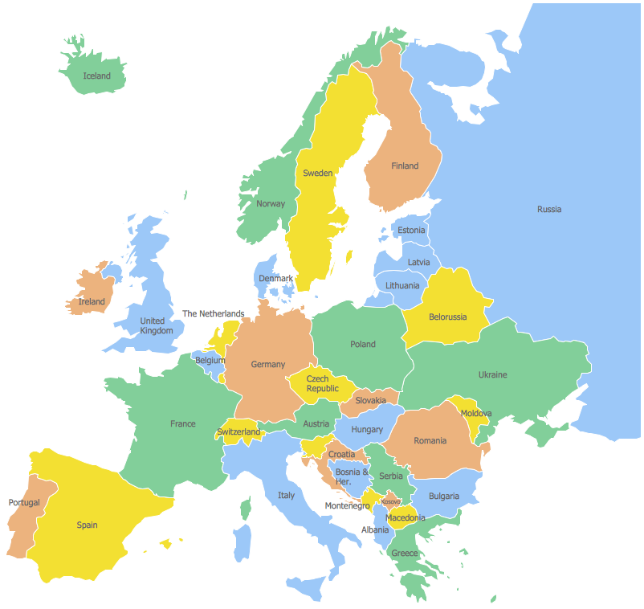 | 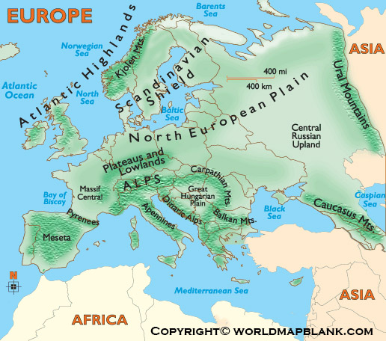
CHARACTERISTICS OF MOUNTAIN ENVIRONMENT
- 1/5 of the world’s surface
- 80% of the water originates
- A peak above 2,500m
- Mountains have colder weather, wetter weather, less breathable air (less oxygen to breathe).
- Different plants and animals compared to the surrounding terrain.
- Steep, sloping sides and sharp or slightly rounded ridges and peaks.
- Can be rocky and barren
- Some have trees growing on sides and very high mountains have snowy peaks.
- Features: Summit, slope, steep valley between (gorge)
- Exist on every continent and below the ocean.
- Extreme weather
- Extreme animals and plants that have adapted to the mountain environment
- Animals: Chamois, wolves, lynx, marmots, golden eagles, vultures
- Plants: Spruce, larch, pine, oak, poplar, elm, spring crocus, snowflake, forget me not, blue bugle, orchid
GLACIERS | ALPINE DEVELOPMENT
- Thick mass of ice that covers a large area of land.  - Glaciers form from snow that doesn’t melt even during the summer. Snow builds u and the weight of the snow compresses and turns into sold ice. It can take hundreds of years for a glacier to form.  - Glaciers are moving  - Slowly moving downhill. The speed varies.  - Ablation Zone, Accumulation Zone, Crevasses, Firn, Head, Terminus  - Glaciers shape the landscape  - Most famous in the French Alps: Mer de Glace  - Roughly 600 glaciers in The French Alps | - Skiing, tourism, sport, events, culture, wildlife, history  - Money making  - Raises the profile of the country  - Transport and communications difficulties  - Resources are limited  - A difficult environment to build in and on  - Care for the environment  - Protection of wildlife: flora and fauna
VOCABULARY – TIER 2 | VOCABUARY – TIER 3
TIER 2  Atlas, map, co-ordinates, country, continent, mountain, range, peaks  Ridges, rocks, slopes, ski, conservation, endangered, Human/Physical Geography | TIER 3  Glacier, terrain, altitude, crag, cornice, topography, contours, avalanche

