STONE AGE BRITAIN

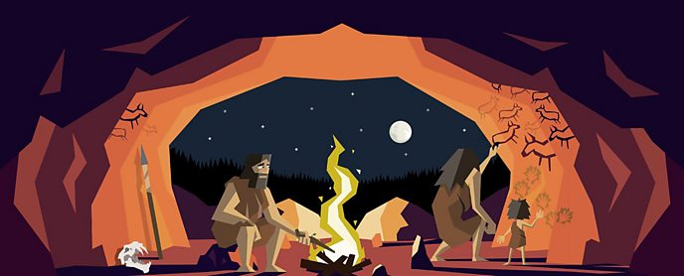

**HUNTER-GATHERERS**

The Middle Stone Age in Britain began around 12000 BC at the end of the last Ice Age. During this period, humans were hunter-gatherers and had to catch or find everything they ate.

**EARLY FARMERS**

During the last part of the Stone Age, people began to settle down in one place and to farm. These early farmers chopped down trees so they could grow crops and vegetables. They kept cattle, sheep and pigs.

The STONE AGE is called the Stone Age because it is a time when humans first started to make tools and weapons using stone.

**STONE AGE TOOLS AND WEAPONS**

During the Stone Age, people made simple hand-axes out of stone and wood. They made hammers from bones or antlers and they sharpened sticks to use as hunting spears. Later, they used bows and arrows and spears tipped with flint or bone.

Stone Age people cut up their food with sharpened stones and cooked it on a fire.

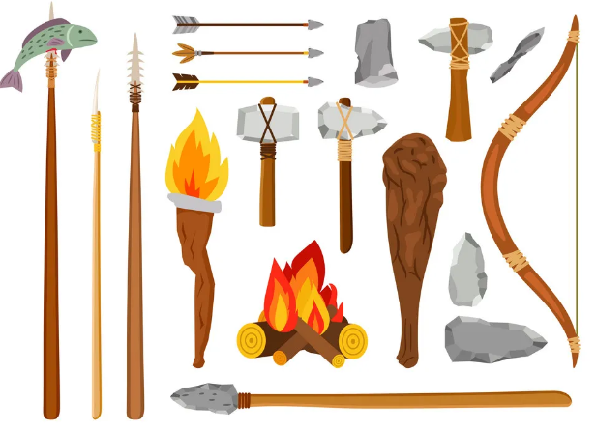

**STONE AGE HOUSES**

People in the Stone Age built their houses out of stone and straw, usually in the shape of a circle with a fire in the centre to keep warm. These are now known as Round Houses

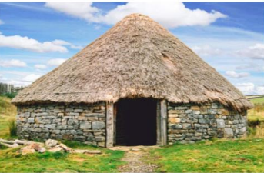

**STONE AGE ANIMALS**

During the Ice Ages, herds of mammoths, reindeer and woolly rhinoceroses roamed across the snow and brown bears sheltered in caves.

After the last Ice Age, the British climate became very similar to how it is today. The forests were full of foxes and red squirrels. Wolves and bears lived in the hills.

Stone Age people drew and painted images of everyday life on the inside of caves. These have survived for thousands of years and are called Cave Paintings .

