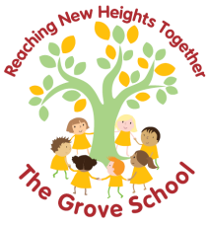

At-a-glance Positive Behaviour
and Respectful Relationships Policy and Guidance 2026

At The Grove, we want to make sure our children are happy, enabling them to thrive and learn effectively. We work closely with parents to support our children

Together, we are on an adventure that has LOVE, HAPPINESS, INDIVIDUALITY,
COMMUNICATION and LEARNING at its core.

Relationships and connection are key. All children need an Emotional Available Adult (EAA) – someone who holds them in mind and cares about them as a person.

Strong relationships between staff and pupils are vital. At The Grove, behaviour is viewed as communication and may indicate an unmet need, difficulty with self-regulation, or a response to stress and environmental demands.
This policy is developed to ensure clear guidance and information for staff, parents and governors. It promotes safe, kind and respectful behaviour within our compassionate environment.

Positive Behaviour is actively promoted and recognised.

Restorative Approach

We believe all behaviour is communication and we ask ourselves, “What is the child trying to communicate?” We use a Restorative Approach, enabling children to reintegrate successfully and regulate their emotional responses, with an understanding of their actions, feelings and relevant outcomes.

We recognise that behaviour is often an expression of an underlying need, emotion or experience and we need to ask "What is this child communicating?". Using a restorative approach, we help children develop emotional regulation, build self-awareness and make positive choices. When behaviour becomes challenging, we prioritise connection through our words, tone, facial expressions and body language before providing guidance and support.

We use the following restorative approaches, which are based on the four key features of: RESPECT, RESPONSIBILITY, REPAIR and RE-INTEGRATION
This approach holds boundaries, limits and expectations firmly, yet is gentle and relational.

With this in mind, we set positive and clear expectations, linked to our values, which are communicated to all and to children in a child-focused and friendly manner and tailored to different areas of the school and off-site activities.
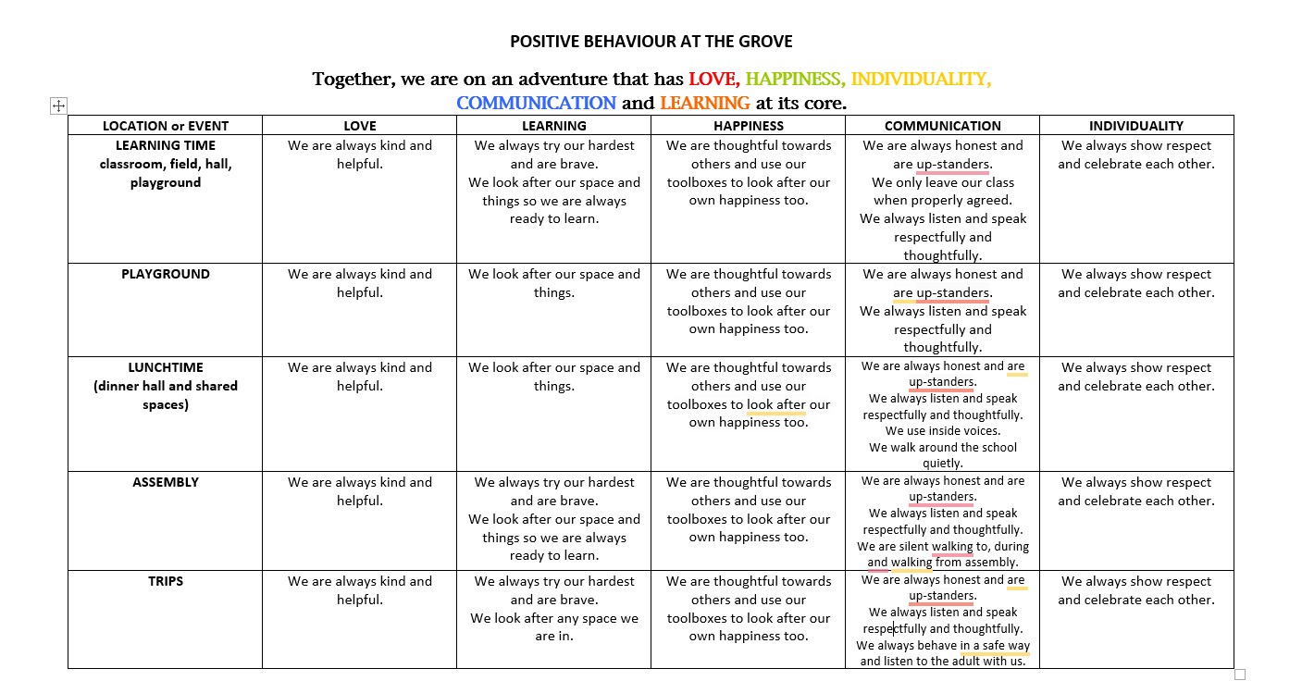

Responses to the expectations not being met are clearly sequenced, with a focus on restoration and learning; they are communicated to all and the different stages require different responses and communication with parents. The responses for the classroom are as follows.
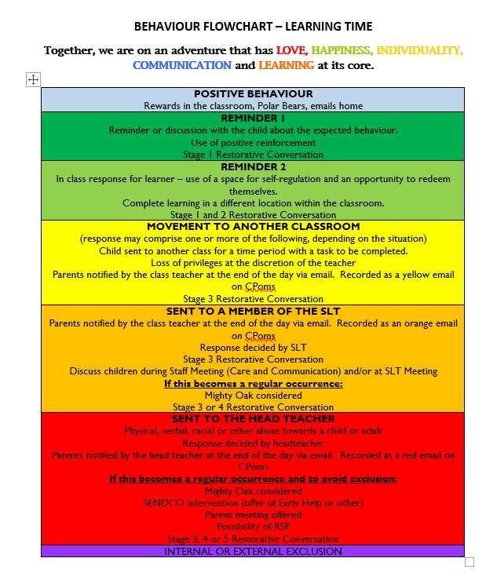
For the full policy, please see our website.

