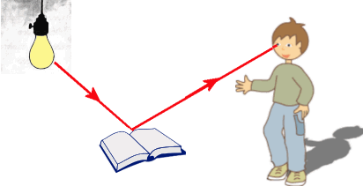
Key Vocabulary
Eyes – Globular organs of sight in the head of humans and vertebrate animals
Filter – Pass through a device to remove unwanted material (liquid, gas, light or sound)
Light – The natural agent that stimulates sight and makes things visible
Light source – Something that provides light, whether it be a natural or artifical source of light (e.g. the sun, a torch)
Periscope – An apparatus consisting of a tube of attached to a set of mirrors or prisms through which an observer can see things that are otherwise out of sight
Rainbow – An arch of colours visible in the sky, caused by the refraction and dispersion of the sun’s light by rain or other water droplets in the atmosphere
Reflection – The throwing back by a body or surface of light, heat or sound without absorbing it
Refraction – The bending of light as it passes from one substance to another with the bending caused by the difference in density between two substances
Shadow – A dark area or shape produced by a body coming between rays of light and a surface
Spectrum – A band of colours, as seen in rainbows, produced by separation of the components of light by their different degrees of refraction

LIGHT
