Y2 Home Learning
Lilac, Lime and Dove Class

- Read your school reading book several times.
- Read and spell the following words which are based on the Y2 weekly spelling programme.

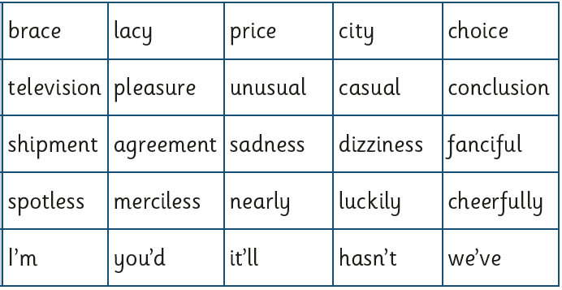

We are learning about time this half term which includes the days of the week and months of the year. The children love singing these songs to help with their learning so they could sing them at home too!
Days of the week
https://www.youtube.com/watch?v=8GKmCQOy88Y
Months of the year
https://www.youtube.com/watch?v=Pq4VC0Uul6w
This is a fun telling the time game:
https://mathsframe.co.uk/en/resources/resource/116/telling_the_time#
Continuing learning the 2, 5 and 10 x tables and playing Numbots would also be a great thing to do.
