VIKINGS AND ANGLO SAXONS
TIME LINE OF EMPIRES
Stone, Bronze and Iron Age  30,000-332 BC | Ancient Egypt  3100 – 30 BC | Ancient Greece  1500 – 300 BC | Ancient Romans  753 BC – 476 AD | Vikings and Anglo Saxons  793 AD – 1066 AD | Mayan Civilisation  1800BC – 900AD |  | Victorians  1837 - 1901 | World War 2  1939 - 1945
KEY DATES |  |  | YGGDRASIL
410 AD: Roman Rule in Britain ends  432 AD: St Patrick arrived in Ireland  459 AD: Angles and Saxons invade  597 AD: Augustine comes to spread Christianity  616 AD: First Christian English King  633 AD: Lindisfarne monastery built  731 AD: Bede finishes his History of England  789 AD: First recorded Viking attack  793 AD: Viking raid on Lindisfarne  867 – 878 AD: Series of big Viking victories  886 AD: Vikings and Alfred divide England  899 AD: King Alfred dies  1066 AD Battle of Hastings – Norman rule |  |  | 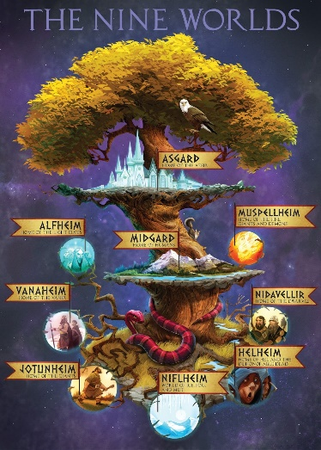  TOP 3 GODS:  ODIN THOR FREY  TOP 3 GODDESSES:  FREYA IDIN FRIGG SKADI
CLOTHING |  |  | FOOD
Because of the harsh weather in Scandinavia the Vikings tried their best to make sure there clothing kept them warm and dry. The women and girls made the wool and wove the fabric to make the clothes. Jewellery was worn by both men and women. Women wore large broaches and necklaces of gold and jewels. Vikings wore clothes similar to those of people in England, Scotland and Wales at this time. Men wore tunics and trousers. Women wore long dresses, with a kind of long apron. Clothes were made from wool, linen and animal skins. |  |  | The Vikings diet included fish, meat (salted and dried for long winters or sea voyages) peas, oats, cabbages and fruits. Food was sweetened with honey, flavoured by garlic and spices, and washed down with large amounts of beer! At a feast, guests drank ale and mead (a strong drink made from honey). People drank out of wooden cups or drinking horns (made from cow-horns). Feasts were held to mark funerals and seasonal festivals, such as midwinter. Some feasts lasted over a week! The Vikings used wooden bowls, spoons and knives and many other kitchen utensils. Most people lived on farms. Farmers used iron tools, such as sickles and hoes.
SHELTER |  |  | VIKING EMPIRE
In Viking times whole family's lived all under the same roof. In the houses there were wooden benches that lined the walls, they were used as beds. The houses were made up of one room and sometimes even more than 1 family lived in the house depending on how big the family or how big the house was. The head of the family would sleep in a box bed. Viking houses were built of wood, stone or blocks of turf - depending on local materials. The houses were long box-shapes with sloping thatched or turf roofs. The walls were made of wattle (woven sticks, covered with mud to keep out the wind and rain). They dug out the floors so that the houses kept warm and there was no draft. |  |  | 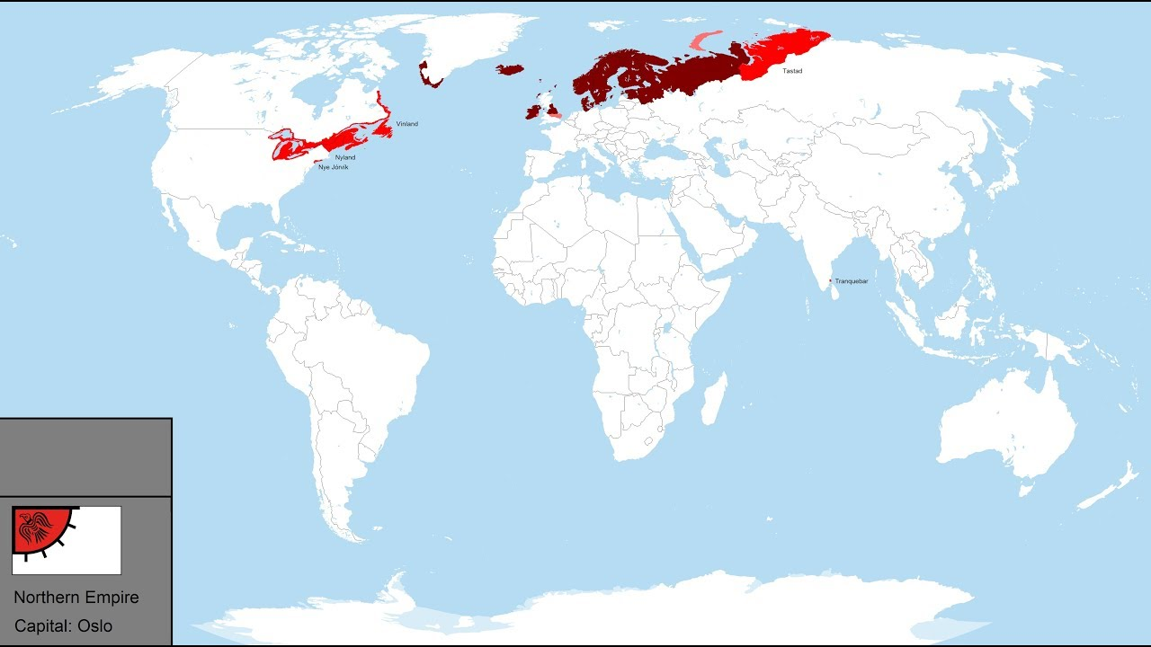
PRIMARY AND SECONDARY SOURCES |  |  | VOCABUARY
 |  |  | TIER 2  chronology  primary  secondary  sources  Gods  Goddesses  Empire  Britain  AD |  |  | TIER 3  Viking  Anglo-Saxon  Yggdrasil
  PRIMARY | SECONDARY
  artefacts  Archives  Photos  Videos  Letters  Diaries  Speeches  Scrapbooks  Newspapers  Letters  Books  Government publications  Oral retellings  Art | - journal articles that comment on or analyse research  - textbooks  - dictionaries and encyclopaedias  - books that interpret, analyse  - political commentary  - biographies  - dissertations  - newspaper editorial/opinion pieces  - criticism of literature, art works or music

