Key Words  Do we know what these words mean? | Religious Education  Christianity - Who do Christians say made the world? Creation
Religion  Christian  Christianity  God  Creator  Creation  Bible  Genesis  Harvest | Day 4 – Sun and Moon  Day 1 – Heaven and Earth  Light - Day and night.  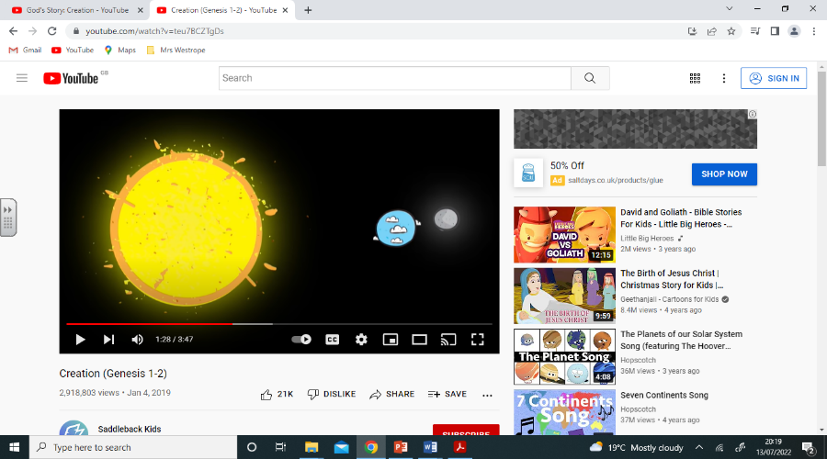  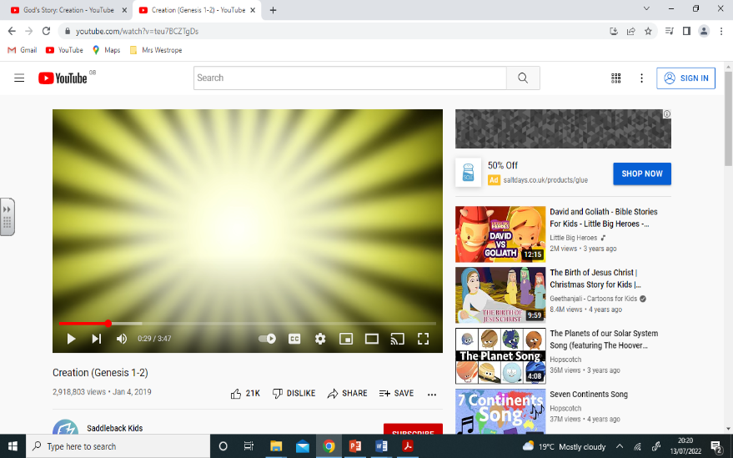  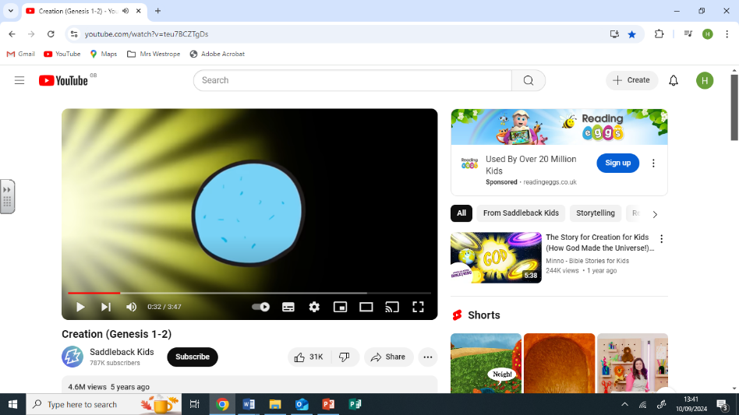  Day 5 – Sea creatures and flying animals  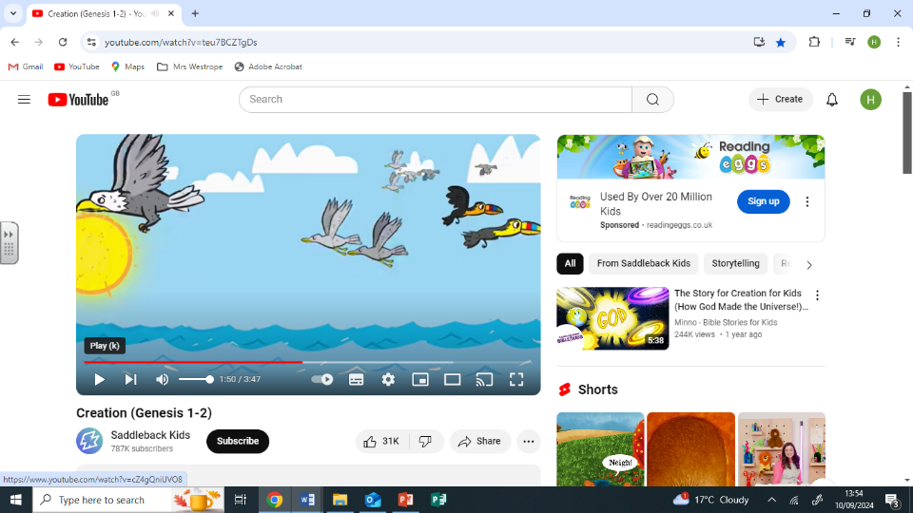  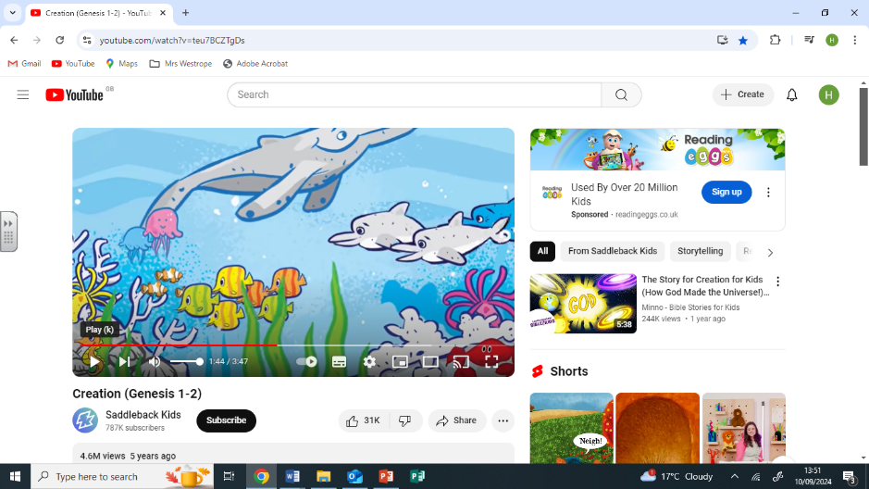  Day 2 – Sky and sea  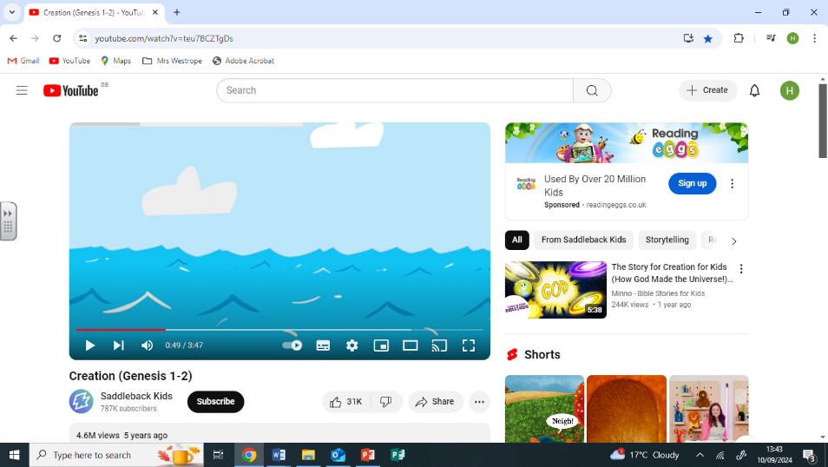  Day 6 – Land animals and humans  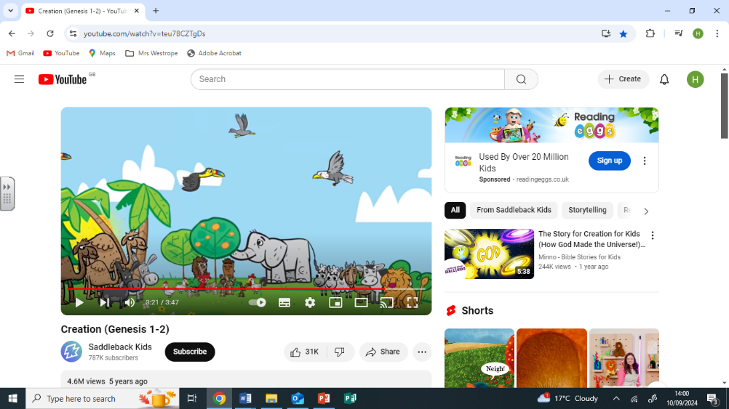  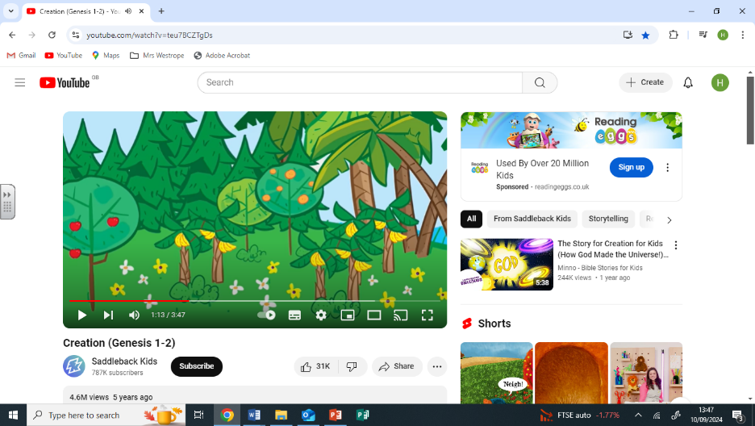  Day 3 – Land and plants  Day 7 – Rest | - Jews, Christians and Muslims believe that there is a Creator of the world, God.  - Creation is the beginning of the big story of the Bible.  - When Christians pray they thank God for creating the world.  - They also thank God for the food they eat as well as for their family and friends and health.
Special Book
Bible
Place of Worship
Church
Festivals
Christmas
Easter
Harvest

