lola
- Lola is a Black Labrador
- She was born on May 2018.
- She LOVES cuddles, being made a fuss of, running, playing, beaches, woodland, chasing feathers and leaves!
- She doesn’t like puddles or jumping up onto the landrover!

BE KIND TO LOLA
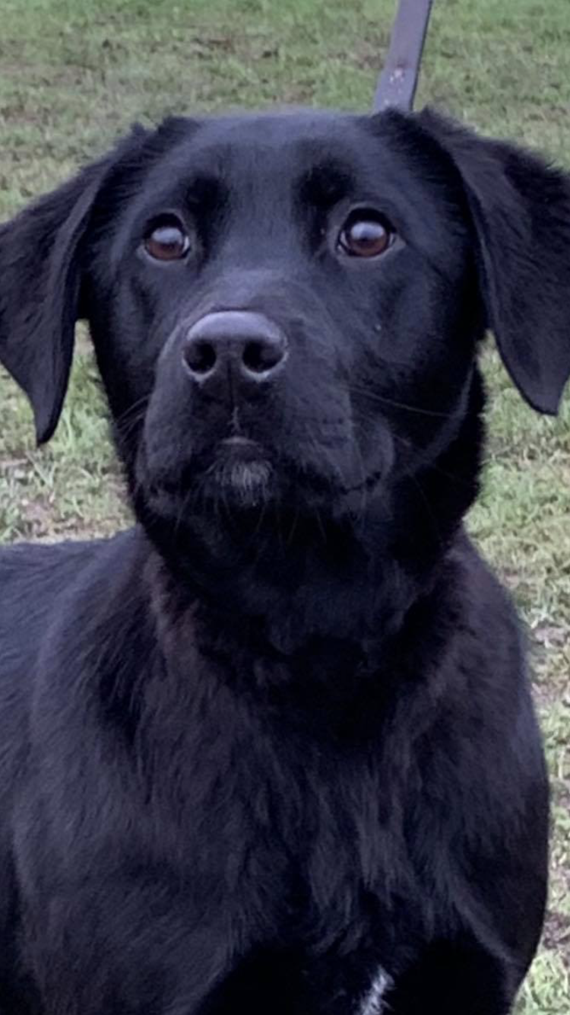
Be kind to …
…. her body
…. her space
…. her mind
Have FUN with Lola

Lola’s Routine
- Breakfast is at 6 am.
- She then loves a morning 3 mile run.
- Into school. Lola’s timetable will evolve and change with time. It starts with a patrol of the school, visiting every classroom.
- Home for a long walk.
- Dinner time is 6pm.
- Play time with the family.
- Quiet time before bed.
- A little outing to the toilet.

THE KEY TO SUCCESS
BUILD A BOND
Below are listed various patterns that can appear and the kinds of behaviour that must be redirected if they show up. The list is not intended to provide a chronological sequence of behaviour as everyone is different but it can help us understand where we are and where we want to go.
CONTACT
The child is:
- Anxious about the dog in the stay position more than three feet away.
- Is relaxed with the dog in the stay position more than three feet away.
- Is anxious about the dog in the stay position less than a meter away.
- Is relaxed with the dog in the stay position less than a meter away.
- Is anxious about the dog in movement less that a meter away.
- Is relaxed with the dog in movement less that a meter away.
- Exhibits anxiety while superficially petting the dog with their fingertips.
- In a relaxed way, pets the dog with both hands and initiates movement.
- Remains relaxed while seated beside the dog and touches, caresses or otherwise maintains contact with the dog.
- Lays down and relaxes on top of the dog.
Behaviour that must be redirected:
- The child manipulates the dog harshly with hands or feet.
- The child wants to treat the dog like a pony and ride it.
- The child grabs the dog inappropriately.

THE LEAD AND THE WALK
The child is:
- Reluctant to take hold of the dog’s lead.
- Takes the lead in a light grasp and holds it briefly.
- Throws the lead on the ground when given it.
- Continues to hold the lead with help.
- Holds the lead by themselves for increasing lengths of time.
- Holds the lead with both hands.
- Grip and control means that they handle the situation even when the dog tugs.
- Lets the dog lead and they follow.
- Walks alongside the dog.
- Seats the pace.
- Transits courses and circuits with the dog
Behaviour that must be redirected:
- The child stereotyped handling of the lead (Snapping, twirling)
- The child uses the lead brusquely.

TOSSING AND GIVING THINGS TO THE DOG
The child is:
- Refuses to pick up or hold the object.
- Takes hold of the object and gives it to the dog with the help of an adult but without eye contact.
- Takes hold of the object and gives it to the dog with the help of an adult but only if the object is dry.
- Takes hold of the object and gives it to the dog with the help of an adult even if it is wet.
- Picks up the object on the floor after the dog has dropped it.
- Placing their hand below the dog’s lower jaw, accepts the object directly from the animal.
- Takes the object directly from the dog’s mouth.
- Gives a verbal command or gesture for the dog to give them the object.
- Refuses to toss the object to the dog
- Tosses the object at a distance of less than three feet.
- Tosses the object at a distance greater than three feet.
- Gives a verbal command or gesture for the dog to fetch the object.
Behaviour that must be redirected:
- The child exhibits anxiety at the dog’s movements.
- The child will not pay attention to whatever the dog is doing.
- The child exhibits impatience.
GROOMING AREA
The child is:
- Does not make eye contact with the dog when they are more than three feet apart.
- Makes eye contact with the dog when they are more than 3 feet apart.
- Remains alert while grooming the dog at a safe distance.
- Grooms the dog in a relaxed way while continually reducing the distance between them.
- Relaxed, begins grooming the dog on their own.
- Grooms the dog using both hands.
- Grooms the dog and is able to follow simple instructions.
- Grooms the dog and is able to follow complex instructions.
- Begins and completes the grooming on their own.
- Is able to guide a companion in the grooming of the dog.
Behaviour that must be redirected:
- The child uses the grooming tools on themselves.
- The child uses the grooming tools incorrectly.
- The child brushes the coat too vigorously or in the wrong direction.
GIVING TREATS
The child is:
- Does not want to touch the treats.
- Tosses the treat to the dog from a distance of more than 3 feet without eye contact.
- Tosses the treat to the dog from a distance of more than 3 feet with eye contact.
- Places the treat on the palm of an adult’s hand and observes its delivery.
- Places the treat on a tray and presents it to the dog.
- Places the treat on the palm of their own hand and presents it to the dog with the help of an adult.
- Places the treat on the palm of their own hand and presents it to the dog without the help of an adult.
- Holds then treat between two fingers and presents it to the dog with help.
- Holds then treat between two fingers and presents it to the dog without help.
Behaviour that must be redirected:
- The child wants to try eating a treat.
- The child performs a repeated or stylised action with the treat before presenting it and giving it to the dog.

IDEAS
There are a variety of activities to carry out with Lola. These come under 4 headings……
SENSORY STIMULATION
COGNITICE STIMULATION
PSYCHO-MOTOR ACTIVITY
SOCIALISATION

SENSORY STIMULATION

COGNITIVE STIMULATION

PSYCHO-MOTOR ACTIVITY

SOCIALISATION

Let’s keep adding to this. If anyone finds anymore ideas or discovers anything for themselves that works well, let us know.
Remember to share stories and put celebrations on Lola’s Web page!!

