CHRONOLOGY - INJUSTICES
TIME LINE OF EMPIRES
Stone, Bronze and Iron Age  30,000-332 BC | Ancient Egypt  3100 – 30 BC | Ancient Greece  1500 – 300 BC | Ancient Romans  753 BC – 476 AD | Vikings and Anglo Saxons  793 AD – 1066 AD | Mayan Civilisation  1800BC – 900AD |  | Victorians  1837 - 1901 | World War 2  1939 - 1945
KEY DATES |  |  | BOUDICCA
30 – 61 AD: BOUDICCA  1507 - 1536: ANNE BOLEYN  13 April 1570 – 31 January 1606: GUY FAWKES  January 15, 1929-April 4, 1968: MARTIN LUTHER KING  1928: VOTES FOR WOMEN |  |  | 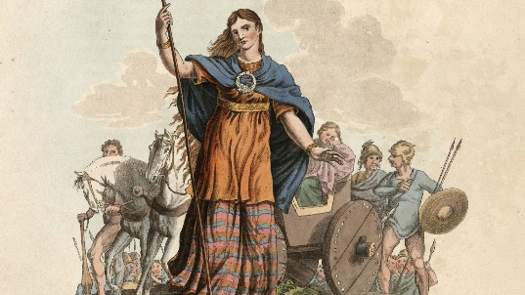  Boudicca was a Celtic queen who led a revolt against Roman Rule.  Inherited her father’s land when he died.  Under Roman Law, women were not allowed to own land.  Her father Prasutagus left half of her land to The Romans in the hope that she would be able to keep the other half.  The Romans took it all. She fought for this and died in the process.
ANNE BOLEYN |  |  | GUY FAWKES
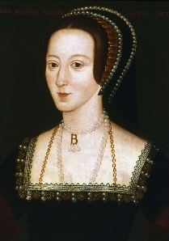  Anne was Henry VIII's second wife  She was mother to Elizabeth I  She was executed for Treason  She failed to give Henry VIII a baby son. |  |  | 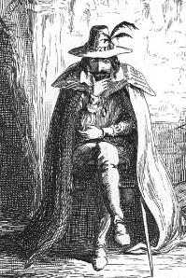  Guy was part of the Gunpowder Plot of 1605  He was a gunpowder expert  He was hung, drawn and quartered.  The plot was to blow-up The Houses of Parliament.
MARTIN LUTHER KING |  |  | VOTES FOR WOMEN
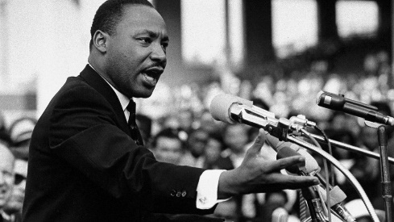  1929 – 1968  Martin Luther King Jr. was an American Baptist minister and activist.  One of the most prominent leaders in the civil rights movement from 1955  Assassination in 1968  Famous Speech – “I have a dream!” |  |  | 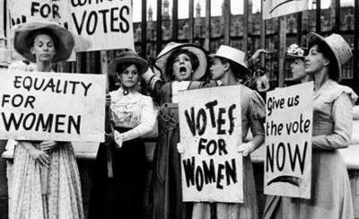  Suffrage means the right to vote in political elections.  Even by 1900, women were not allowed to vote.  Women started to campaign for the right to vote: Suffragist movement.  Two groups formed – SUFFRAGETTES (militant) and SUFFRAGISTS (peaceful).  World War One interrupted the campaign but also contributed to helping women gain the vote.  1928 – women gained the right to vote
PRIMARY AND SECONDARY SOURCES |  |  | VOCABUARY
PRIMARY SECONDARY  artefacts Archives Photos Videos Letters Diaries Speeches Scrapbooks Newspapers Letters Books Government publications Oral retellings Art - journal articles that comment on or analyse research - textbooks - dictionaries and encyclopaedias - books that interpret, analyse - political commentary - biographies - dissertations - newspaper editorial/opinion pieces - criticism of literature, art works or music |  |  | TIER 2  Chronology  Time period  Era  Injustice  inheritance  primary source  secondary source  sources  AD, BC  Peaceful  Vote  Campaign  Guilty  Treason  plot  Innocent  execution  divorce  heir (to the throne)  gun powder  guilty, framed  government |  |  | TIER 3  Anne Boleyn  Henry VIII  Suffragettes  Suffragists  Petition  Parliament  Militant  Emmeline Pankhurst  Millicent Garette  Emily Davison  Tudors  Pope  Catholic Church  Rome  Katherine of Aragon  Elizabeth I  political activist  minister  segregation  Guy Fawkes  James I  Houses of Parliament

