Key Words  Do we know what these words mean? | Religious Education  Christianity – What do Christians believe God is Like? Easter
Christian  God  Bible  Parable  Forgiveness | What do Christians believe God is like?  Christians believe that God is loving and forgiving.  Parable of ‘The Lost Son’ teaches people that God loves all people no matter what.  Christians believe that there are four main types of prayer:  - Praise  - Saying sorry  - Saying thank you  - Asking for forgiveness. | 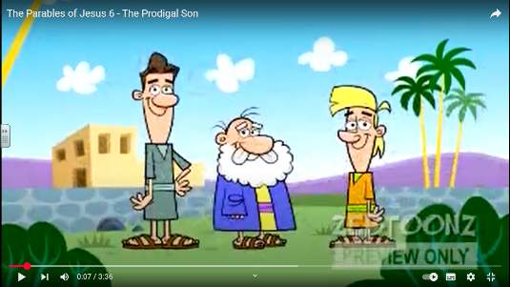  The Lost Son  The Lost Sheep  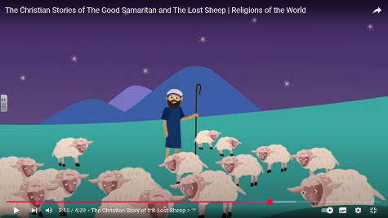  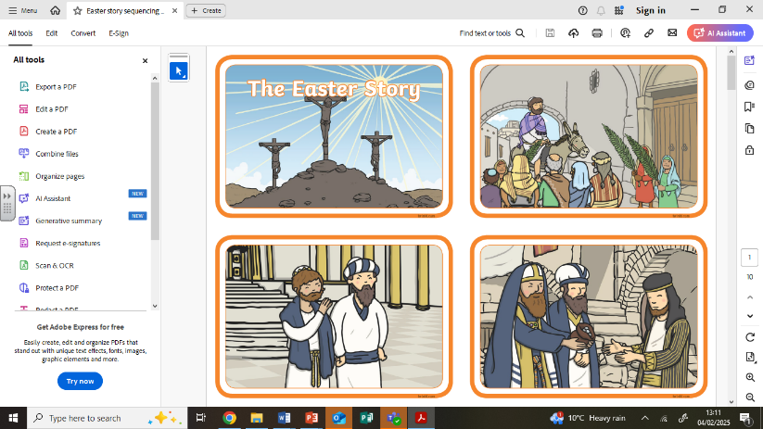  Holy Week
Special Book
Bible
Place of Worship
Church
Holy Week
Christians celebrate Holy Week. This is divided up in to several parts.
Jesus enters Jerusalem on Palm Sunday.
Jesus is betrayed by a friend and arrested on Maundy Thursday – Last Supper.
Jesus is crucified and dies – Good Friday.
Jesus is placed in a tomb.
Three days later the tomb is found empty – Easter Sunday
Christians believe that Jesus rose from the dead. This is called resurrection.
Easter is celebrated by Christians and is the most important of all their festivals.
During Easter, Christians feel sadness and joy.
Festivals
Harvest
Christmas
Easter

