THE RIVER DART
WHAT IS GEOGRAPHY?
Geography is the study of places and the relationships between people and their environments. Geographers explore both the physical properties of Earth’s surface and the human societies spread across it.

They also examine how human culture interacts with the natural environment and the way that locations and places can have an impact on people.

Geography seeks to understand where things are found, why they are there, and how they develop and change over time.

Physical geography is the study of Earth’s seasons, climate, atmosphere, soil, streams, landforms, and oceans.

Human geography is the study of the distribution of networks of people and cultures on Earth’s surface.
WHERE IS THE RIVER DART? TOTNES AND THE RIVER DART | STRUCTURE OF A RIVER
The River Dart starts off at source as The East Dart and The West Dart.  The East and West Dart meet at Dartmeet.  The mouth of The River Dart is Dartmouth. The Dart meets The English Channel.  The river's name may be Celtic meaning 'river where oak trees grow'. The banks of the lower Dart are covered in ancient woods of native oak.  The East and West Dart are crossed by a number of "clapper bridges" which are big slabs of stone laid on the river bed.  At Totnes the river becomes tidal, and there are no bridges below the town.  As well as being a key feature of the town’s picturesque landscape the River Dart has been an important part of trade in Totnes for hundreds of years. Today Totnes is a tourist hotspot but up until the late 20th century it was an important trading post on a busy river. | 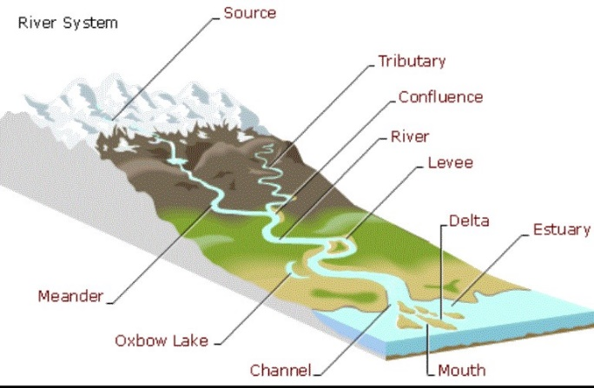
MEANDER, OX BOW LAKE and DRAINAGE BASINS
Meanders: a meander is a curve in a river. Meanders form a snake-like pattern as the river flows across a fairly flat valley floor.

Oxbow Lakes: eventually meanders turn into oxbow lakes when two outside bends erode together making a shorter route for the water.
Drainage Basin: It is an area of land. All water that falls on that land flows into one river. It can flow directly into the river or go through tributaries (smaller rivers that flow into the bigger river) first.
One river can drain a large area. For example, more than half of the United States is drained by the Mississippi and its tributaries

SALINITY
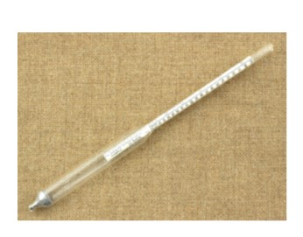  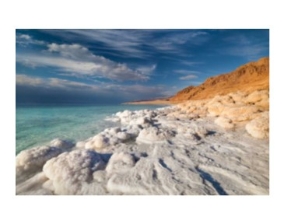 | A hydrometer measures salinity.  At the Weir in Totnes, there is a divide between freshwater and saltwater.  The Dart is tidal below the weir.
VOCABULARY – TIER 2 | VOCABUARY – TIER 3
TIER 2  Physical Geography  Human Geography  Buoyancy, salt water, freshwater, river | TIER 3  Salinity, Hydrometer, Marine, Brackish water, Estuary, Mill leat,  Water wheel, Weir, Source, Tributary, Meander, Confluence, Levee, Oxbow lake, Channel, Delta Estuary, Mouth, Ox bow lake

