Key Words  Do we know what these words mean? |  | Religious Education  Christianity - Salvation – Why does Easter matter to Christians?
Religion  Cross  Tomb  Resurrection  Jerusalem  Jesus  Crucifixion | Shrove Tuesday  Ash Wednesday  Palm Sunday  Maundy Thursday  Good Friday  Easter Sunday  Holy Week | Lent  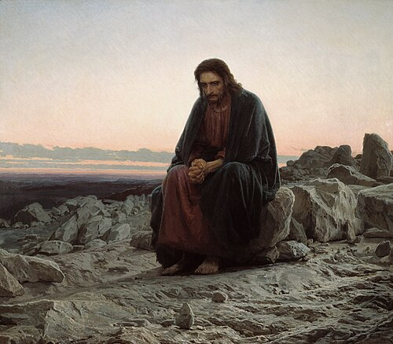  Wednesday 18th Feb -Thursday 2nd April 2026  Jesus went in the dessert to fast and pray before starting his work for God.  Lent allows Christians to remember Jesus's fasting in the desert.  It is a time of giving things up and a test of self-discipline such as food (meat, fish, eggs, fats) or something you really enjoy (cakes/chocolate). | 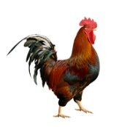    Symbols of Holy week        Easter Eggs      A symbol of new life and the belief in Jesus’ resurrection.
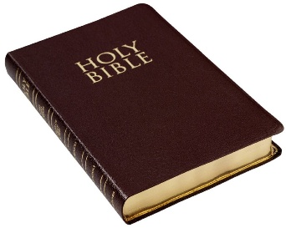
Special Book

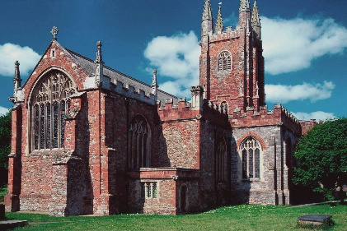
Place of Worship

Holy Week
Christians celebrate Holy Week. This is divided up in to several parts.
Jesus enters Jerusalem on Palm Sunday.
Jesus is betrayed by a friend and arrested on Maundy Thursday – Last Supper.
Jesus is crucified and dies – Good Friday.
Jesus is placed in a tomb.
Three days later the tomb is found empty – Easter Sunday
Christians believe that Jesus rose from the dead. This is called resurrection.
Easter is celebrated by Christians and is the most important of all their festivals.
During Easter, Christians feel sadness and joy.
Festivals
Harvest
Christmas
Easter

