Key Words  Do we know what these words mean?  senses  eye  pupil  iris  ear  sound waves  vibration  pitch  skin  tongue  taste buds  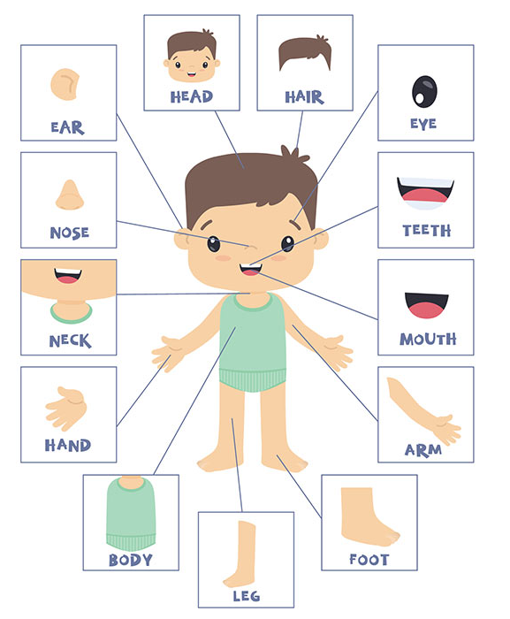  nostril | Science  Amazing bodies - senses
 | Sight  The eyes are organs that take in light through the pupil. We need light to see.  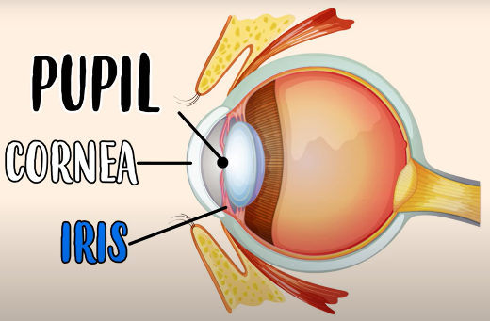 | Hearing  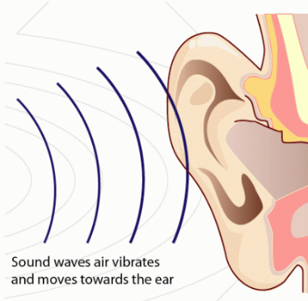  Sound travels through vibrations that reach our ears. |  | Touch  The skin is the body part that helps us to sense touch.  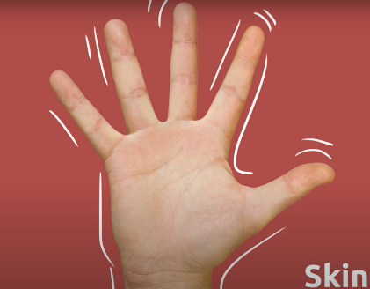
 | Taste  The tongue helps human to taste with taste buds. There are five basic tastes – sweet, salty, sour, bitter and savoury.  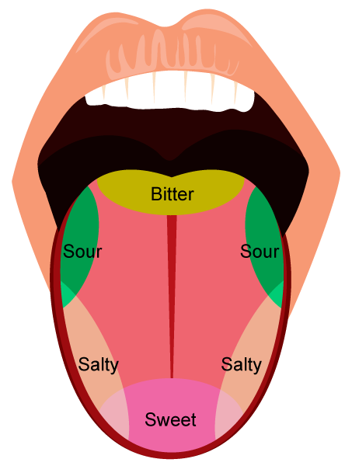 |  | Smell  The nose helps us to sense smell. Some items have a stronger smell than others.  