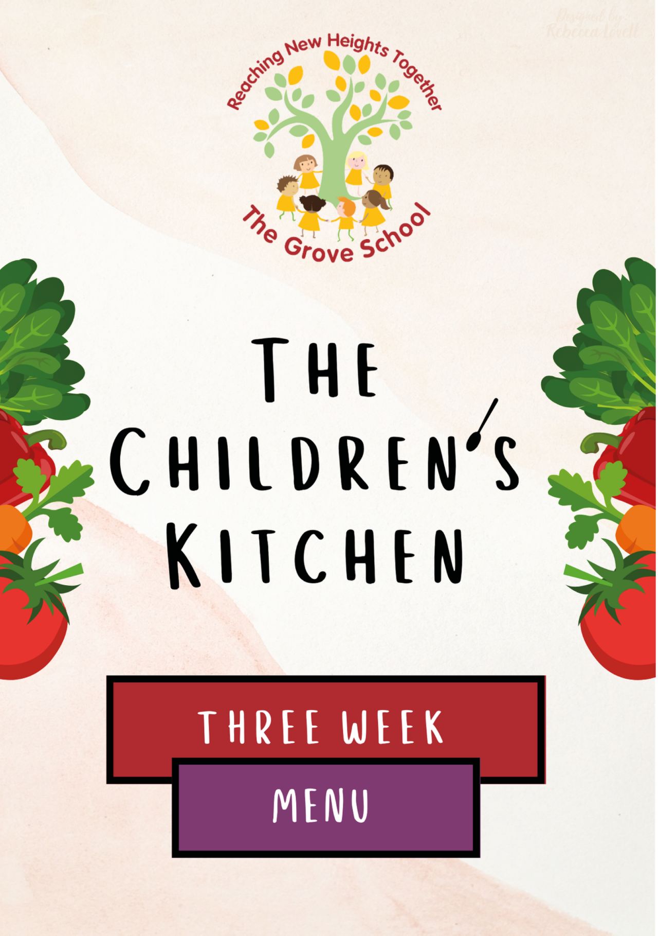
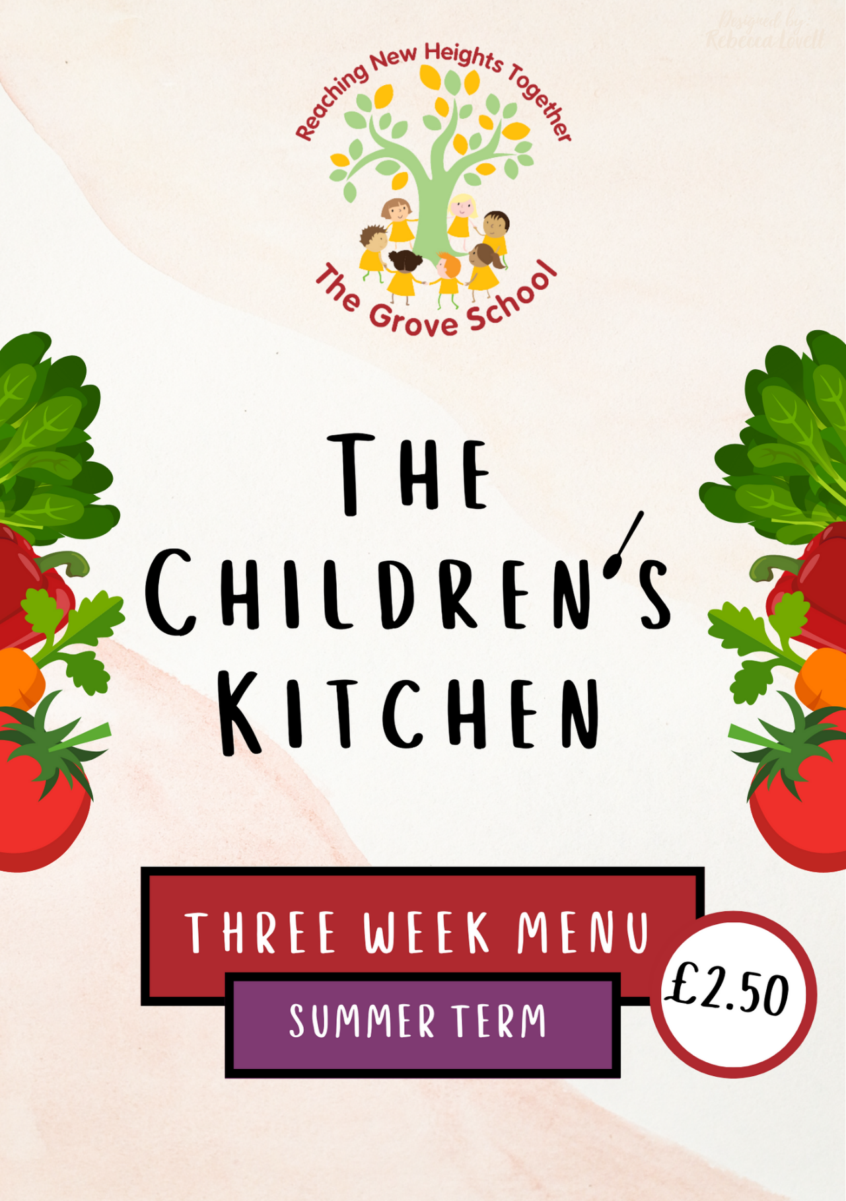
.+ New Heights
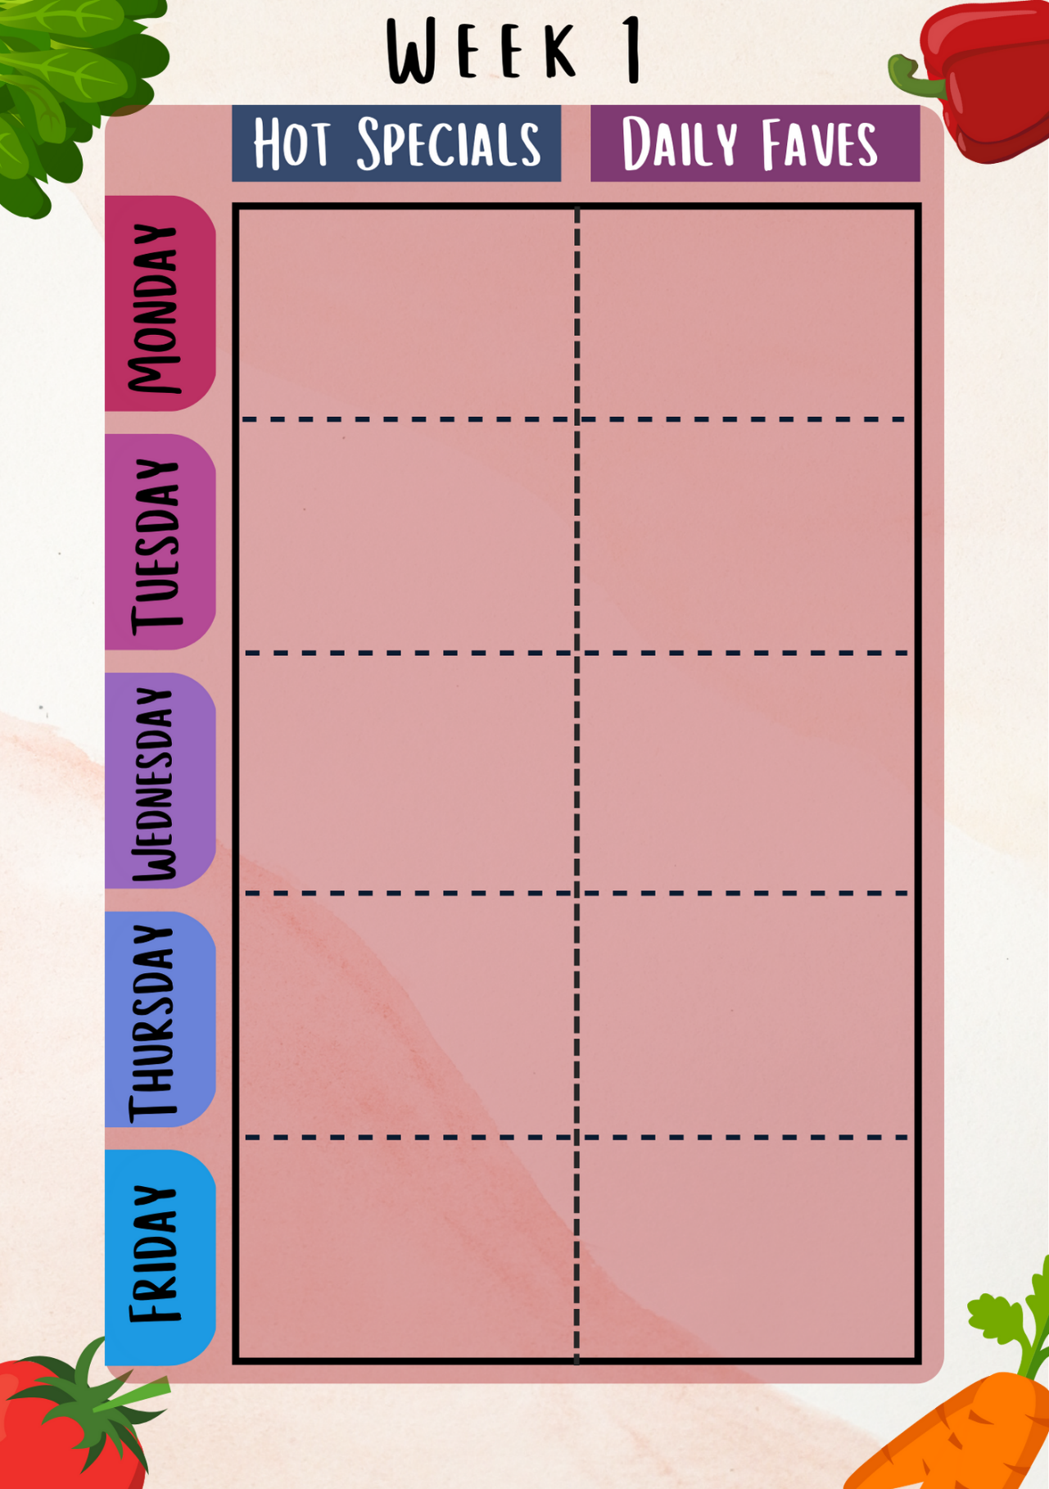
W/B: 31st August, 21st September, 12th October
Wholemeal Soft Taco (Wheat)
Homemade bread (wheat)
Wholemeal Rice
Salad bar
Seasonal vegetables

Build your own fish taco (fish)
Or
Jacket potatoes with cheese and beans (milk)

Homemade bread (wheat)
Salad bar
Seasonal vegetables

BBQ Sticky Chicken Wings
OR
Golden Halloumi and Tofu bites
(milk, wheat, soya)

Homemade bread (wheat)
Oven baked chips
Salad bar
Seasonal vegetables
Cake of the day
(wheat)

Homemade Beef lasagne
(wheat, celery, milk)
OR
Homemade tomato pinwheels
(wheat)

Make your own Pizza
(wheat, milk)
Or
Egg fried rice with edamame beans
(soy, egg)

Homemade carbonara pasta (wheat, egg, milk)
Or
Homemade 10 veg tomato sauce pasta (wheat, celery)

(wheat)

Homemade bread (wheat)
Roast potatoes
Salad bar
Seasonal vegetables
Homemade bread (wheat)
Salad bar
Seasonal vegetables

Allergen free options will always be available and we aim to match at least 1 choice from the set menu (common allergens labelled)
Fruit and yoghurt available daily
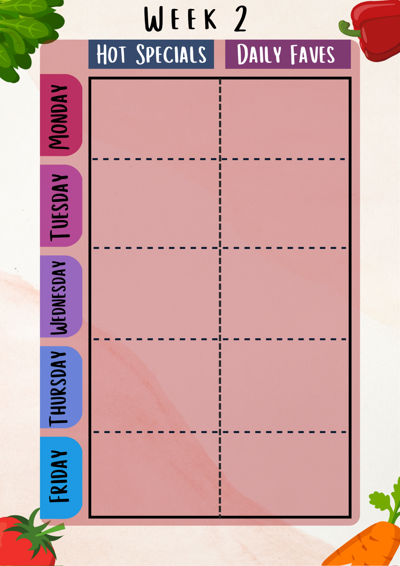
W/B: 7th September,
28th September, 19th October
Homemade bread (wheat)
Wholemeal Soft tacos (Wheat)
Wholemeal Rice
Salad bar
Seasonal vegetables

Homemade bread (wheat)
Seasonal vegetables
Roast potatoes

Make your own Pizza
(wheat, milk)
Or
Vegetarian Paella
(soya, celery)

Breaded Fish of the Day
(wheat, fish)
Or
Cauliflower popcorn
(wheat)

Homemade sausage roll
(wheat)
Or
Homemade Moroccan vegetarian falafel
(wheat)

Homemade bread (wheat)
Skin on French fries
Salad bar
Seasonal vegetables
Cake of the day
(wheat)

Homemade bread (wheat)
Salad bar
Seasonal vegetables

Homemade bread (wheat)
Salad bar
Seasonal vegetables

Build your own Veggie taco (soya)
OR
Oven baked salmon
Creamy butternut squash sauce
(fish)

Super cheesy Mac
(wheat, milk)
OR
Homemade 10 veg tomato sauce pasta
(wheat, celery)

* Allergen free options will always be available and we aim to match at least 1 choice from the set menu (common allergens labelled)

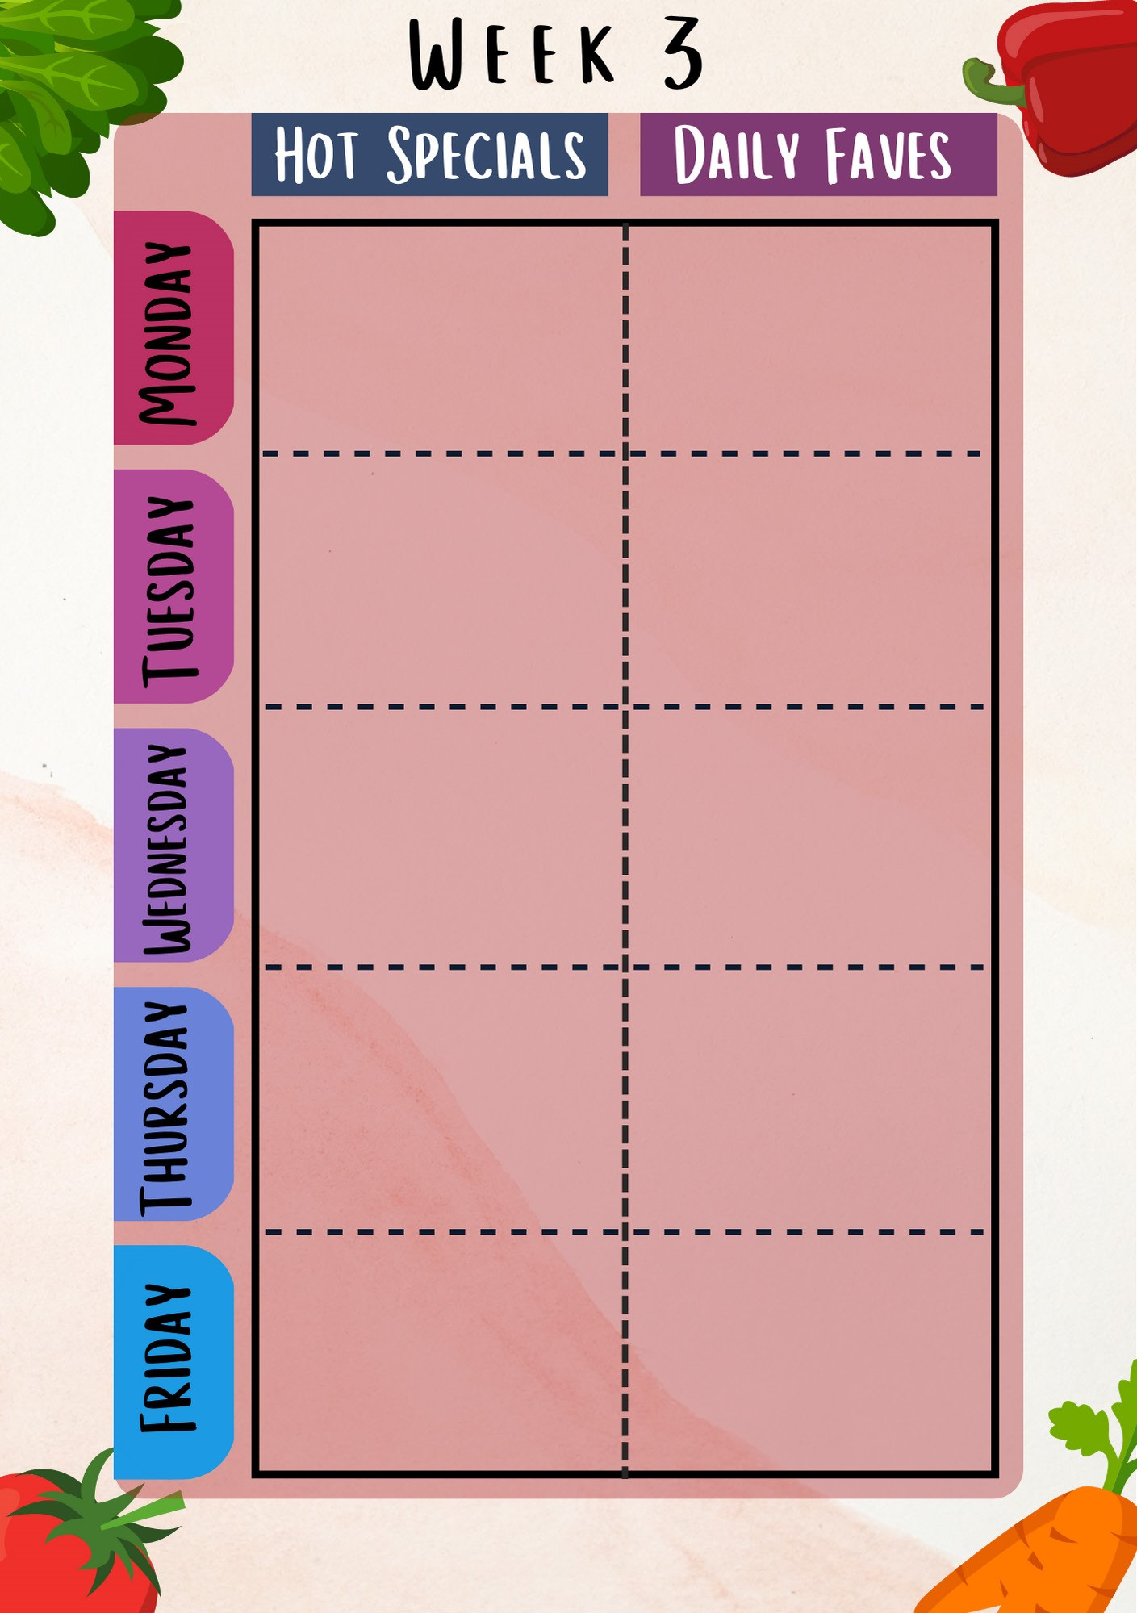
Homemade bread (wheat)
Wholemeal Soft tacos (Wheat)
wholemeal Rice
Salad bar
Seasonal vegetables

Make your own Pizza
(wheat, milk)
Or
Homemade Tomato Soup
With garlic dippers
(wheat)

Homemade bread
(wheat)
Salad bar
Seasonal vegetables

Homemade bread (wheat)
Oven baked chips
Salad bar
Seasonal vegetables
Cake of the day
(wheat)

Homemade bread (wheat)
Roast potatoes
Homemade gravy
Salad bar
Seasonal vegetables

Crunchy Chicken Strips
(wheat)
OR
Rainbow Tofu Skewers
(wheat, Soya)
Homemade bread (wheat)
Salad bar
Seasonal vegetables

W/B: 14th September, 13th July, 5th October

Homemade pesto pasta (wheat. milk)
Or
Homemade 10 veg tomato sauce pasta
(wheat, celery)

Autumn roast chicken
Or
Homemade Veggie Crunch bites
(wheat)

Tex-mex bean Taco (mild)
Or
Loaded fish Jacket potatoes with mackerel/tuna mayo or hummus
(fish)

Allergen free options will always be available and we aim to match at least 1 choice from the set menu (common allergens labelled)

