Key Words  Do we know what these words mean?  Christian  Bible  Jesus  Tradition  Incarnation  Christmas  Nativity  Gabriel  Bethlehem  Advent | Religious Education  Christianity – Christmas
 | Jesus  Christians believe he was very special – not an ordinary baby but God on Earth.  Christmas celebrates the Incarnation – God becoming flesh.  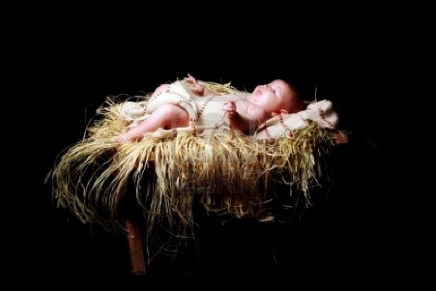 | Christmas  Christmas is a Christian festival celebrated on 25th December.  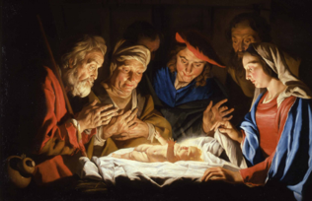 | Advent  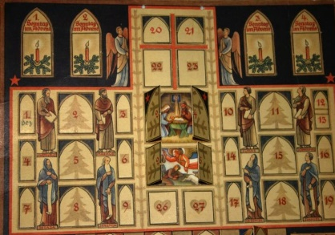  When Christians prepare for Jesus’ arrival.    Advent Wreath
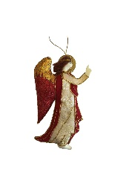
Traditions
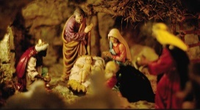
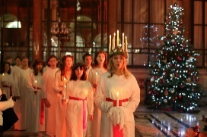
Special Book
Bible
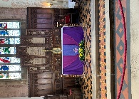

Place of Worship
Church
Nativity Story
The Christmas story is told to Christians.
Angel Gabriel visited Mary and told her that she was going to have a baby and she would call him Jesus.
Jesus was born in a stable in Bethlehem.
Shepherds and Kings visited Jesus and gave him gifts.
Christians celebrate Christmas by going to church, sending cards and giving gifts.
Festivals
Harvest
Christmas
Easter

