Key Words  Do we know what these words mean?  Bulb  Seed  Stem  Leaves  Trunk  Branch  Root  Petal  Plant  Evergreen  Deciduous | Science  Plants  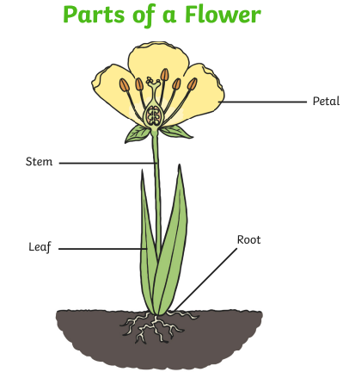 | Types of wild plants we can find in our area  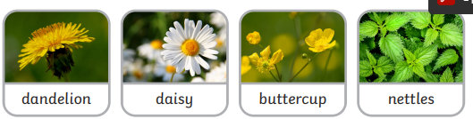  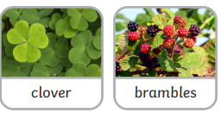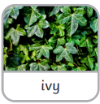  Types of garden plants we can find in our area  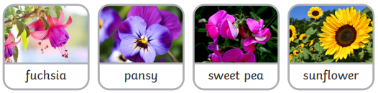  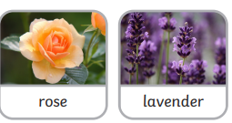
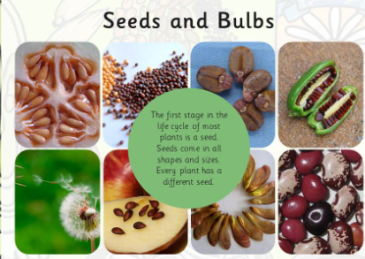 | Identifying trees  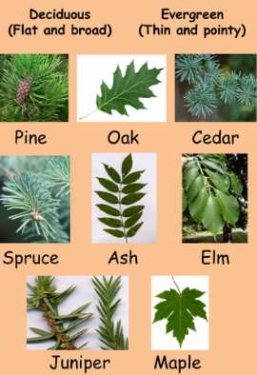 | Types of Trees we can find in our area  