Key Words  Do we know what these words mean?  map  symbol  river  forest  hill  valley  house  shop  village  town  Totnes  city  Plymouth  Devon  Country  England  United Kingdom | Geography - Totnes Castle  Where is Totnes Castle?  Totnes Castle is built on a hill and by a river.  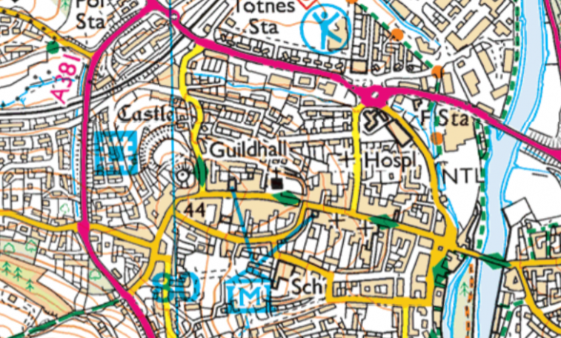 | Aerial view  An image taken from hig h up.  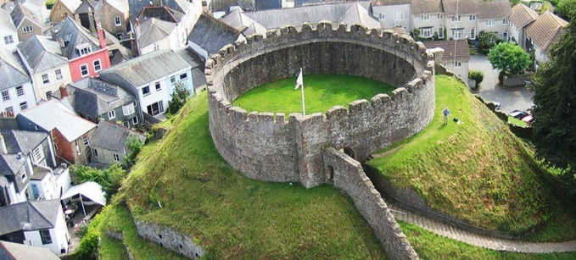  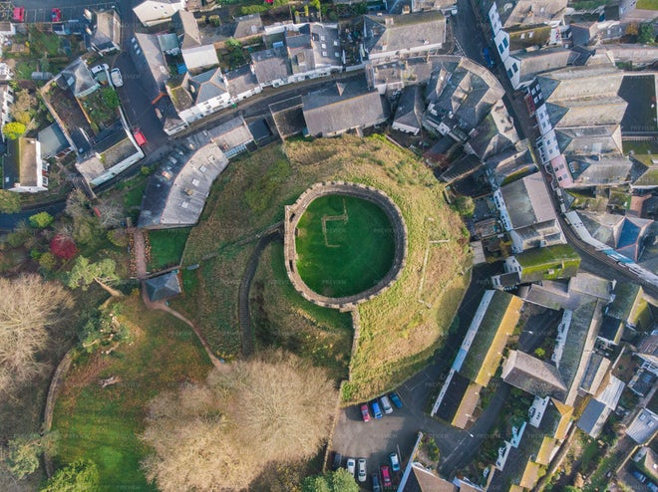  Ground-level view  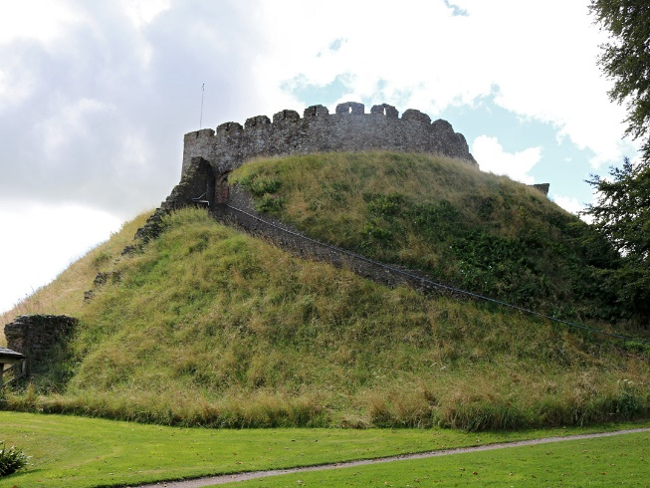  An image taken from the ground.
  Map symbols    Main road    footpath    river  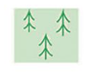  trees  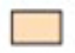  building |   School    English  Heritage    Museum    Place of  Worship  Leisure  centre

