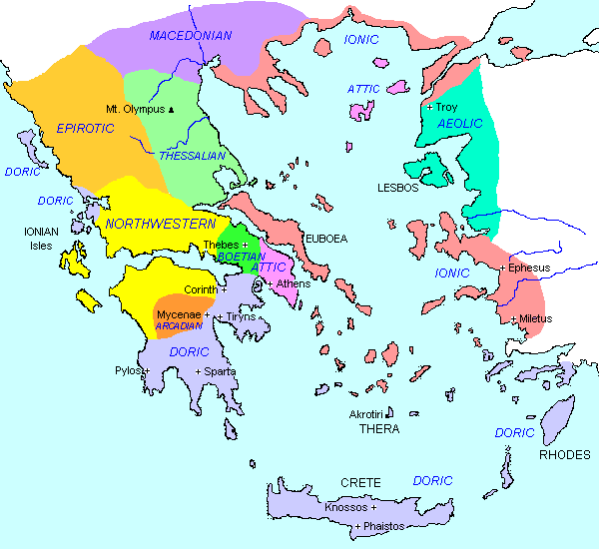
BOYS
Boys were favoured over girls. In Athens they lived in the Gynaikon until the age of 6 and were trained by their fathers to master different crafts such as fishing or metalwork. At 7, they went to school where they learned music, reading, writing and maths using an abacus. They also prepared to be soldiers by running, throwing javelins and wrestling in the gymnasium
In Sparta boys left home at 7 to be trained for the military. They were not allowed to leave the army until they were 30 years old.
GIRLS
In Athens, girls lived with their mothers in the GYNAIKON. They were taught how to cook and to look after the home and rarely left the Gynaikon until they reached marrying age (12 or 13). Their father would arrange marriages to men, often in their 30s. When a girl married, she would offer her dolls to the Goddess Artemis to show her childhood was over.
In Sparta, girls had more freedom and were encouraged to take part in athletics, music, singing and dancing.
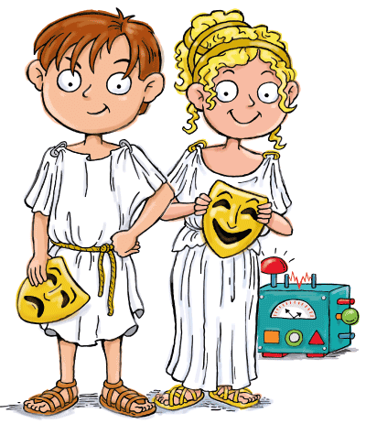
THE ANCIENT OLYMPIC GAMES The very first Olympic games were held in Olympia in Ancient Greece in 776 BC. The games were held in honour of the Greek God Zeus. The main events included running, jumping throwing and wrestling. Athletes competed naked. Women were not allowed to take part or even to watch the competition.

ANCIENT GREECE
Ancient Greece was made up of lots of CITY STATES (Polis). The most powerful City States were ATHENS and SPARTA.

KEY VOCABULARY
Acropolis Assembly Democracy Helles Gymnasium Gynaiknon Polis Oikos Olympics Stylus

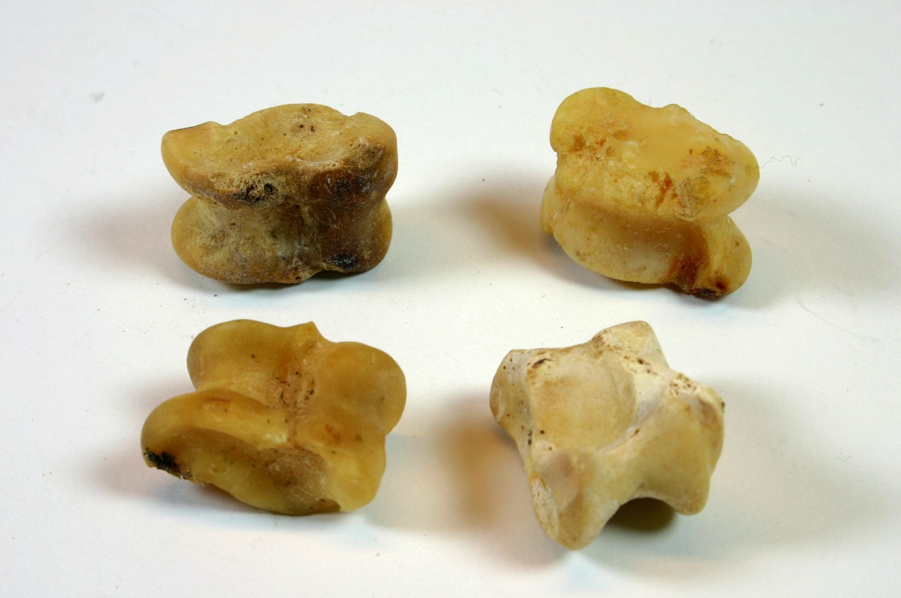
TOYS Archaeologists have found lots of artefacts from Ancient Greece, including children’s toys.. Toys included:
- Knucklebones made from sheep and goat bones (these were popular and cheap)
- Yo-yos (made from clay)
- Marbles (stones, acorns or conkers)
- Dolls made from rags, wax or clay
Richer children had better toys.

INFLUENCE ON TODAY The Ancient Greeks introduced and developed many things that we can recognise today, including:
- The Alphabet
- The Olympic Games
- Democracy
- Poetry
- Philosophy
- Theatre
- Universities (Academia)

