Key Words  Do we know what these words mean?  Bible  Old Testament  New Testament  Disciples  Tax collector  Gospel  Confession  Forgiveness  Prayer  Church  Priest  Charity | Religious Education  Christianity – Good News
 | 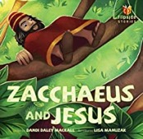  Tax Collectors worked for the Romans.  The story of Zacchaeus tells Christians that even though people do wrong and unkind things Jesus will still forgive them.  This story tells people that Jesus came to help ALL people. | Jesus  Jesus teaches his followers that God will forgive them.  Jesus teaches his followers to forgive each other.  Jesus was a friend to ALL the people. |   Forgiveness    Jesus teaches his followers that God forgives them, but they need to forgive others too.
Confession
Confession is a sacrament for Christians. They speak to God and say that they are sorry.
Special Book
Bible
Place of Worship
Church
Place of Worship  Church | Peace  People get peace through music, laughter, being quiet, exercise, saying sorry, being forgiven, a hug.  Christians receive peace from Jesus | Church  Going to church helps Christians to remember the ways in which Jesus’ life and teaching offers the ‘Good News’.
Festivals
Harvest
Christmas
Easter

