CRACKPOT THEORIES
TIME LINE
Stone, Bronze and Iron Age  30,000-332 BC | Ancient Egypt  3100 – 30 BC | Ancient Greece  1500 – 300 BC | Ancient Romans  753 BC – 476 AD | Vikings and Anglo Saxons  793 AD – 1066 AD |  | Mayan Civilisation  1800BC – 900AD
RA THE SUN |  |  | THE EARTH IS FLAT
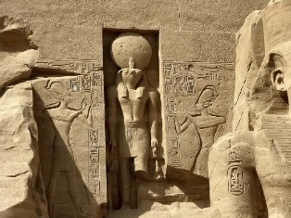  When did the live?  What did they believe?  Why did they believe?  How do we know?  How do we know they were wrong?  What do you think? |  |  | 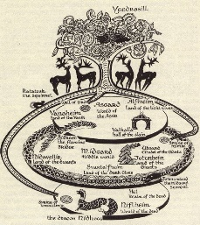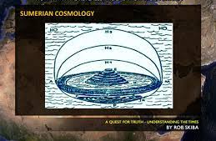  When did the Vikings live? 793 AD – 1066 AD  What did they believe? They believed the world was flat.  Why did they believe? No technology. Religion  How do we know? Viking records and drawings  How do we know they were wrong?  We can’t see endlessly into the distance  Shadows  During a lunar eclipse you can see the Earth’s shadow on the moon.  Satellite images  What do you think?
PTOLEMY AND COPERNICUS |  |  | DARWIN
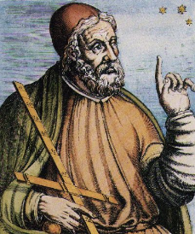  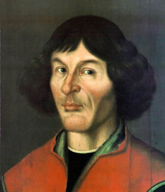  When did they live? 150 AD – Ptolemy 1543 BC - Copernicus  What did they believe?  Ptolemy – the geocentric model of the solar system  Copernicus – the heliocentric model of the solar system  Why did they believe?  Ptolemy believed in the geocentric model because of his observations and findings. To start, Ptolemy didn't have modern technology to observe space. He used his own observations during the night and mapped out planetary movement, along with the Sun and stars.  Copernicus believed, because of his observations and findings, that the sun was at the centre of the universe. Because of the changing position of the sun and stars in the sky he theorised that the earth revolved on its axis every 24 hours and that it took a year for the earth to orbit the sun.  How do we know? Their records, notes and books. Records from the church.  How do we know they were wrong? Galileo (1632) built a telescope and proved Copernicus was right. Kepler worked out that circular orbits mean the planets are not in the right place at the right time. The orbits must be elliptical. Newton discovered gravity as the reason for the shaped orbits.  What do you think? |  |  | 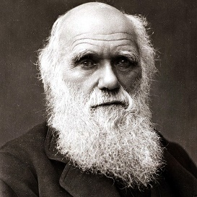  When did the Darwin live? 1809 – 1882 BC  What did they believe? Darwin’s travels and observations inspired his theory of evolution. Religion prevented him publishing his ideas.  Wallace developed the theory of Natural Selection. Wallace’s letters to Darwin prompted him to publish his letters.  Why did they believe? Careful observations.  How do we know? Written records and drawings.  How do we know they were right? Continued observations over the past 200 years have continued to prove the theory of evolution and natural selection.  What do you think?
MOON LANDING |  |  | VOCABUARY
When did it take place? 1969  What did they believe? Did the Moon Landing take place? Some people believed it was a hoax!  Why did they believe the moon landing was a hoax?  The shadows in the pictures were all over the place.  You couldn’t see Neil’s camera in his reflection.  The flag planted on the moon rippled – how if there’s no breeze?  No crater/big mark was formed from the Eagle landing.  There were no stars in the images taken from the moon.  Buzz Aldrin confessed that they didn’t walk on the moon.  How do we know it actually took place?  Shadows would have been all over the place as sunlight was being reflected in different ways.  Neil’s camera was mounted on his suit.  The flag rippled as the men moved it.  There’s less gravity on the moon so no real mark would have been made.  Brighter/closer objects were in the sky so stars wouldn’t have been seen in photos.  If Buzz had made the claims, there would be much more publicised about this.  Moon rock was collected.  What do you think? |  |  | TIER 2  Chronology  BC  AD  Ancient  Crackpot  Horizon  Astronomy  Solar system  Moon  Hoax  Evolution  Orbit |  | TIER 3  Ra  Hieroglyphics  Ygdrasil  Ptolemy  Copernicus  Geocentric  Heliocentric  Neil Armstrong  Apollo 11  Natural selection  Darwin  Neil Armstrong

