Key Words  Do we know what these words mean?  country  Australia  continent  Oceania  ocean  Equator  Southern Hemisphere  Northern Hemisphere  landmark  aboriginals  Sydney  physical features  human features  landmarks | Geography - Sydney  Landmarks  Darling Harbour Queen Victoria Building  Sydney Harbour Bridge Sydney Observatory  Sydney Opera House Sydney Tower Hyde Park |  | Where is Sydney?  Country of Australia  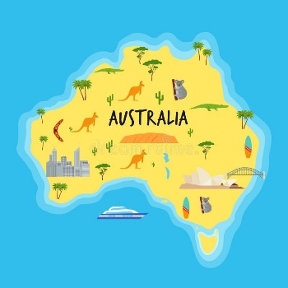  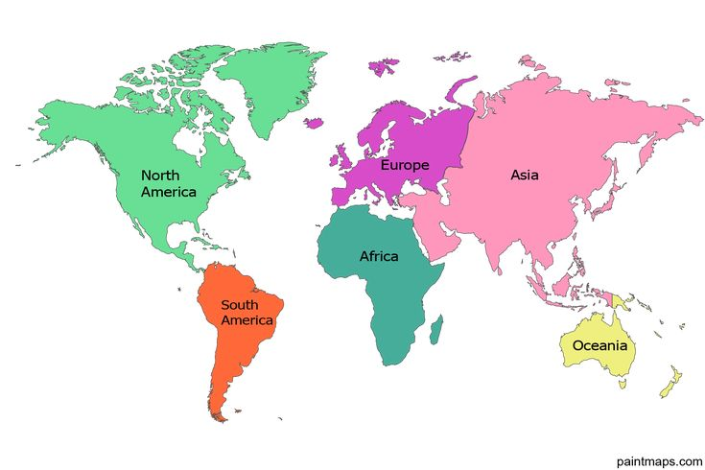  Continent of Oceania
The 2 flags of Australia  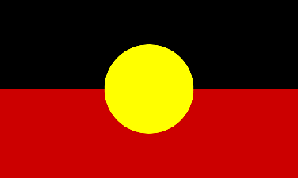  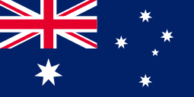  The Australian The Australian  Aboriginal Flag National Flag |  | Aboriginal people    