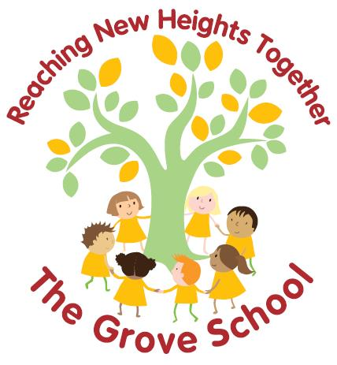

Concrete / Pictorial / Abstract
Maths Calculation Policy

This policy has been largely adapted from the White Rose Maths Hub Calculation Policy with further
material added. It is a working document and will be revised and amended as necessary. Many
variations have been included to provide teachers with a range of tools to support children in their
grasp of number and calculation. To ensure consistency for pupils, it is important that that the
mathematical language used in maths lessons reflects the vocabulary used throughout this policy.

True mastery aims to develop all children’s mathematical understanding at the same pace. As much as possible, children should be accessing the same learning. Differentiation should primarily be through support, scaffolding and deepening, not through task.
Consistency in language is essential for pupils to understand the concepts presented in mathematics. If other, ‘child-friendly’ terminology is used, this must be alongside the current terminology recommended by maths specialists. Using this will support children with their examinations and throughout secondary school.
Evidence repeatedly shows that mixed ability seating increases less confident pupils’ perception of mathematical capability, which impacts positively upon outcomes. While not a school policy, it is recommended to avoid ability groups. This presents a challenge in ensuring the more confident mathematicians are being extended. An extension tasks to deepen understanding is the most simplistic way around this.
Concrete, pictorial, abstract (CPA) concepts should not be confused as differentiation for lower, middle, higher attaining children. CPA is an approach to be used with the whole class and teachers should promote each area as equally valid. Manipulatives in particular must not be presented as a resource to support the less confident or lower attaining pupils.

Used well, manipulatives can enable pupils to inquire themselves- becoming independent learners and thinkers. They can also provide a common language  with which to communicate cognitive models for abstract ideas. Drury, H. (2015) |  | Children aged seven to ten years old work in primarily concrete ways and that the abstract notions of mathematics may only be accessible to them through embodiment in practical resources. Jean Piaget's  (1951) |  | Real things and structured images enables children to understand the abstract. The concrete and the images are a means for children to understand the symbolic so it’s important to move between all modes to allow children to make connections. Morgan, D.  (2016)

The abstract should run alongside the concrete and pictorial stage as this enables pupils to better understand mathematical statements and concepts.

YEAR 1 Addition
Objective / Strategy | Concrete | Pictorial | Abstract
Combining two parts to make a whole: part- whole model | 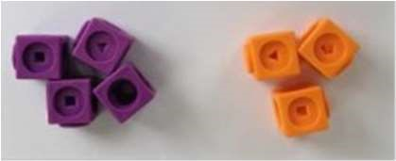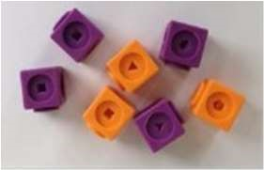  Use part, part whole model.  Use cubes to add two numbers together as a group or in a bar.  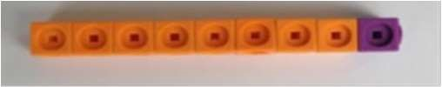  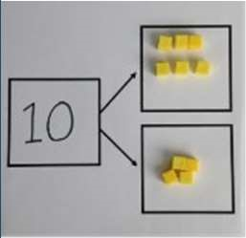 | Use pictures to add two numbers together as a group or in a bar.  8 1  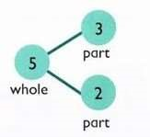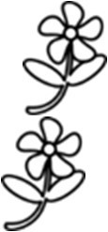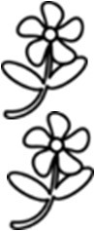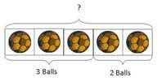 | 8 = 5 + 3 5 + 3 = 8  5  3  Use the part part whole diagram as shown above to move into the abstract.  Include missing number questions to support varied fluency:  8 = ? + 3  5 + ? = 8
Starting at the bigger number and counting on | 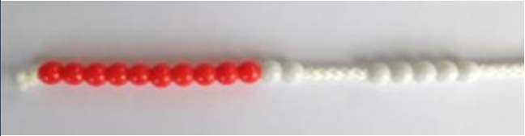  Start with the larger number on the bead string and then count on to the smaller number 1 by 1 to find the answer. | 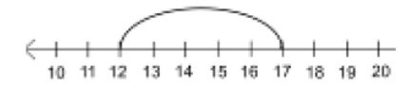  12 + 5 = 17  Start at the larger number on the number line and count on in ones or in one jump to find the answer. | 5 + 12 = 17  Place the larger number in your head and count on the smaller number to find your answer.
Regrouping to make  10.  This is an essential skill for column addition later. | 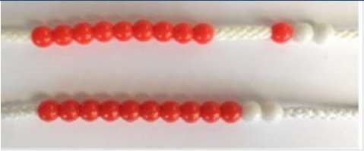  6 + 5 = 11  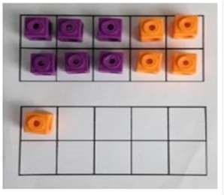  Start with the bigger number and use the smaller number to make 10.  Use ten frames. | 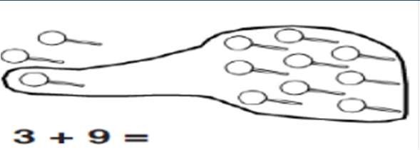  Use pictures or a number line. Regroup or partition the smaller number using the part, part whole model to make 10.  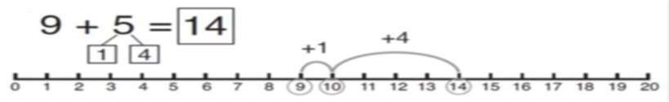 | 7 + 4= 11  If I am at seven, how many more do I need to make 10? How many more do I add on now?
Represent & use number bonds and related subtraction facts within 20 | 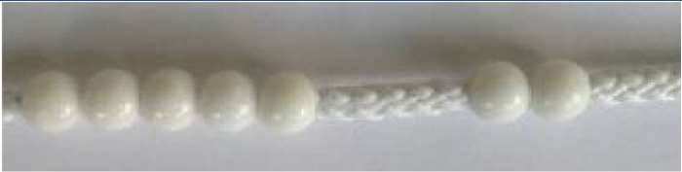  2 more than 5. | 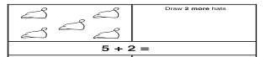  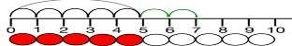 | Include missing number questions:  8 = ? + 3  5 + ? = 8  Emphasis should be on the language  ‘1 more than 5 is equal to 6.’  ‘2 more than 5 is 7.’  ‘8 is 3 more than 5.’

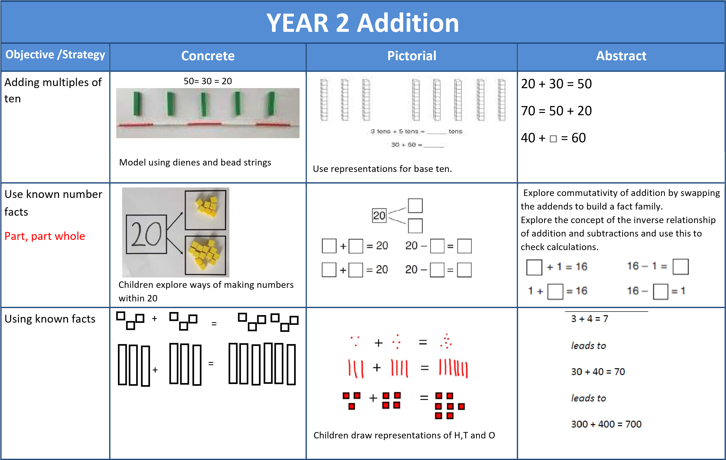

Bar model | 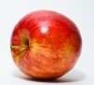  3 + 4 = 7 |  | 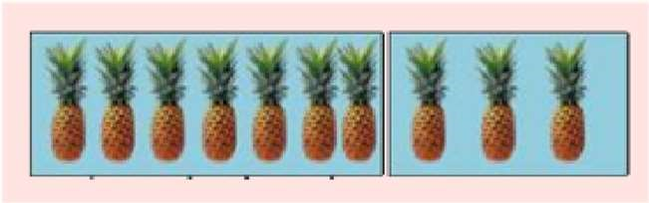  7 + 3 = 10 | 23 + 25 = 48
Add a two digit number and ones | 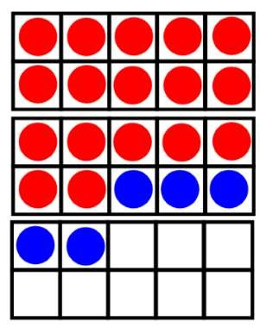  17 + 5 = 22  Use ten frame to make ‘magic ten  Children explore the pattern.  17 + 5 = 22  27 + 5 = 32 |  | 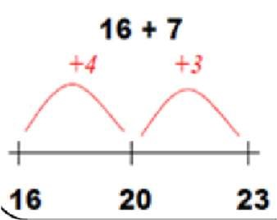  3  2  20  Use part  part whole  and number  line to  model.  17  + 5 = 22 | 17 + 5 = 22  Explore related facts  17 + 5 = 22  2 2  17 5  5 + 17 = 22  22—17 = 5  22—5 = 17  Lead into recording in column format, to reinforce place value and prepare children for formal written methods with larger values.
Add a 2 digit number and tens | 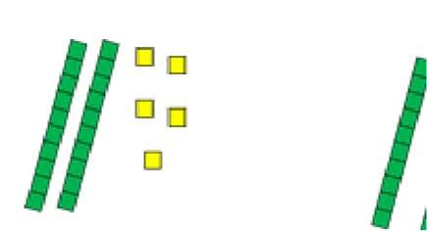  25 + 10 = 35  Explore that the ones digit does not change |  | 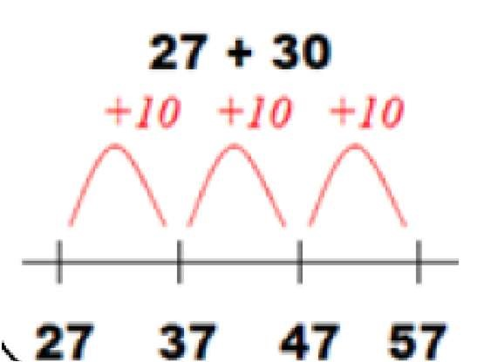 | 27 + 10 = 37  27 + 20 = 47  27 + □ = 57
Add two 2-digit numbers | 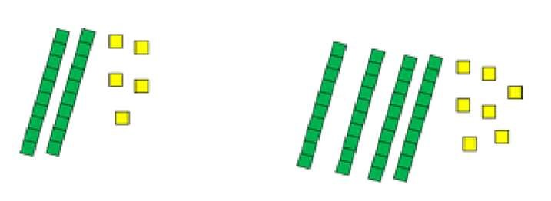  Model using dienes , place value counters  and numicon |  | 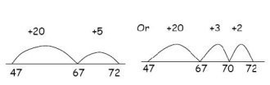  Use number line and bridge ten using part whole if necessary. | 25 + 47  20 + 5 40 + 7  20 + 40 = 60 5+ 7 =12  60 + 12 = 72
 |  |  |  | Lead into recording in column format, to reinforce place value and prepare children for formal written methods with larger values.
Add three 1-digit numbers | 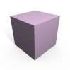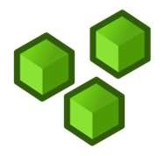  Combine to make 10 first if possible, or bridge 1o then add third digit | +  Regroup and draw representation.  +  = 15  + |  | 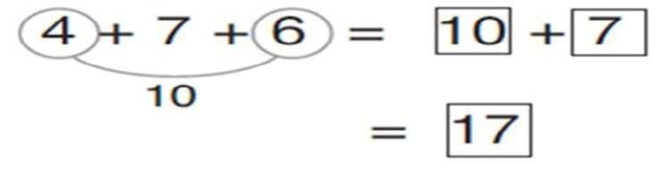  Combine the two numbers that make/ bridge ten then add on the third.

YEAR 3 Addition
Objective /Strategy | Concrete | Pictorial |  | Abstract
Column Addition—no regrouping (friendly numbers)  Add two or three 2 or 3digit numbers. | 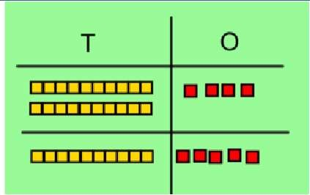  Dienes or numicon  Add together the ones first, then the tens.  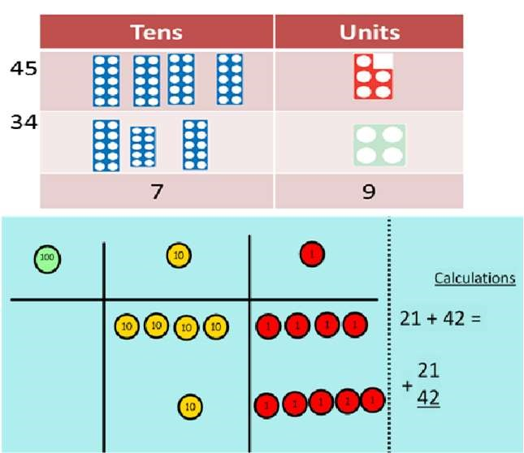  Move to using place value counters | Children move to drawing the counters using a tens and one frame.  tens | ones | - 2 3 + 1 1 4  - 3 7  Add the ones first, then the tens, then the hundreds.
Column Addition with regrouping. | 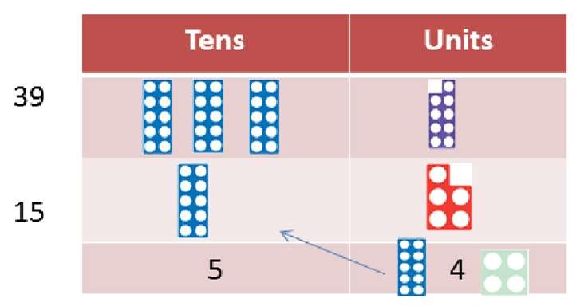  Exchange ten ones for a ten. Model using numicon and place value counters. | 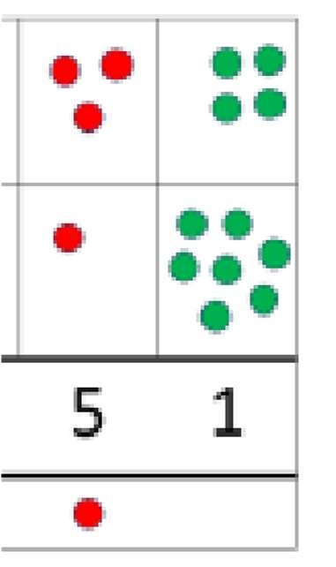 | 3 4  +1 7 | 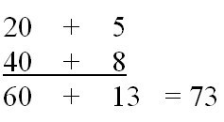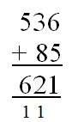  Start by partitioning  the numbers before  formal column to show  the exchange.
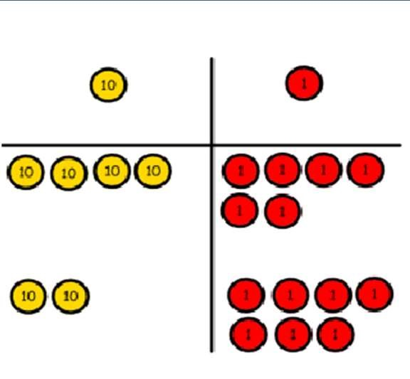

46 + 27 = 73
Estimate the answers to questions and use inverse operations to check answers | 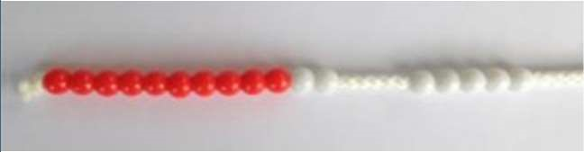  Estimating 98 + 17 = ? 100 + 20 = 120 | Use number lines to illustrate estimation.  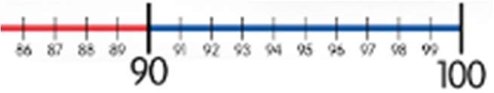 |  | Building up known facts and using them to illustrate the inverse and to check answers:  98 + 18 = 116 116 – 18 = 98  18 + 98 = 116 116 – 98 = 18

YEARS 4 – 6 Addition
Objective /Strategy | Concrete | Pictorial | Abstract
Years 4 – 6  Estimate and use inverse operations to check answers to a calculation |  | AS per Year 3
Y4—add numbers with  up to 4 digits | Children continue to use dienes or place value counters to add, exchanging ten ones for a ten and ten tens for a hundred and ten hundreds for a thousand.  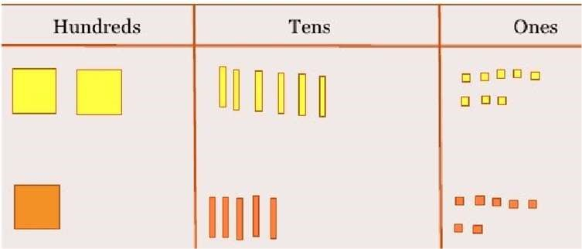 | 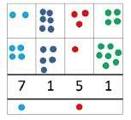  Draw representations using place value grid. | 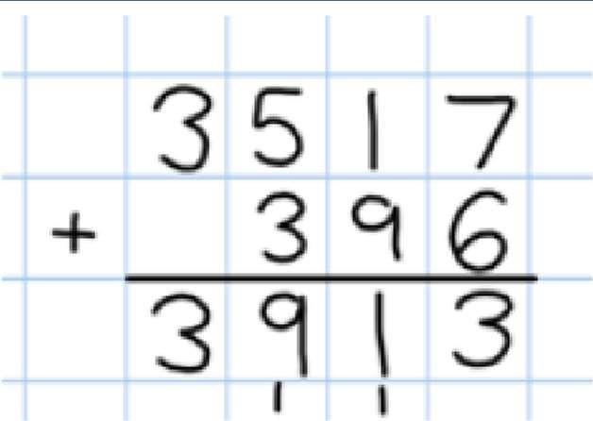  Continue from previous work to carry hundreds as well as tens.  Relate to money and measures.
Y5—add numbers with more than 4 digits.  Add decimals with 2 decimal places, including money. | As year 4  Tens  ones  tenths  hundredths  Introduce decimal place value counters and model exchange for addition. | 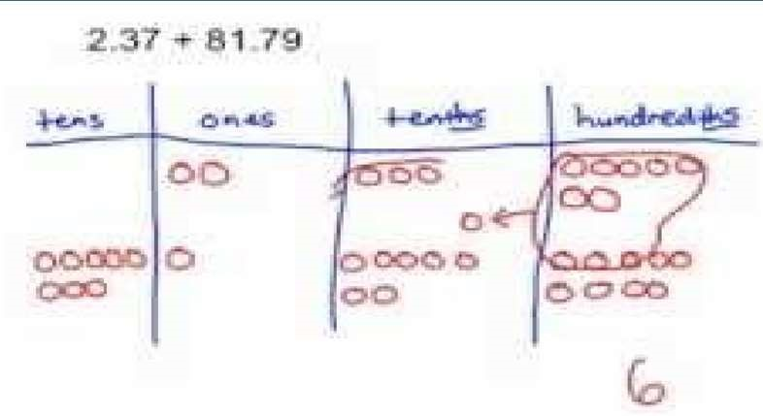 | 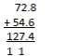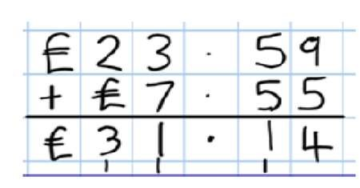
Y6—add several numbers of increasing complexity, including adding money, measure and decimals with different numbers of decimal points. | As Y5 | As Y5 | Insert zeros for place holders.  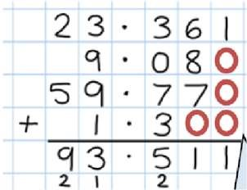  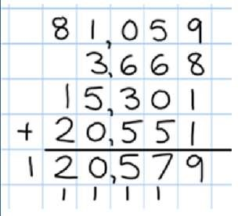

YEAR 1 SUBTRACTION
Objective /Strategy |  | Concrete |  | Pictorial |  | Abstract
Taking away ones. | Use physical objects, counters, cubes etc to show how objects can be taken away.  4—2 = 2  6—4 = 2 |  | Cross out drawn objects to show what has been taken away.  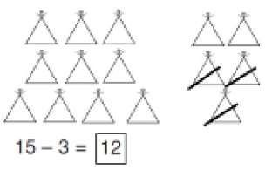 |  | 7—4 = 3  16—9 = 7
Counting back | 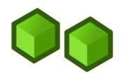  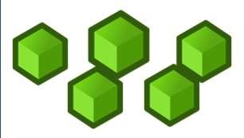  Move objects away from the group, counting backwards.  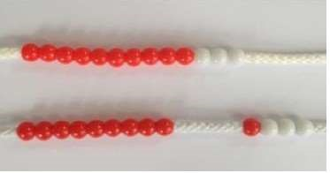  Move the beads along the bead string as you count backwards. |  | 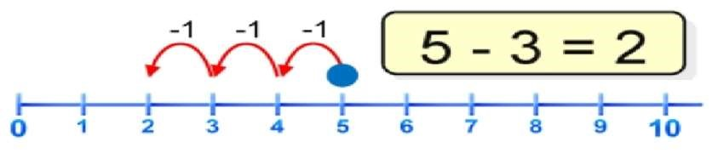  Count back in ones using a number line. |  | Put 13 in your head, count back 4. What number are you at?
Find the  Difference | Compare objects and amounts  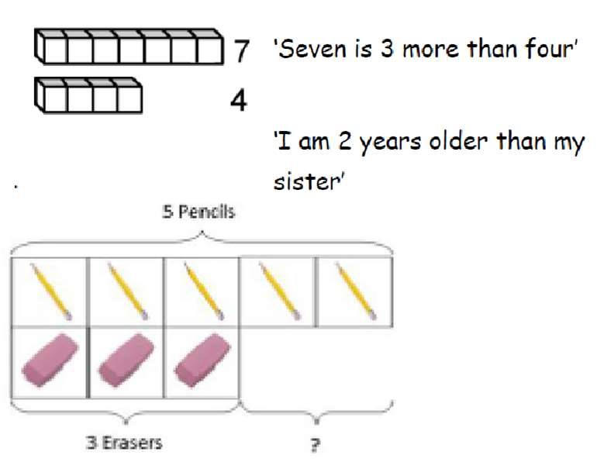  Lay objects to represent bar model. |  | Count on using a number line to find the difference.  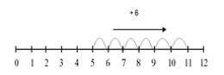 |  | Hannah has12 sweets and her sister has 5.  How many more does Hannah have than her sister.?

Objective/Strategy | Concrete | Pictorial | Abstract
Represent and use number bonds and related subtraction facts within 20  Include subtracting zero  Part Part Whole model | 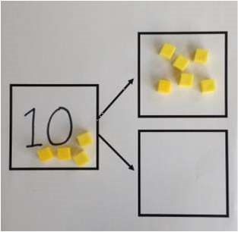  Link to addition. Use PPW model to model the inverse.  If 10 is the whole and 6 is one of the arts, what s the other part?  10—6 = 4 | 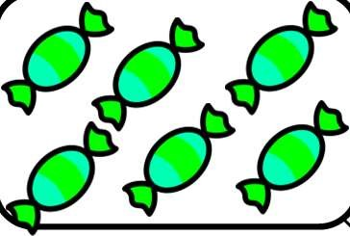  Use pictorial representations to show the part. | Move to using numbers within the part whole model.  12  5  7  Include missing number problems:  12 - ? = 5 7 = 12 - ?
Make 10 | 14—9  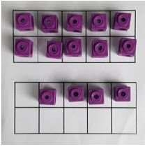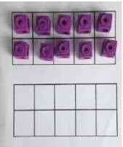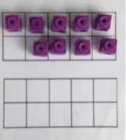  Make 14 on the ten frame. Take 4 away to make ten, then take one more away so that you have taken 5. | 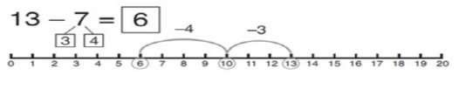  13—7  Jump back 3 first, then another 4. Use ten as the stopping point. | 16—8  How many do we take off first to get to 10?  How many left to take off?

Bar model  Including the inverse operations. | 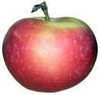 | 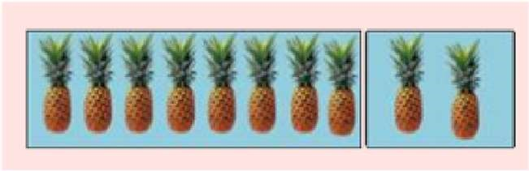 | 8 2
 | 5—2 = 3 |  | 10 = 8 + 2  10 = 2 + 8  10—2 = 8  10—8 = 2

YEAR 2 - SUBTRACTION
Objective & Strategy |  | Concrete | Pictorial | Abstract
Regroup a ten into ten ones |  | 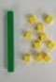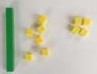  Use a PV chart to show how to change a ten into ten ones, use the term ‘take and make’ | 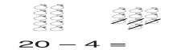 | 20—4 = 16
Partitioning to subtract without regrouping.  ‘Friendly numbers’ |  | 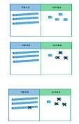  34—13 =  21  Use Dienes to show how to  partition the  number when subtracting without regrouping. | Children draw representations of Dienes and cross off.  43—21 = 22 | 43—21 = 22
Make ten strategy  Progression should be crossing one ten, crossing more than one ten, crossing the hundreds. |  | 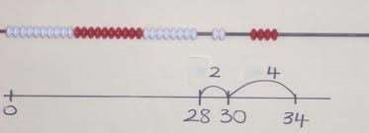  34—28  Use a bead bar or bead strings to model counting to next ten and the rest. | 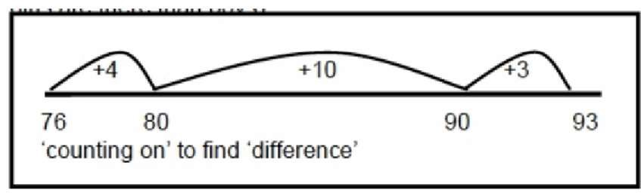  Use a number line to count on to next ten and then the rest. | 93—76 = 17
YEAR 3 - SUBTRACTION
Objective/ Strategy | Concrete |  | Pictorial | Abstract
Subtract numbers mentally, including:  three digit number + ones  three digit number + tens  three digit number + hundreds |  |  | 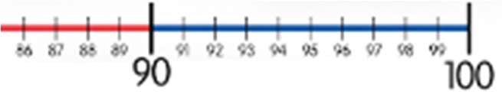 | Vary the position of the answer and question.  Expose children to missing number questions and vary the missing part of the calculation.  678 = ? - 1 688 – 10 = ?  678 = ? – 100
Column subtraction without regrouping (friendly numbers) | 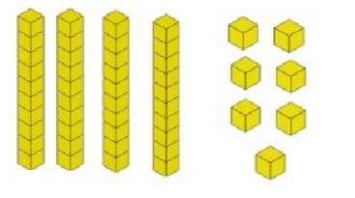  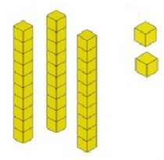47—32  Use base 10 or Numicon to model |  | 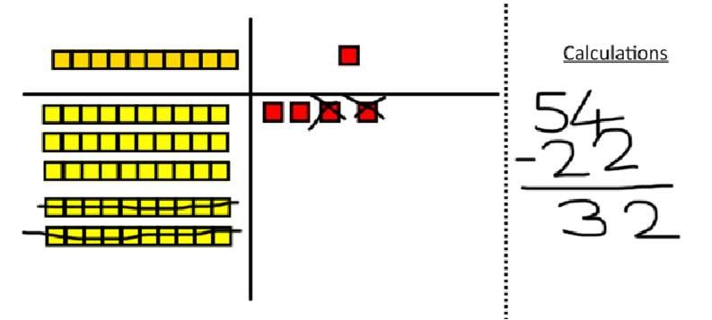  Draw representations to support understanding | 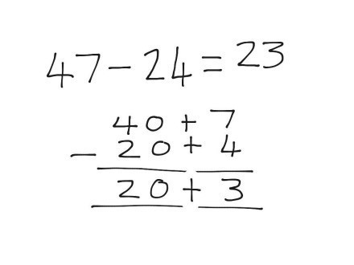  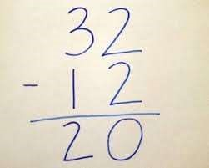  Intermediate step may be needed to lead to clear subtraction understanding.
Column subtraction with regrouping | 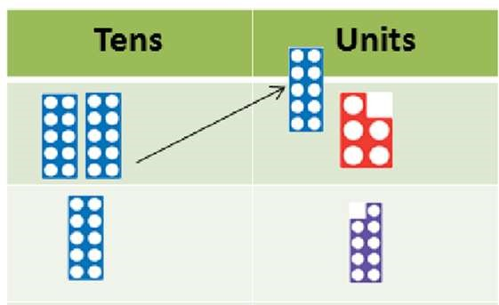  Begin with base 10 or Numicon. Move to pv counters, modelling the exchange of a ten into ten ones. Use the phrase ‘take and make’ for exchange. |  | 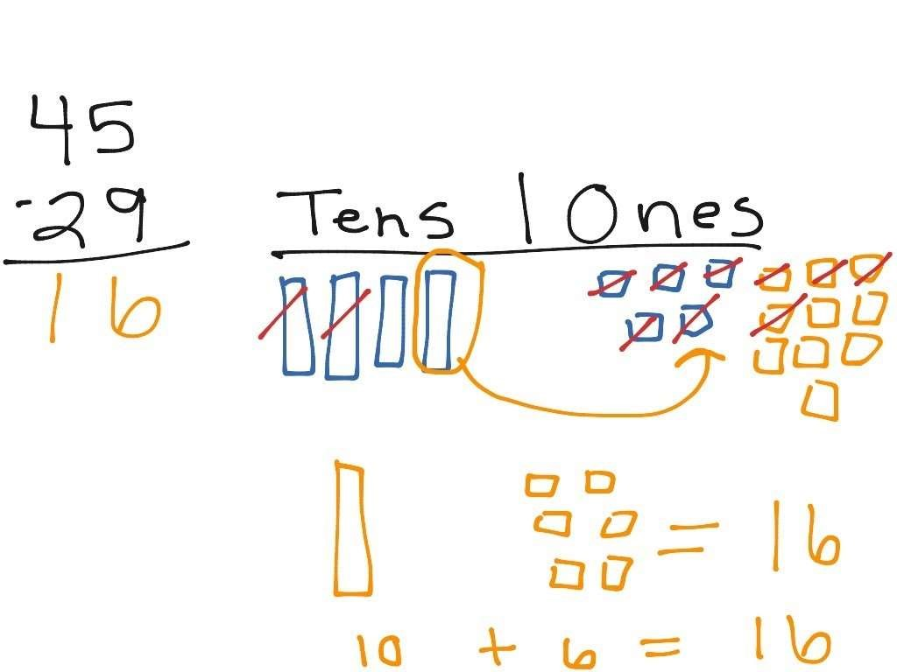  Children may draw base ten or PV counters and cross off. | 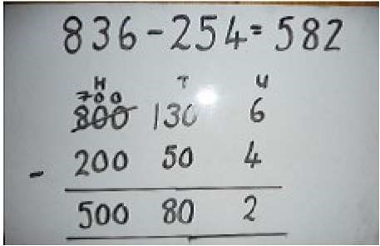  Begin by partitioning into pv columns  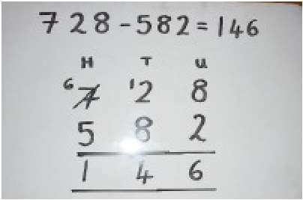  Then move to formal method.

YEARS 4 – 6 SUBTRACTION
Objective /Strategy | Concrete | Pictorial | Abstract
Subtracting tens and ones  Year 4 subtract with up to 4 digits.  Introduce decimal subtraction through  context of money | 234 - 179  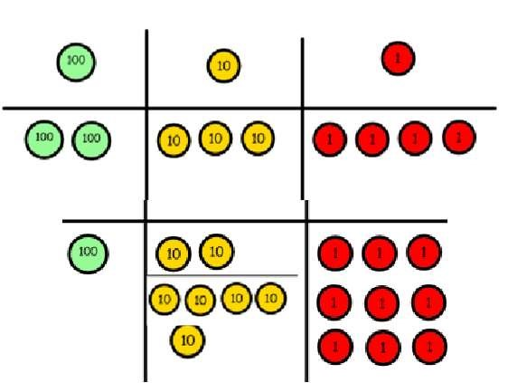 | Children to draw pv counters and show their exchange—see Y3 | 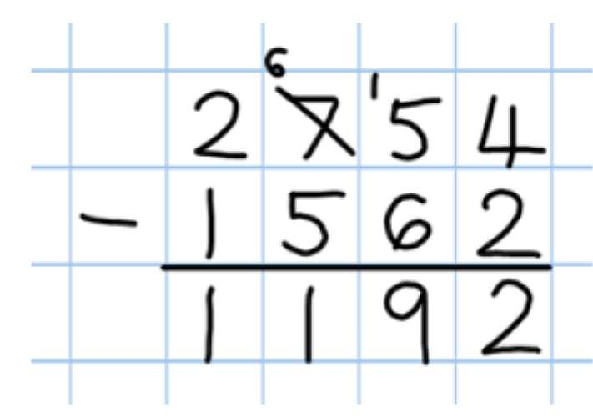
 | Model process of exchange using Numicon, base ten and then move to PV counters. |  | Use the phrase ‘take and make’ for exchange
Year 5- Subtract with at least 4 digits, including money and measures.  Subtract with decimal values, including mixtures of integers and decimals and aligning the decimal Up to 3 decimal places | As Year 4 | Children to draw pv counters and show their exchange—see Y3 | 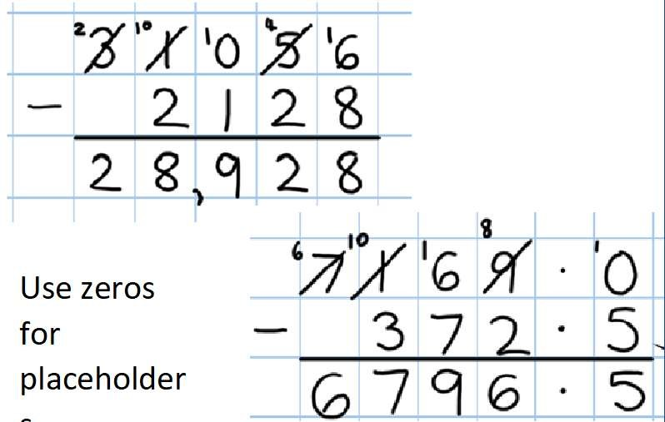s.  Use zeros  for  placeholder
Year 6—Subtract with increasingly large and more complex numbers and decimal values (up to 3 decimal place). | As Year 4 | Children to draw pv counters and show their exchange—see Y3 | 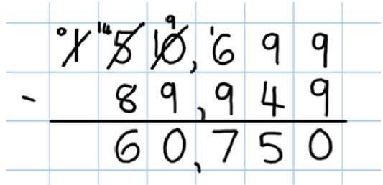  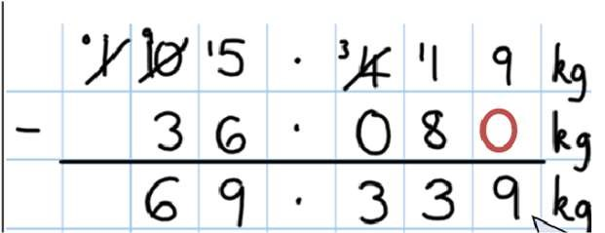

YEAR 1 MULTIPLICATION
Programme of Study specifies the following objectives, however it does not require the explicit teaching of the mathematical symbol of multiplication
Objective / Strategy | Concrete | Pictorial | Abstract
Doubling | Use practical activities using manipultives including cubes and  Numicon to demonstrate doubling  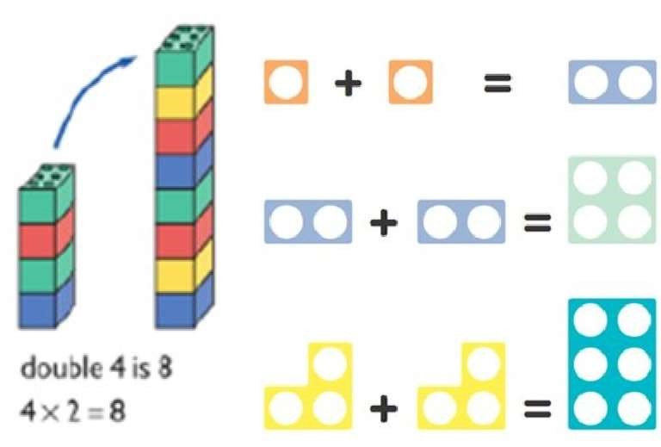 | Draw pictures to show how to double numbers  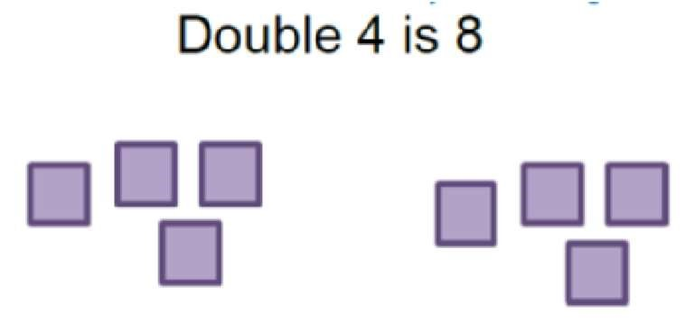 | Partition a number and then double each part before recombining it back together.  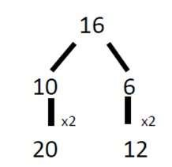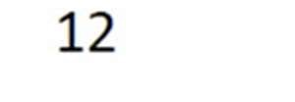  +  =  32
Counting in multiples  (2s, 5s, 10s) | Count the groups as children are skip counting, children may use their fingers as they are skip counting.  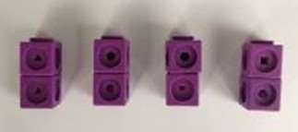  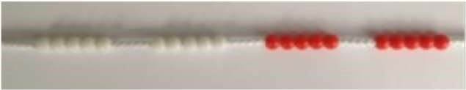 | Children make representations to show counting in multiples.  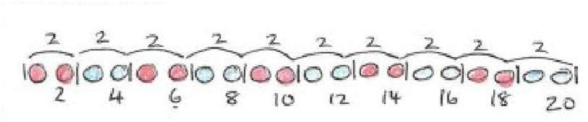 | Count in multiples of a number aloud.  Write sequences with multiples of numbers.  2, 4, 6, 8, 10  5, 10, 15, 20, 25 , 30
Making equal groups and counting the total | 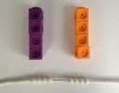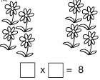  Use manipulatives to create equal groups. | 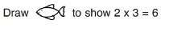  Draw and make representations | 2 x 4 = 8
Repeated addition | 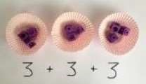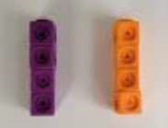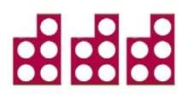  Use different objects to add equal groups | Use pictorial including number lines to solve  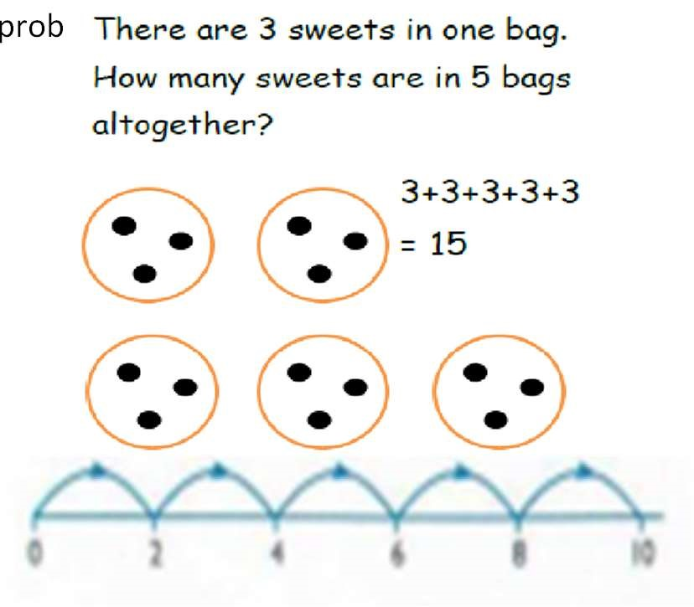  problems | 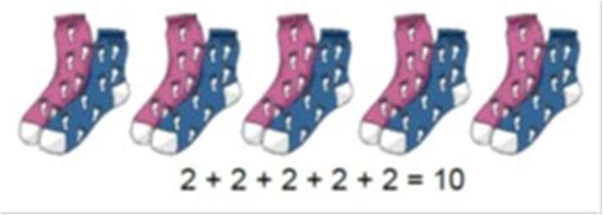  Write addition sentences to describe objects and pictures.
Understanding  arrays | Use objects laid out in arrays to find the answers to 2 lots 5, 3 lots of 2 etc.  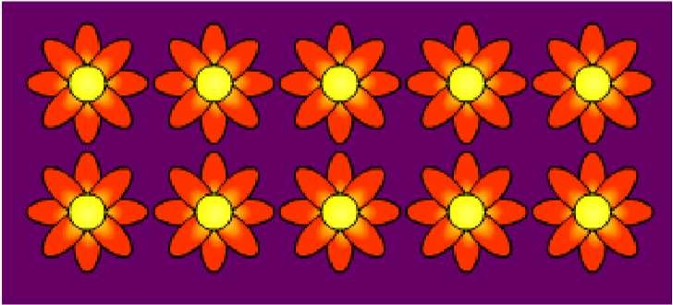 | Draw representations of arrays to show  understanding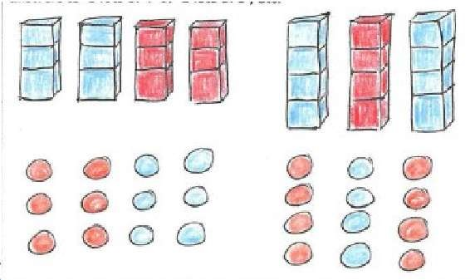 | 3 x 2 = 6  2 x 5 = 10

YEAR 2 MULTIPLICATION
Children should be able to recall and use multiplication and division facts for the 2, 5 and 10 times times tables.
Objective / Strategy |  | Concrete |  | Pictorial |  | Abstract
Doubling |  | Model doubling using dienes and PV counters. 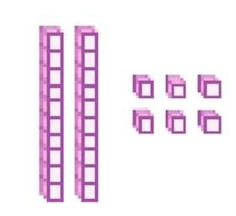 |  | Draw pictures and representations to show how to double numbers |  | Partition a number and then double each part before recombining it back together.
 |  | 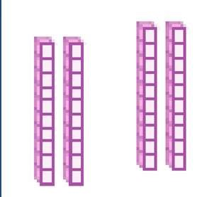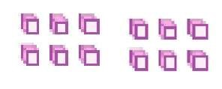  40 + 12 = 52 |  |  |  | 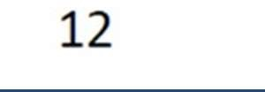  +  =  32
Counting in multiples of 2, 3, 4, 5, 10 from 0  (repeated addition) |  | Count the groups as children are skip counting, children may use their fingers as they are skip counting. Use bar models.  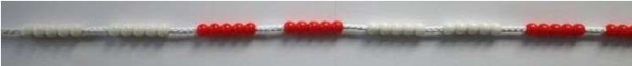  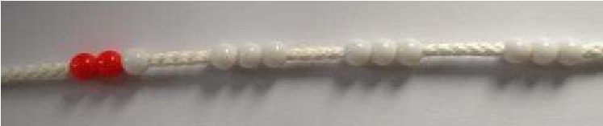  5 + 5 + 5 + 5 + 5 + 5 + 5 + 5 = 40  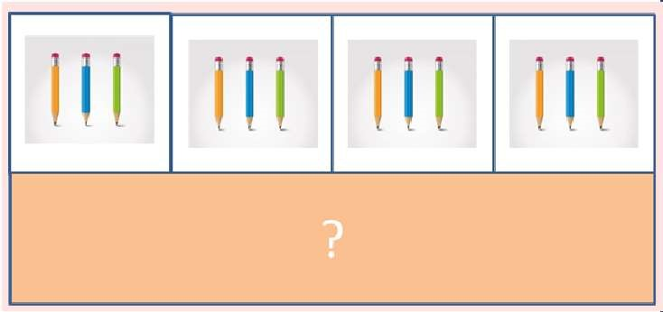 |  | Number lines, counting sticks and bar models should be used to show representation of counting in multiples.  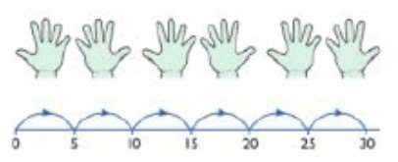  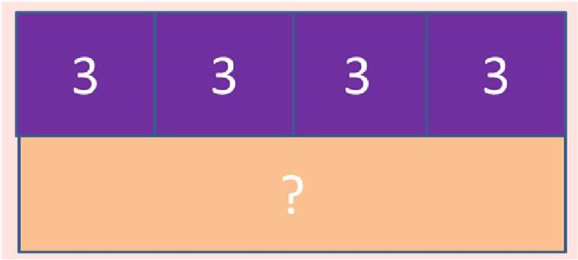 |  | Count in multiples of a number aloud.  Write sequences with multiples of numbers.  0, 2, 4, 6, 8, 10  0, 3, 6, 9, 12, 15  0, 5, 10, 15, 20, 25 , 30  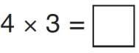
 | Objective / Strategy |  | Concrete |  | Pictorial |  | Abstract
 | Multiplication is commutative |  | 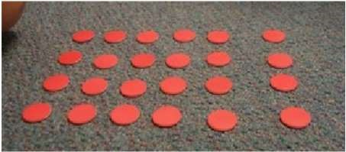  Create arrays using counters and cubes and  Numicon.  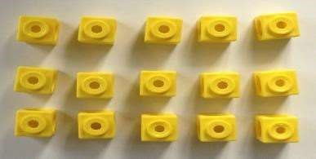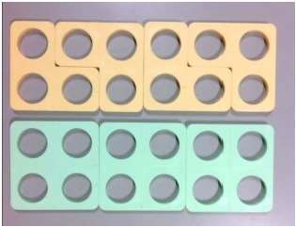  Pupils should understand that an array can represent different equations and that, as multiplication is commutative, the order of the multiplication does not affect the answer.  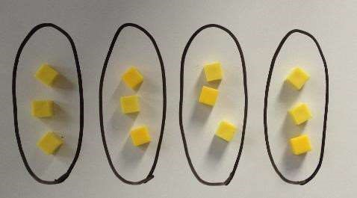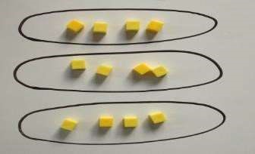 |  | Use representations of arrays to show different calculations and explore commutativity.  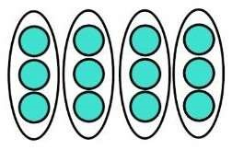  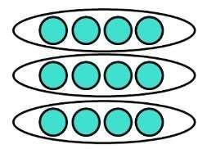 |  | 12 = 3 × 4 12 = 4 ×  3  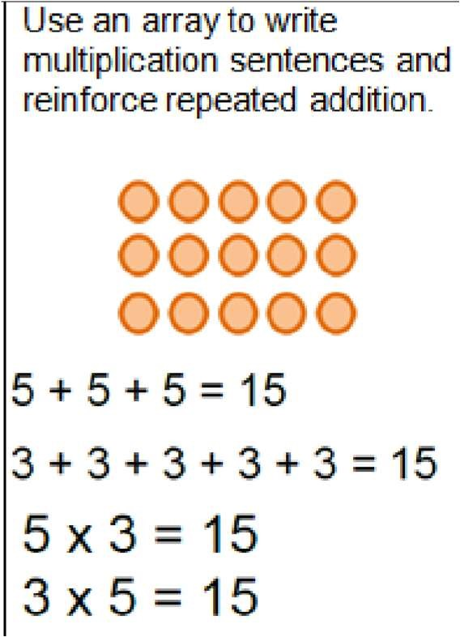
 | Using the Inverse  This should be taught alongside division, so pupils learn how they work alongside each other. |  | 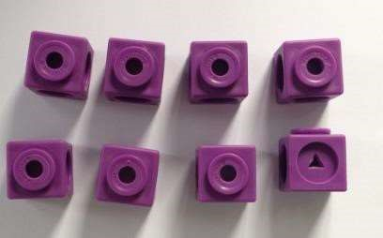 |  | 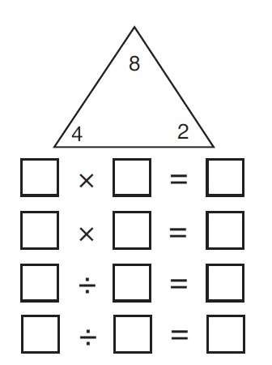 |  | 2 x 4 = 8  4 x 2 = 8  8 ÷ 2 = 4  8 ÷ 4 = 2  8 = 2 x 4  8 = 4 x 2  2 = 8 ÷ 4  4 = 8÷ 2  Show all 8 related fact family sentences.

YEAR 3 MULTIPLICATION
Children should be able to recall and use multiplication facts for the 3,4, and 8 times tables
Objective /Strategy | Concrete | Pictorial | Abstract
Grid method, progressing to the  formal method  Multiply 2 digit  numbers by 1 digit  numbers | Show the links with arrays to first introduce the grid method.  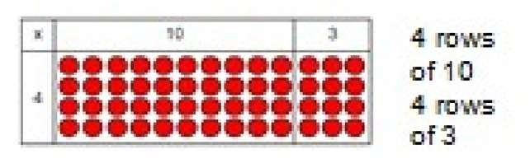  Move onto base ten to move towards a more compact method.  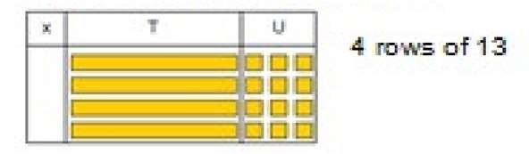  Move on to place value counters to show how we are finding groups of a number. We are multiplying by 4 so we need 4 rows  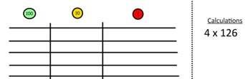  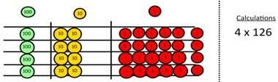  Fill each row with 126.  Add up each column, starting with the ones making any exchanges needed Then you have your answer. 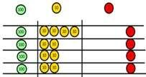 | Children can represent their work with place value counters in a way that they understand.  They can draw the counters using colours to show different amounts or just use the circles in the different columns to show their thinking as shown below.  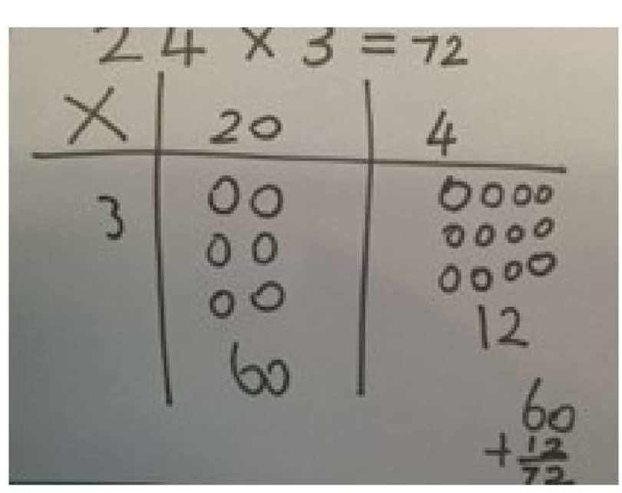  Bar model are used to explore missing numbers  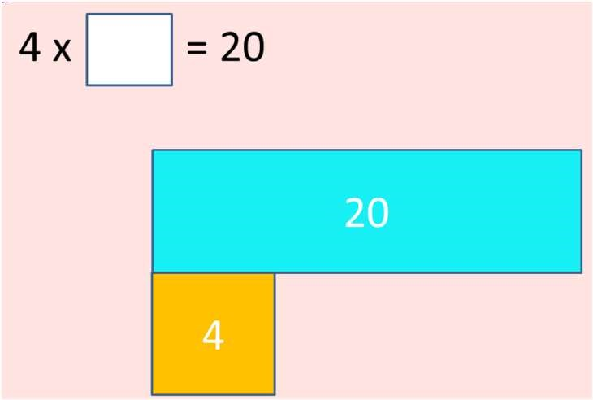 | Start with multiplying by one digit numbers and showing the clear addition alongside the grid.  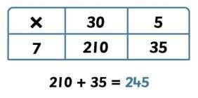  Move forward to the formal written method:  3 5  X 7  2 4 5  3
Solve problems, including missing  number problems, integer scaling problems, |  |  | Three times as high, eight times as long  ? x 5 = 20  20 ÷ ? = 5  3 hats and 4 coats, how many different outfits?

 | YEARS 4 – 6 Multiplication
Objective /Strategy | Concrete | Pictorial | Abstract
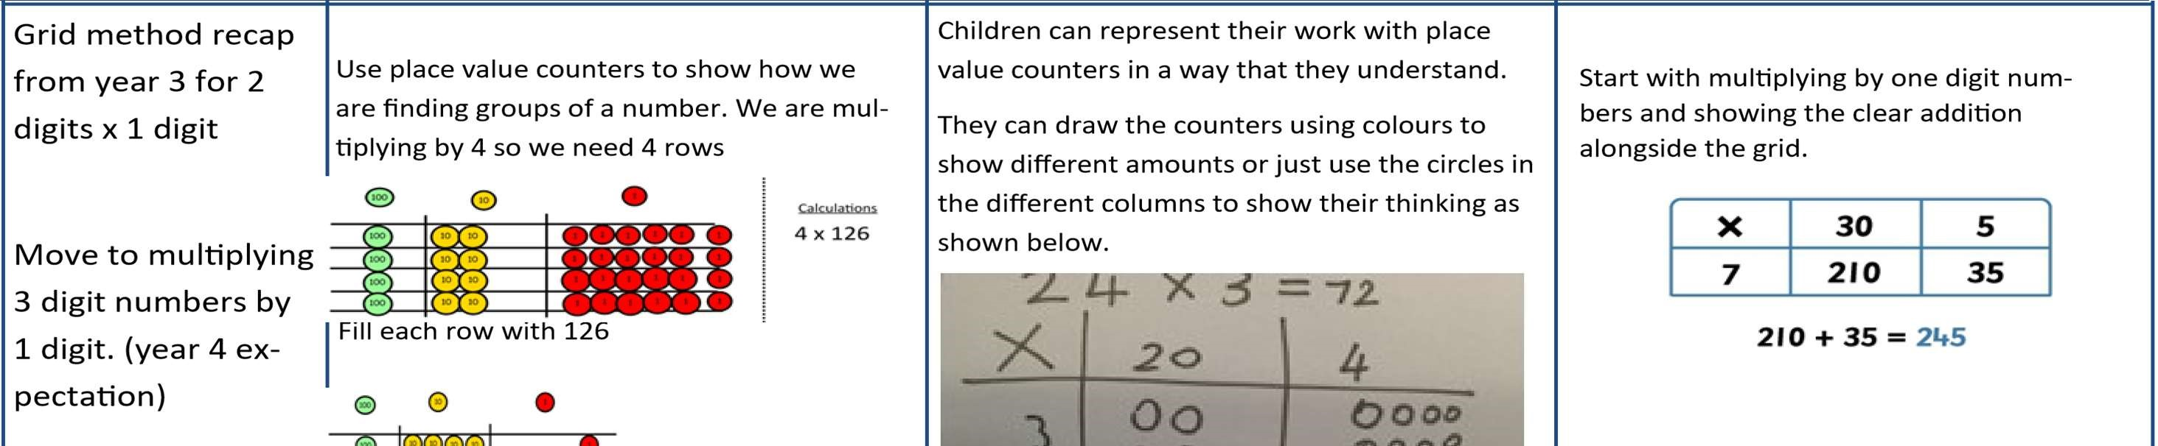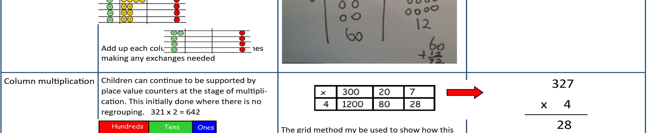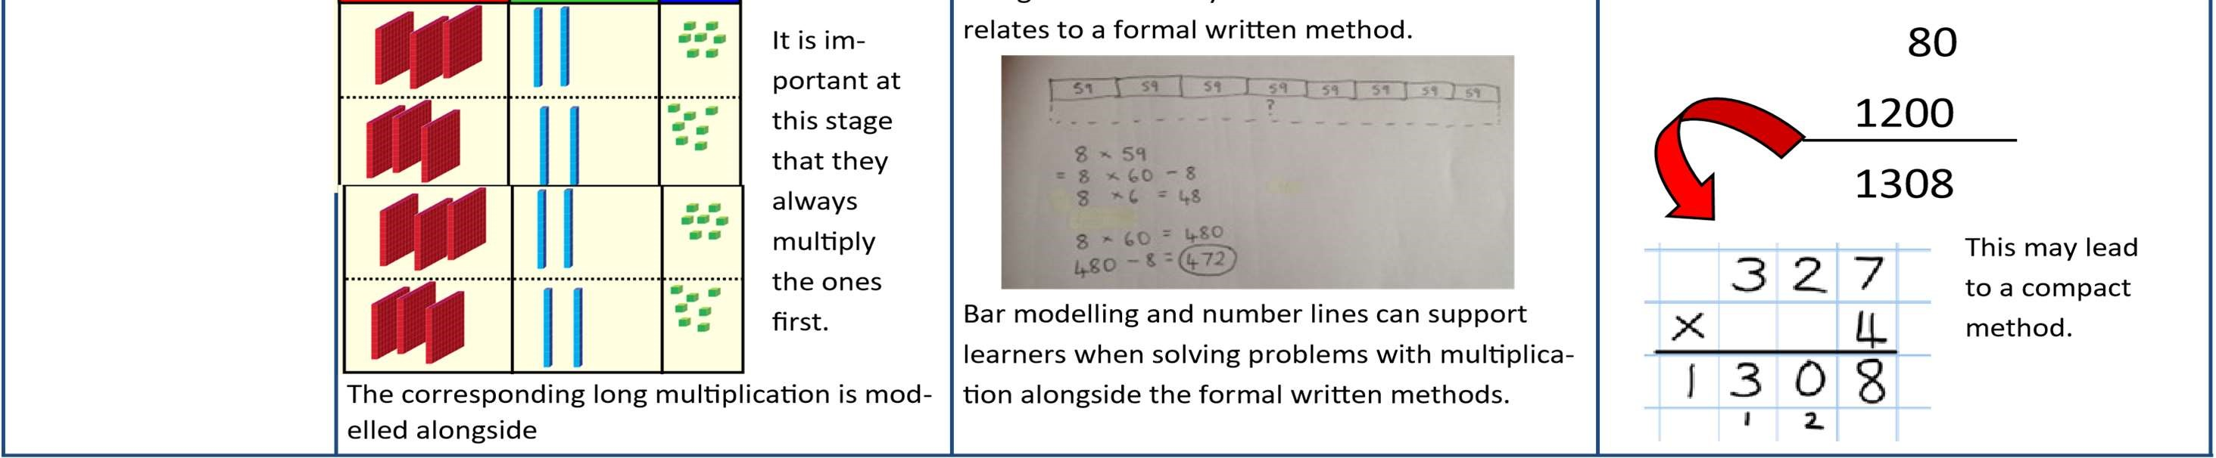

Objective /Strategy | Concrete | Pictorial | Abstract
Column Multiplication for 3 and 4 digits x 1 digit. | 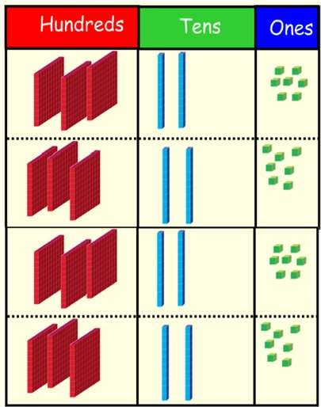  It is important at this stage that they always  Multiply the ones first. Children can continue to be supported by place value counters at the stage of  multiplication. This initially done where there is no regrouping. 321 x 2 = 642 | 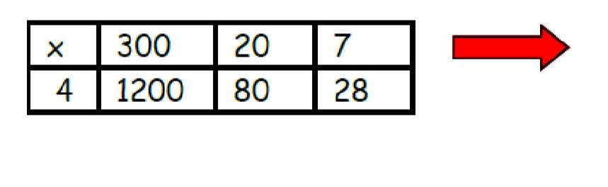 | 327  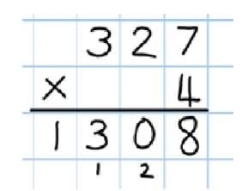  x 4  80  1200  28  1308
Column multiplication | Manipulatives may still be used with the corresponding long multiplication modelled alongside. | 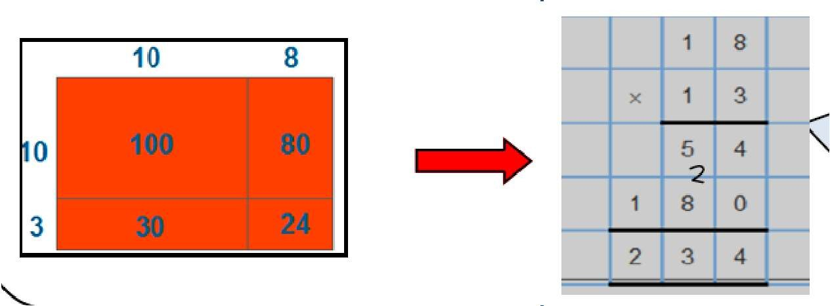  Continue to use bar modelling to support problem solving | 18 x 3 on the first row  (8 x 3 =24, carrying the 2 for 20, then 1  x 3)  18 x 10 on the  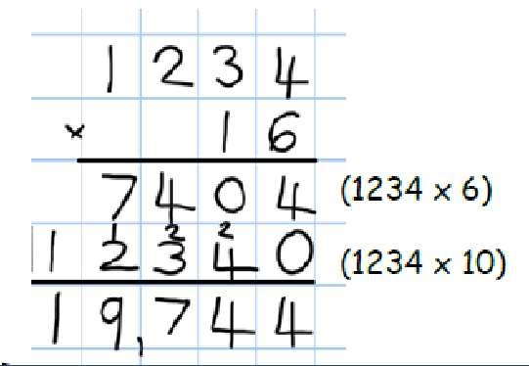  2nd row. Show multiplyi ng by 10 by putting zero in units first

Objective/Strategy | Concrete | Pictorial | Abstract
Multiplying decimals up to 2 decimal places by a single digit. |  |  | Remind children that the single digit belongs in the units column. Line up the decimal points in the question and the answer.  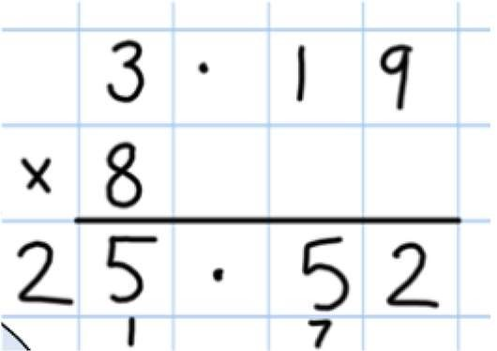

 |  | YEAR 1 DIVISION
Objective /Strategy | Concrete | Pictorial | Abstract
Objective/ Strategy | Concrete | Pictorial | Abstract
Division as sharing  Use Gordon ITPs for modelling | 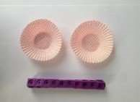  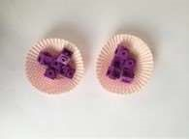  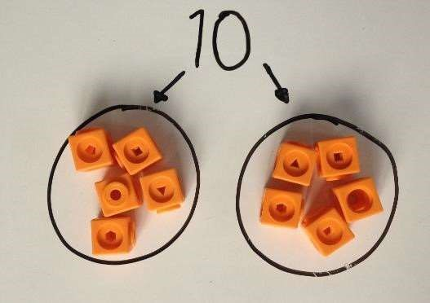  I have 10 cubes, can you share them equally in 2 groups? | Children use pictures or shapes to share quanti- ties.  4  shared between 2 is  8  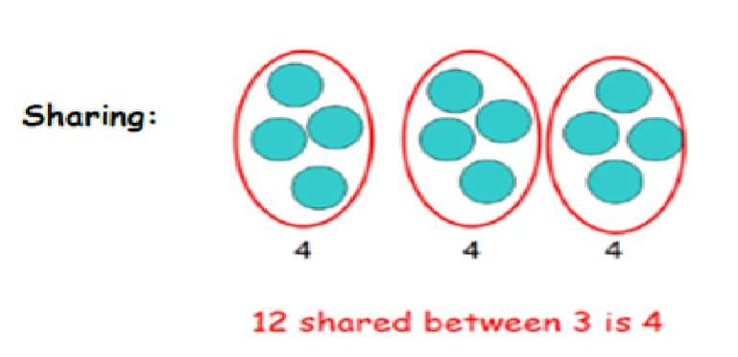 | 12 shared between 3 is  4
Objective/Strategy | Concrete | Pictorial | Abstract
Division as sharing | 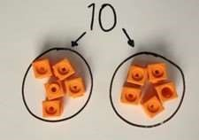  I have 10 cubes, can you share them equally in 2 groups? | Children use pictures or shapes to share quantities.  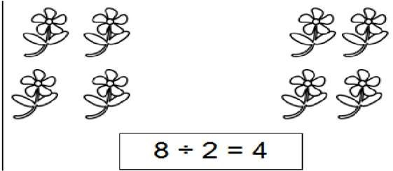  Children use bar modelling to show and support understanding.  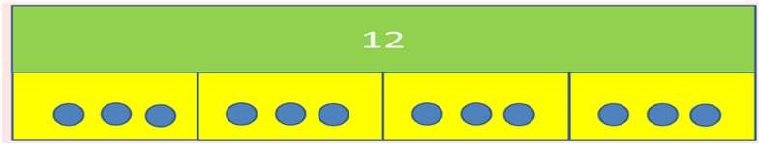  12 ÷ 4 = 3 | 12 ÷ 3 = 4
Division as grouping | Divide quantities into equal groups.  Use cubes, counters, objects or place value counters to aid understanding.  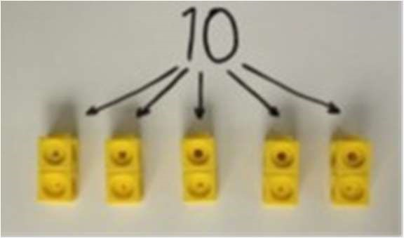  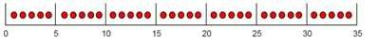 | Use number lines for grouping  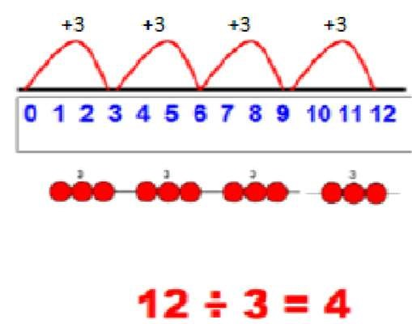  Think of the bar as a whole. Split it into the number of groups you are dividing by and work out how many would be within each group.  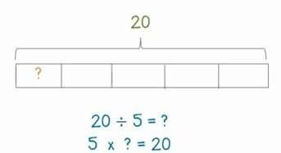 | 28 ÷ 7 = 4  Divide 28 into 7 groups. How many are in each group?

 |  | YEAR 2
Objective/Strategy | Concrete | Pictorial | Abstract
Division as grouping | Use cubes, counters, objects or place value counters to aid understanding.  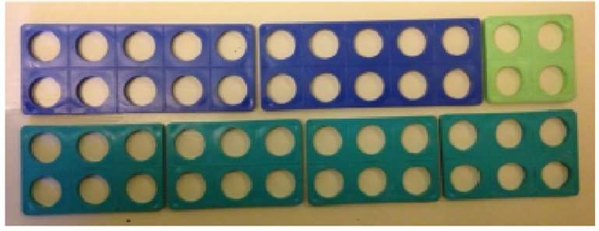  24 divided into groups of 6 = 4  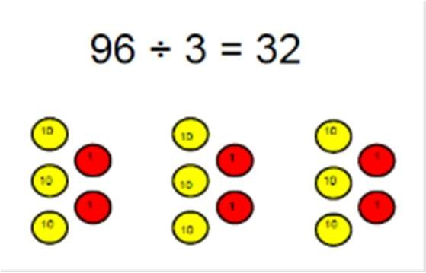 | Continue to use bar modelling to aid solving division problems. | How many groups of 6 in 24?  24 ÷ 6 = 4
Division with arrays | 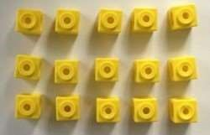  Link division to multiplication by creating an array and thinking about the number sentences that can be created.  Eg 15 ÷ 3 = 5 5 x 3 = 15  15 ÷ 5 = 3 3 x 5 = 15 | Draw an array and use lines to split the array into groups to make multiplication and division sentences  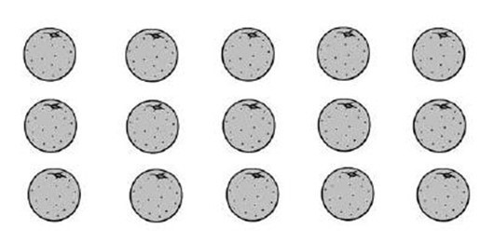 | Find the inverse of multiplication and division sentences by creating eight linking number sentences. 7 x 4 = 28  4 x 7 = 28  28 ÷ 7 = 4  28 ÷ 4 = 7  28 = 7 x 4  28 = 4 x 7  4 = 28 ÷ 7  7 = 28 ÷ 4

YEAR 3 (_{Greater Depth Y2)}
Objective/Strategy | Concrete | Pictorial | Abstract
Division with remainders. | 14 ÷ 3 =  Divide objects between groups and see how much is left over  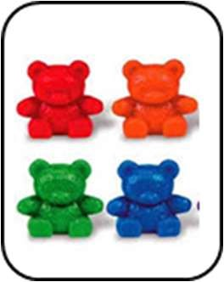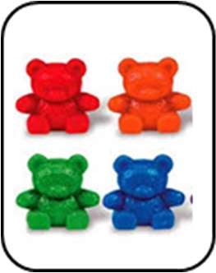  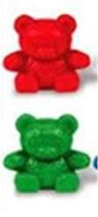 | Jump forward in equal jumps on a number line then see how many more you need to jump to find a remainder.  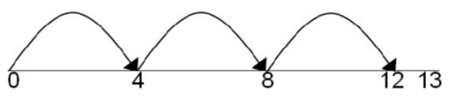  Draw dots and group them to divide an amount and clearly show a remainder.  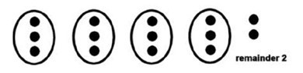  Use bar models to show division with remainders.  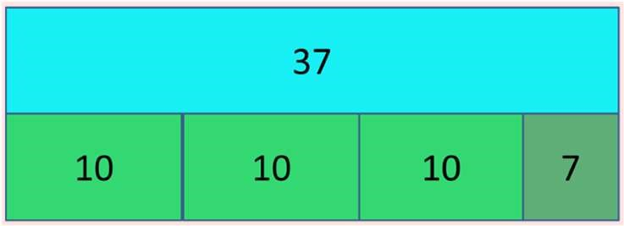  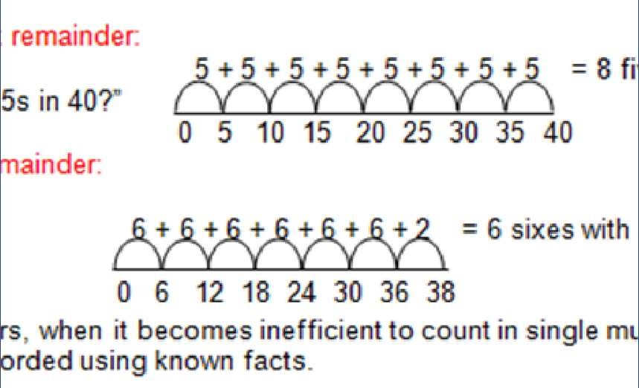 | Complete written divisions and show the remainder using r.  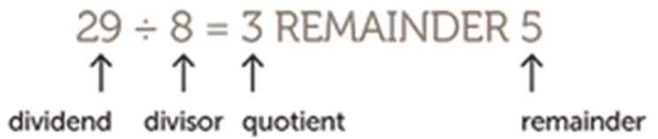

Year 4-6
Objective/Strategy | Concrete | Pictorial | Abstract
Divide at least 3 digit numbers by 1 digit.  Short Division | 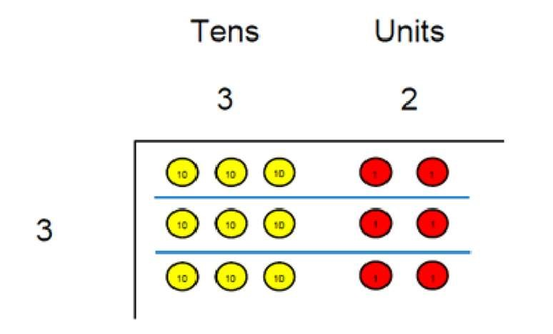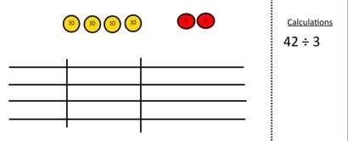  96  ÷  3  Use place value counters to divide using the bus stop method alongside  42 ÷ 3=  Start with the biggest place value, we are sharing 40 into three groups. We can put 1 ten in each group and we have 1 ten left over.  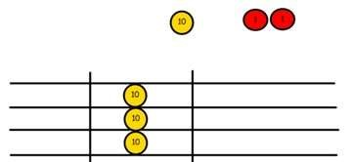  We exchange this ten for ten ones and then share the ones equally among the groups.  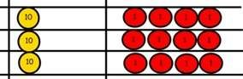  We look how much in 1 group so the answer is 14. | Students can continue to use drawn diagrams with dots or circles to help them divide numbers into equal groups.  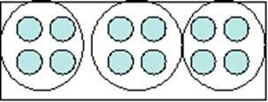  Encourage them to move towards counting in multiples to divide more efficiently. | Begin with divisions that divide equally with no remainder.  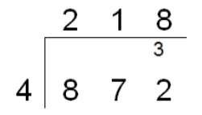  Move onto divisions with a remainder.  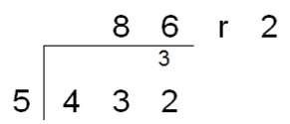  Finally move into decimal places to divide the total accurately.  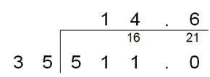  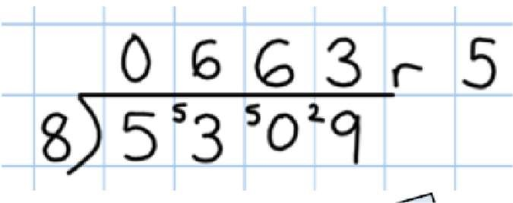

Long Division
Step 1—a remainder in the ones
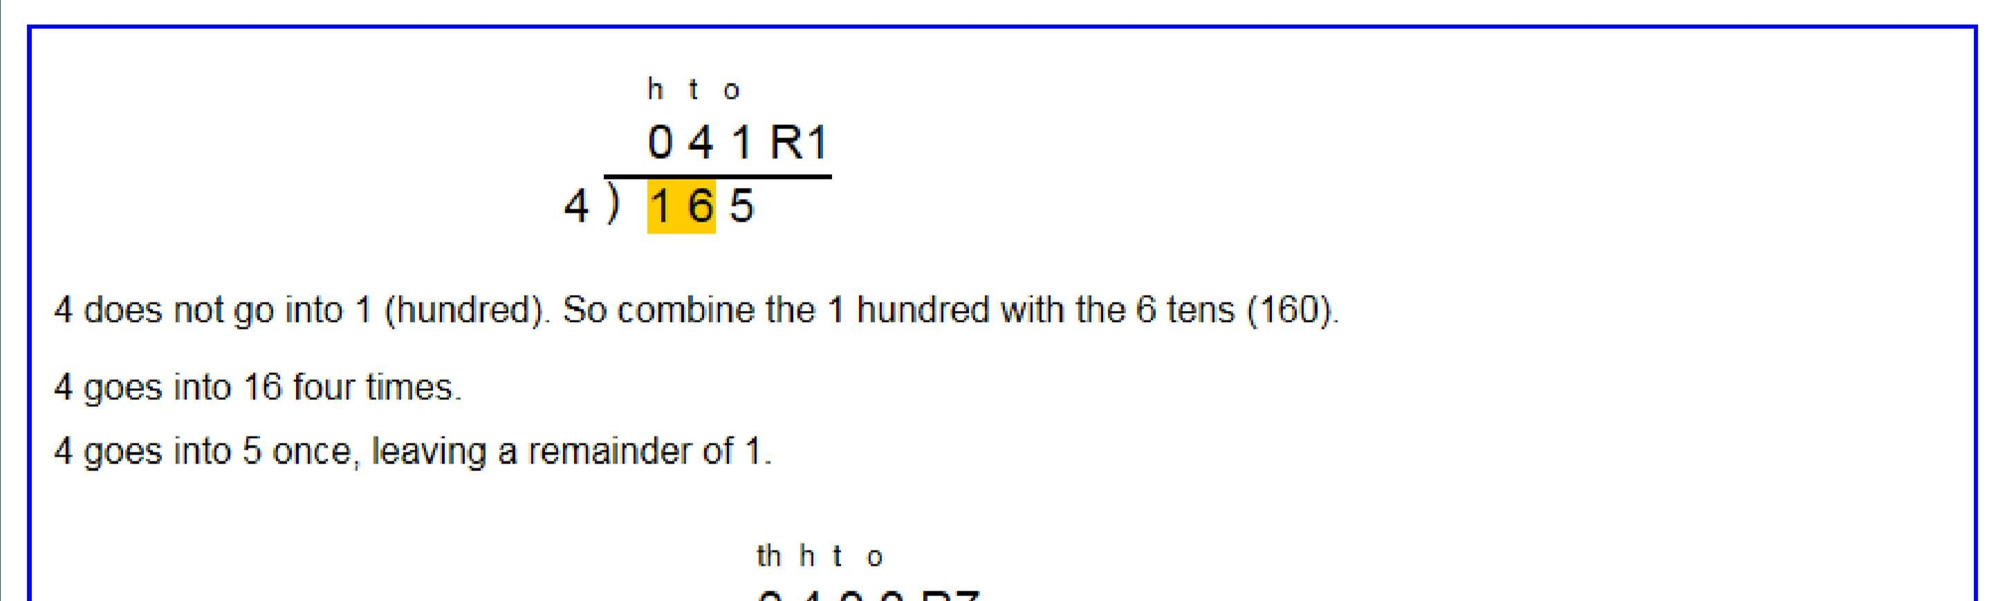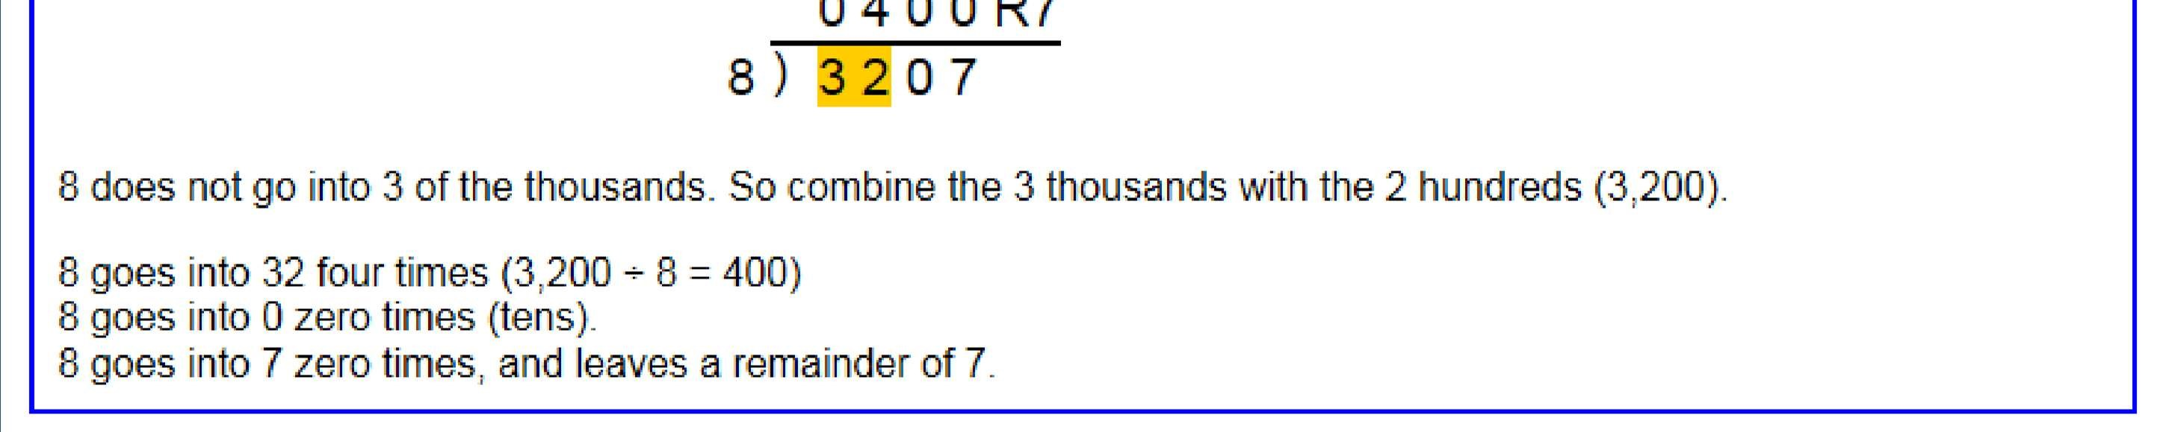
Long Division
Step 1 continued...
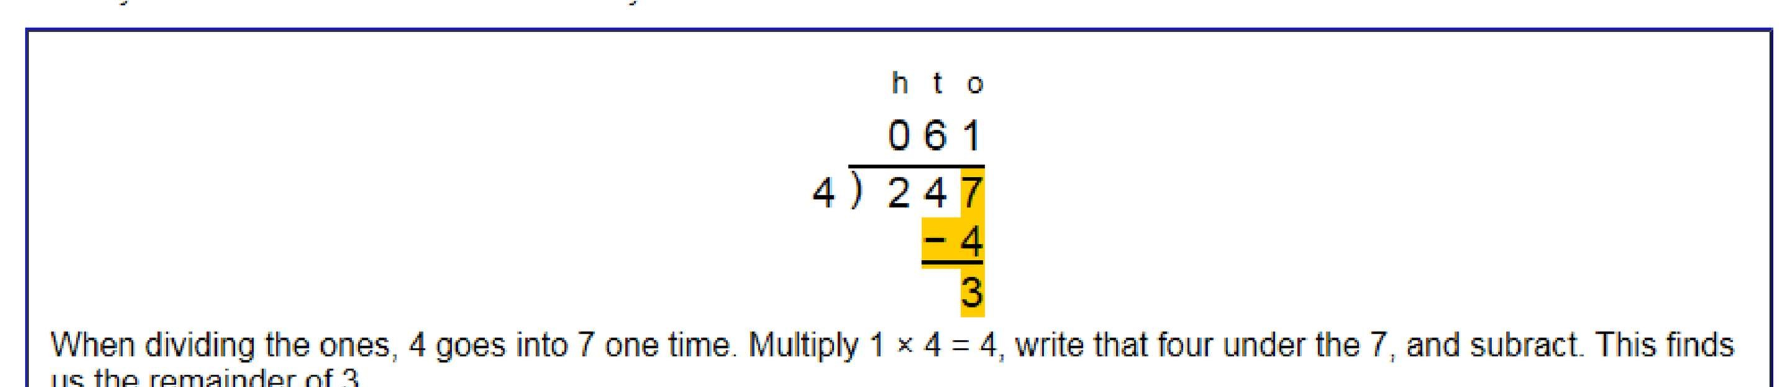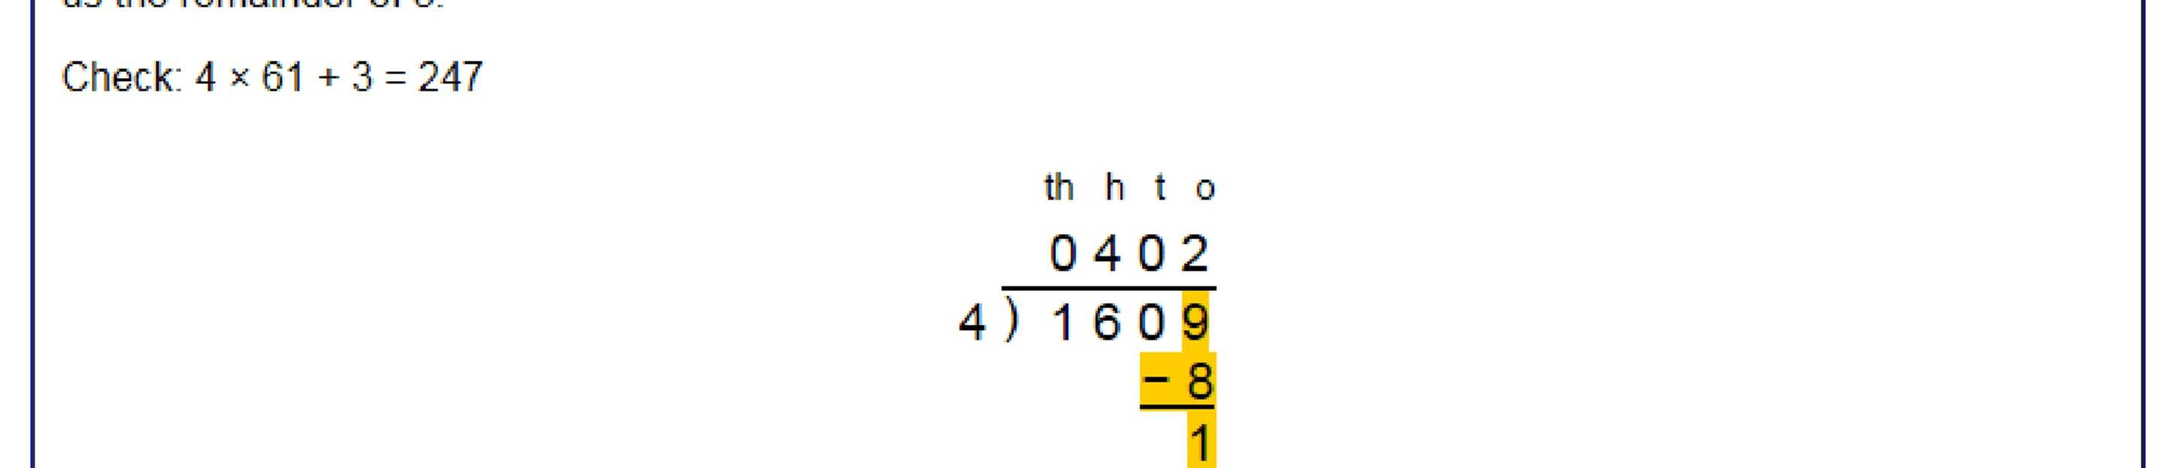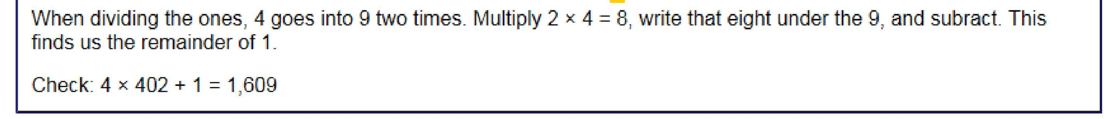

Long Division
Step 2—a remainder in the tens
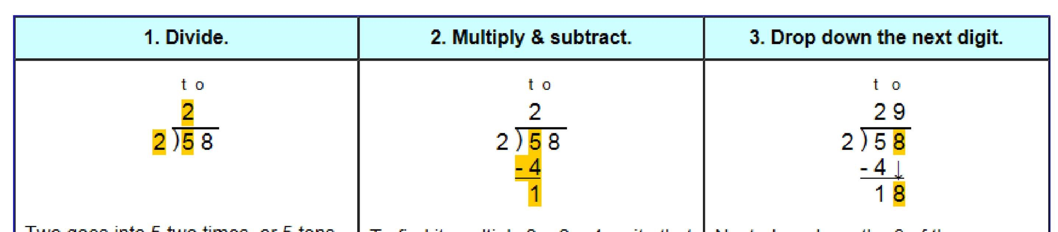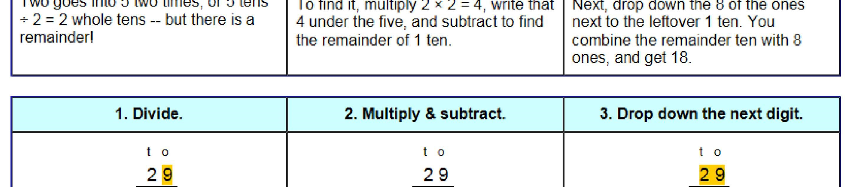
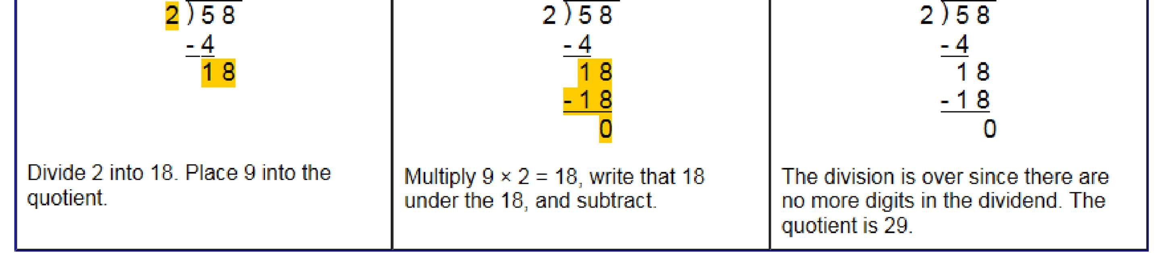
Long Division
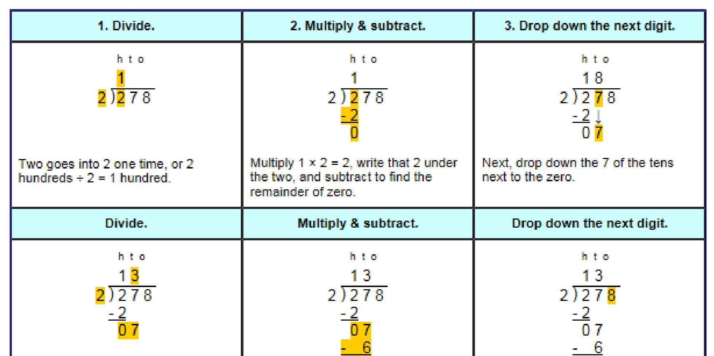
Step 2—a remainder in any of the place values 