LIFE AS A CHILD IN VICTORIAN TOTNES
TIME LINE OF EMPIRES
Stone, Bronze and Iron Age  30,000-332 BC | Ancient Egypt  3100 – 30 BC | Ancient Greece  1500 – 300 BC | Ancient Romans  753 BC – 476 AD | Vikings and Anglo Saxons  793 AD – 1066 AD |  | Mayan Civilisation  1800BC – 900AD
KEY DATES |  |  | THE VICTORIAN ERA
1838: Queen Victoria crowned aged 18.  1840: Queen Victoria married Prince Albert.  1842: Children under 10 can no longer work in underground mines.  1844: Children aged 8 – 13 could no longer work for more than 6.5 hours per day.  1856: Each county had to have their own police force.  1861: Prince Albert died of typhoid.  1864: Children under 10 can no longer work as chimney sweeps.  1864: Prison reform act.  1866: Barnardo begins all his work and sets up his first ragged school.  1867: Safety in mines and factories act.  1867: Child Labour Act  1870: Schools are built for children aged 5 – 10.  1875: Public Health Act.  1880: The Education Act makes schooling compulsory for all children aged 5 – 10.  1901: Queen Victoria dies and Edward VII becomes king. |  |  | 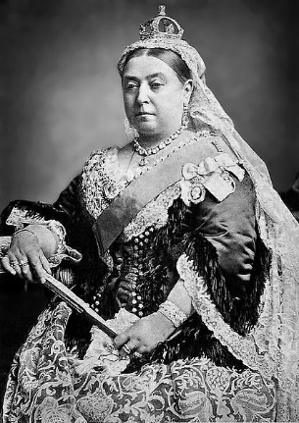  The period of time between 1837 to 1901 when Queen Victoria reigned over Britain. During her 63 year reign, there was a huge contrast between how the rich and poor Victorians lived. Queen Victoria led the expansion of The British Empire and saw major changes to all aspects of Britain due to exciting discoveries, travel and inventions.
KEY INVENTIONS
1800s- Railway Network 1838- Photography 1840- Penny Black Stamp 1843- Christmas Cards 1852- British Pillar Post Box 1852- Public Flushing Toilet 1863- London Underground Railway 1872- The Penny Farthing Bicycle 1876- Telephone 1879- Electric Bulb 1885- Petrol Motor Car 1895- X-rays
RICH CHILDREN |  |  | POOR CHILDREN
- usually well fed, clean and well clothed.  - didn't need to work  - went on holidays  - had expensive toys  - had pets such as ponies. |  |  | - had few luxuries.  - ate poor food  - worked long hours  - lived in damp, filthy conditions.  - Many children died of disease
BARNARDO |  |  | SCHOOL LIFE
Dr Thomas Barnardo: 1845 – 1905.  Arrived in London in 1866 – a city struggling to cope with the effects of The Industrial Revolution.  Population boom.  Outbreak of Cholera epidemic, killing more than 3000 people.  Thousands of children slept on the streets and many others were forced to beg after being maimed in factories.  1867: Set up ragged school  Met Jim Jarvis – showed him children sleeping on roofs and in gutters.  The encounter so affected him, he decided to devote himself to helping destitute children.  Charity he founded ran 96 homes. Still exists today.  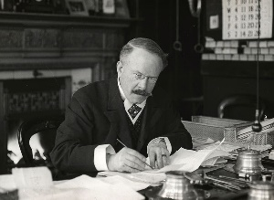 |  |  | Classroom was called the schoolroom.  Sometimes more than 100 children in the class.  Walls bare and windows high up.  Most important lessons were the 3R’s – reading, writing and arithmetic.  Pupil’s chant text.  Geography and history and science taught.  PE lessons were called drills.  Girls and boys were taught different lessons. Boys – farming and shoe making; girls – needlework and cookery.  Wrote on slates. Globes and abacus.  Strict punishments – cane, dunce’s cap, children given lines.  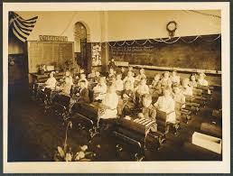
WORKHOUSE |  |  | VOCABUARY
Huge buildings built for very poor people to live and work.  Whole families would move in together but men, women and children were all kept separate.  Jobs for men included working the field, breaking stones and chopping wood.  Jobs for women included laundry, sewing and scrubbing the floors.  Food was very basic including bread, porridge (gruel), watered down milk and occasionally meat and potatoes.  Children had to have 3 hours of reading, writing, arithmetic and Christian religion lessons.  Girls’ education was learning to sew, knit and how to be a servant.  In 1930, workhouses were closed for good.  Some of the buildings were used as part of the National Health Service.  Totnes had a workhouse: |  |  | TIER 2  Empire  Charity  Industrial revolution  Industrial  revolution  Era  Monarchy  chronological  slum  pauper  sovereign  reign  mill |  | TIER 3  Barnardo  Queen Victoria  Albert  Workhouse  