We recognise unkindness and bullying and are upstanding.

We are calm, polite and respectful of others.

We have high expectations of ourselves and other people.

We take responsibility for our own behaviours and make repairs if needed.

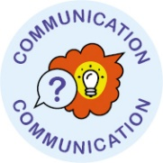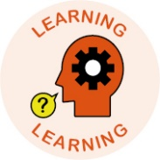



We learn how to and make every effort to communicate effectively – we listen and talk and share information so that we understand each other.

We develop positive learning relationships.

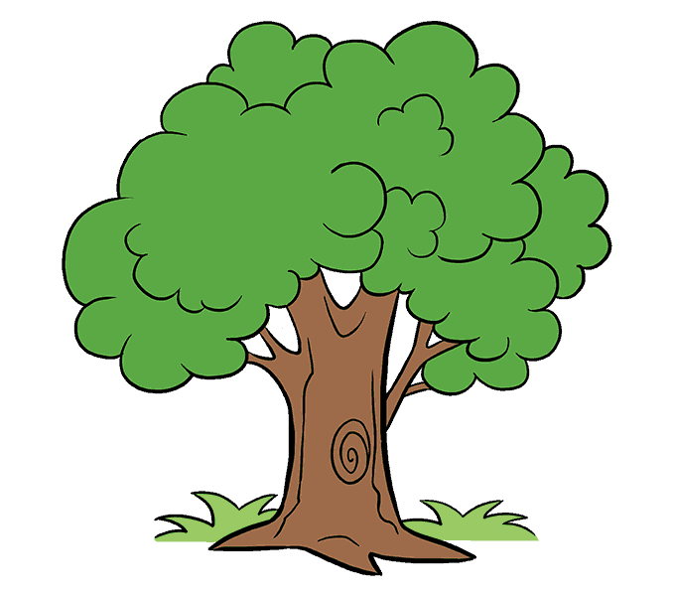

We understand the impact of words and actions on others – we are always kind and in discriminatory.

Be safe!

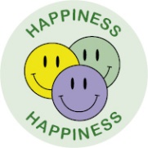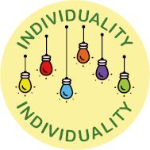

We meet the needs of our Children.

Safeguarding is EVERYONE’S responsibility.

We learn how to and make every effort to have good relationships.

**Together, we are on an adventure that has LOVE, HAPPINESS, INDIVIDUALITY, COMMUNICATION and LEARNING at its core. At The Grove, there is an atmosphere where children and adults are treated as individuals whose rights, values, beliefs and cultures are respected…**

We always promote and model positive behaviours.

We work hard to understand and empathise with each other, understand the trauma people may have been through and use therapeutic, restorative practices.