Key Words  Do we know what these words mean?  Bulb  Seed  Stem  Leaves  Trunk  Branch  Root  Petal  Plant  Botanist  Cyanotype  Photographer | Science  Plants  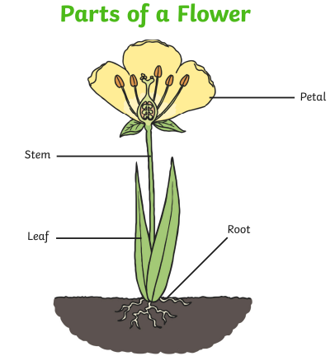 | Famous Scientist – Anna Atkins  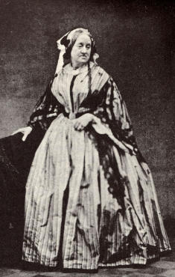  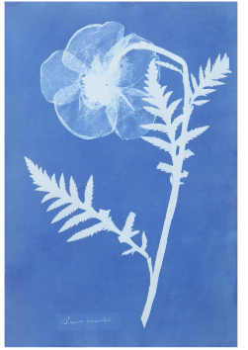  Anna Atkins was an English botanist and photographer who illustrated the first book with photographs using cyanotype images.
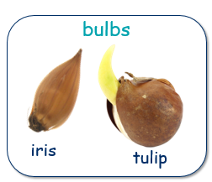 | 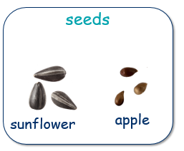 | 