LONDON
WHAT IS GEOGRAPHY?
Geography is the study of places and the relationships between people and their environments. Geographers explore both the physical properties of Earth’s surface and the human societies spread across it. They also examine how human culture interacts with the natural environment and the way that locations and places can have an impact on people. Geography seeks to understand where things are found, why they are there, and how they develop and change over time.
Physical geography is the study of Earth’s seasons, climate, atmosphere, soil, streams, landforms, and oceans.
Human geography is the study of the distribution of networks of people and cultures on Earth’s surface.
WHERE IS LONDON? | LANDMARKS OF LONDON
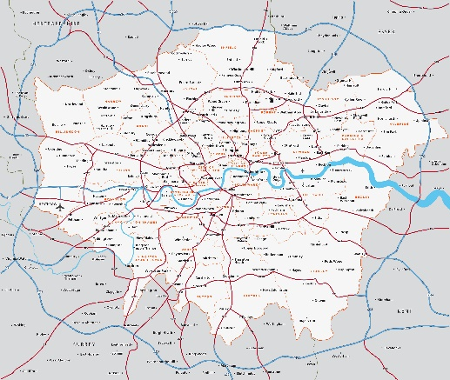  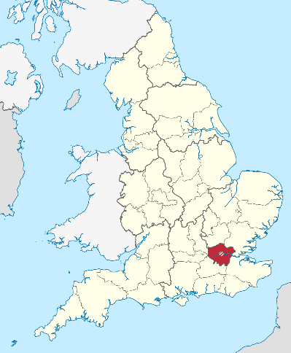 | - Tower of London  - Buckingham Palace  - 10 Downing Street  - Big Ben  - National History Museum  - Trafalgar Square  - Hamleys  - Covent Garden  - Gherkin  - The London Eye  - Houses of Parliament  - Tower Bridge
AERIAL PHOTOGRAPHY – LANDMARKS OF LONDON
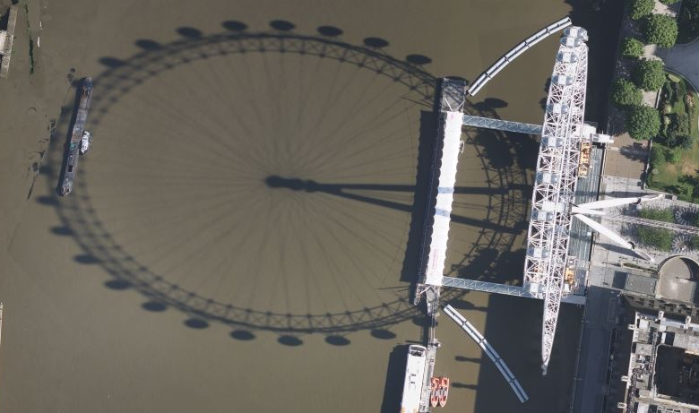
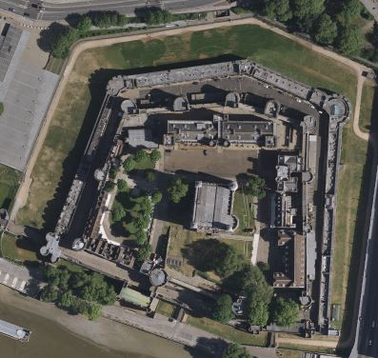
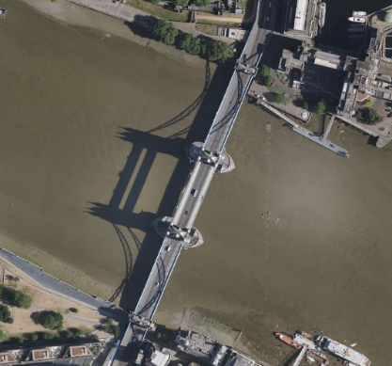
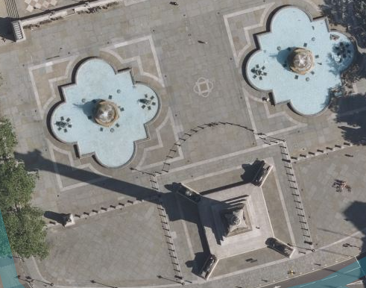
BURGESS MODEL OF A CITY | HOYT MODEL OF A CITY
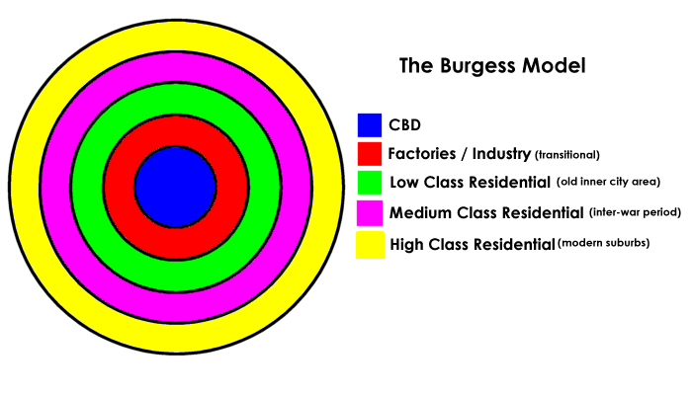  Model of typical city when no environmental factors are taken into account. | 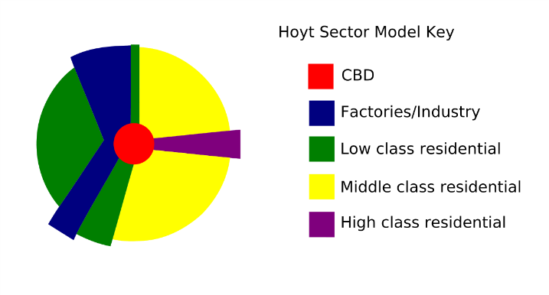  Model of typical city with some environmental factors are taken into account eg prevailing easterly wind.
THE THAMES BARRIER | THE TUBE SYSTEM OF LONDON
- Prevents flooding in London  - At risk of being overwhelmed by rising sea levels.  - Multi-functional – stops flooding, allows ships to pass through.  - Currently designers are trying to develop alternatives looking at other models around the world. | 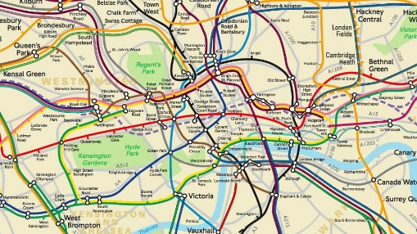  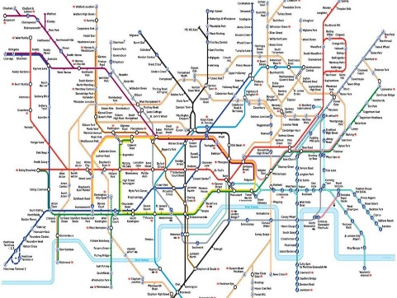
VOCABULARY – TIER 2 | VOCABUARY – TIER 3
TIER 2  urban, rural, river, industrial, population, settlement, tourist, scales, map, sustainability, congestion, pollution, climate change, grid reference, landmark | TIER 3  Business District, Thames, Thames Barrier, Hoyt, Burgess, Underground Tube

