HISTORY DETECTIVES: VICTORIAN COOKERY
KEY DATES
1811  Ichthyosaur fossil discovered in the time of Mary Anning | 1837  Queen Victoria became Queen | 1840s  Victorian Beach Holidays became popular | 1861  Mrs Beeton’s Victorian Cookbook is published | 1865  The Grove School is built | 1901  Queen Victoria died | 2020/21  Started school at The Grove School
THE VICTORIAN ERA
Queen Victoria Prince Albert  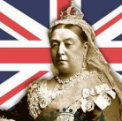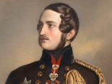 |  |  | Previous Learning for Y2 to retrieve  Mary Anning/ Ichthyosaur A Victorian School  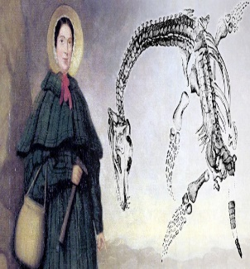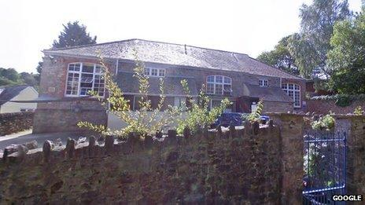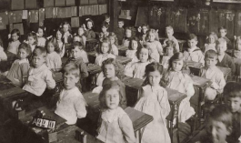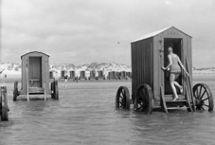  The Grove School was built Victorian Seaside
KEY VOCABULARY
Victorian Queen Victoria cookery processed imported multi-cultural

recipe upper class middle class poor Mrs Beeton gruel past present modern fresh

preserved: to be treated in a way which means food can be stored to eat later
seasonal: only grows at certain times of year
processed: food which has been altered and has lots of added or artificial ingredients
multi-cultural: food which is traditionally eaten in other countries
imported: to bring in from another country
VICTORIAN COOKERY
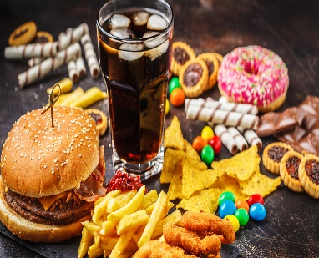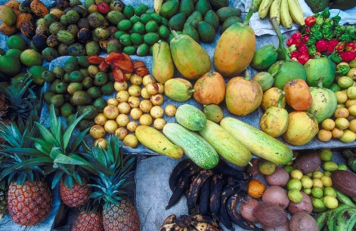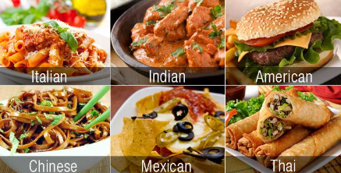
processed food imported food food from other cultures
Victorians ate fresh, seasonal food which was grown locally. They didn’t have refrigerators so food had to be kept fresh with ice and couldn’t be stored for long periods of time. The rich had a much better and varied diet than the poor. Victorians didn’t eat processed, imported* or food from other cultures. *Some fruit was beginning to be imported such as pineapples and oranges, but mainly for the rich and was a luxury/treat.
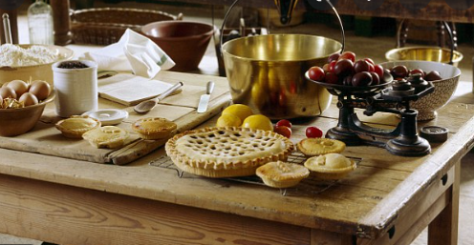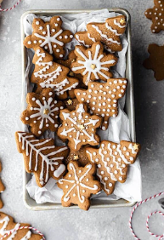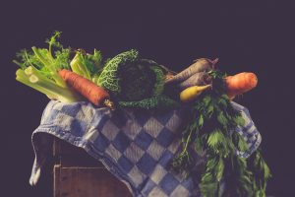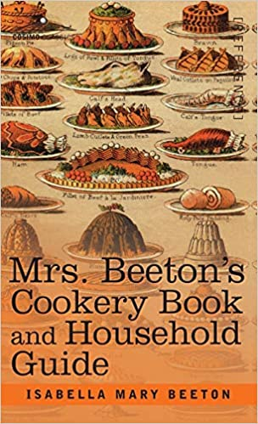

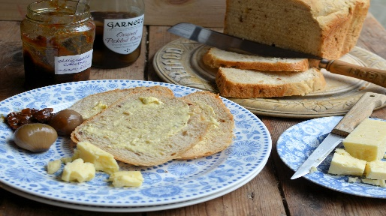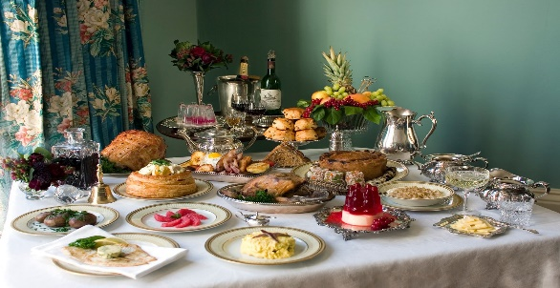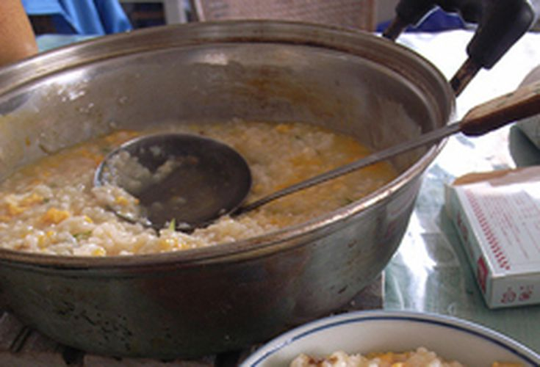
gruel

