

Behaviour policy and guidance 2026

With thanks to Plymouth CAST for sharing this great practice
Introduction

In our school we want to make sure our children are happy and have maximum opportunity to learn effectively. We work alongside parents to encourage our children to develop as fully as possible.

Together, we are on an adventure that has LOVE, HAPPINESS, INDIVIDUALITY,
COMMUNICATION and LEARNING at its core.

The most important aspect in children feeling valued, safe and secure is the sense of connection and trust with a member (or more than one member) of staff. These are known as Emotionally Available Adults (EAA). Children should be safe in the knowledge you have them in your mind, care about them as a person, about how they are feeling and what they are doing.

Strong relationships between staff and pupils are vital. Staff must be fair and consistent with children (taking into account individual needs). Children are supported to understand the boundaries, routines and structures are there to keep them safe, happy and able to learn. Adults will hold these boundaries firmly while being approachable, kind and compassionate.

Our behaviour policy guides staff to teach self-discipline not blind compliance. It echoes our core values in managing poor conduct and dynamic interventions which support staff and learners.

In our school, behaviour is understood as communication. Poor behaviour is understood to result from an unmet need or as an adapted, defensive, stress response. The understanding that children learn best within positive, trusting relationships informs our approach to managing and then to adapting behaviour. We expect staff to work to identify pupils’ needs and provide developmentally appropriate support to remove the barriers to successful engagement in school life.

We believe staff wellbeing is equal to pupil wellbeing. We understand the importance of developing a school community and culture in which anyone in the school, leadership included, can ask for help.

“Just as teachers are unable to take care of the children unless they first take care of themselves, leaders are unable to take care of their staff unless they first look after themselves.”

Stephen Waters, ‘Cultures of Staff Wellbeing and Mental Health in Schools’ (2021)

This policy is developed to ensure clear guidance for staff (and information for parents and governors). It promotes safe, kind and respectful behaviour within our compassionate environment.

Policy Aims

- To ensure that all children and adults feel safe, have a sense of belonging, feel secure, loved and valued.
- To foster, nurture and value strong and healthy relationships.
- To provide a clear, fair and consistent approach to behaviour.
- To ensure that our children are intrinsically motivated to do the right thing because it is the right thing to do.
- To maintain a calm and purposeful working atmosphere.
- To model and teach excellent behaviour and respect for others.
- To ensure that all children are supported to achieve their full potential (equity).

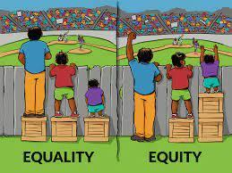
Equality is treating everybody the same.
Equality aims to promote fairness, but it can only work if everyone
starts from the same place and needs the same help.

Equity is giving everyone what they need to achieve success.
At The Grove School we advocate for each child to receive the
resources, experiences, appropriate interventions and support to be the best they can be.

Positive Behaviour

We actively promote building positive relationships. We believe that by investing in a child from the start, we will develop a quality relationship where children want to achieve and be the best they can be.
We teach positive behaviour through:

- Role modelling
- Consistency
- Prioritising positive behaviour
- Educational reward and positive reinforcement
- Feedback and recognition
- Reassurance and forgiveness
- Positive language
- Restorative Practice

We believe positive behaviour should be recognised. We use class rewards, polar bear whole school rewards, praise awards in assemblies as well as verbal praise and thanks in the moment.

Positive behaviour is taught formally through the curriculum as well as through modelled behaviour from all staff and positive reinforcement. Every opportunity is taken to help children understand why positive behaviour is linked to high expectations e.g. through stories, Team Grove and class time, discussions, drama, photographs, dance, art, PSHE, RE, social skills development and activities and educational trips. we ensure children understand not only what is expected of them, but also WHY.

Our Expectations of Behaviour

Our expectations are intrinsically linked to our values of LOVE, LEARNING, HAPPINESS, COMMUINICATION and INDIVIDUALITY.
We set positive and clear expectations, linked to our values, which are communicated to all and to children in a child-focused and friendly manner. The expectations are similar but also tailored to different areas of the school and off-site activities. These are as follows:

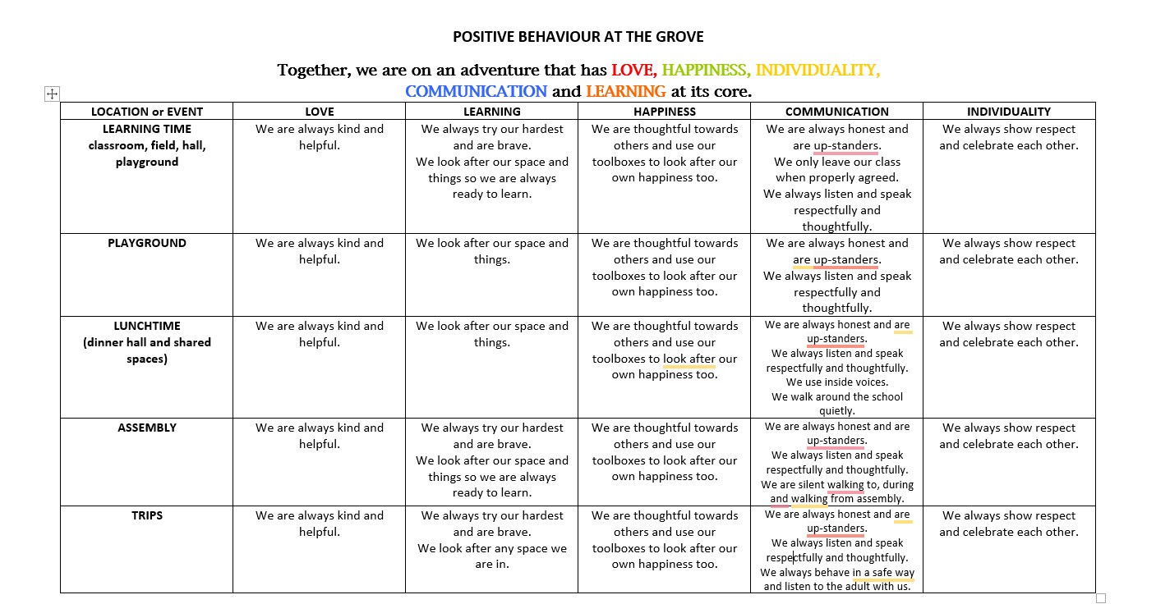

Responses to the expectations not being met are clearly sequenced, with a focus on restoration and learning; they are communicated to all and the different stages require different responses and communication with parents. The responses for the classroom are as follows.

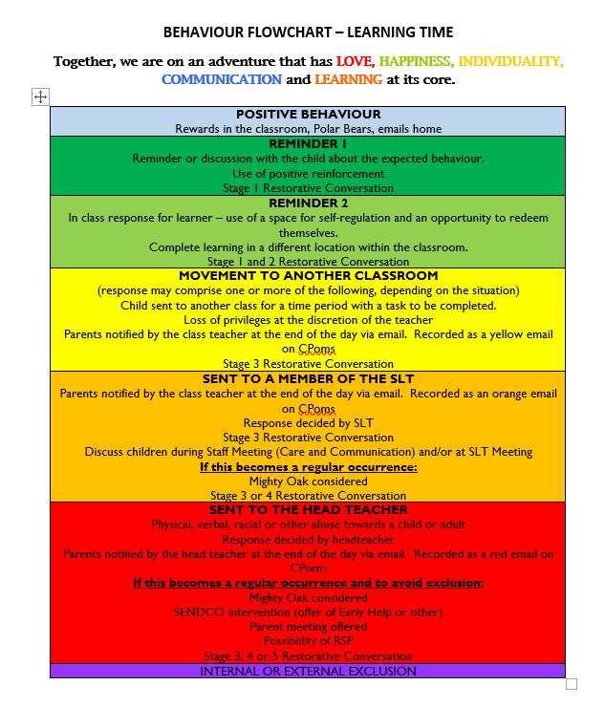
ALL THE POSITIVE BEHAVIOUR EXPECTATIONS AND RESPONSES FLOWCHARTS CAN BE FOUND ON OUR WEBSITE.

Roles and Responsibilities

Everyone is responsible for:

- Being positive role models.
- Ensuring that they are fully aware of the behaviour approach that is expected in the school.
- Creating a calm and well-ordered environment for teaching and learning and promoting pride in it.
- Establishing and maintaining high expectations at all times and praising when expectations (however small) are reached or exceeded.
- Creating an atmosphere whereby pupils and adults are treated as individuals whose rights, values, beliefs and cultures are respected.
- Ensuring they strive to develop positive working relationships with all members of the school community by demonstrating mutual respect and tolerance.
- Recognising bullying and unkindness when they occur and taking the necessary steps immediately to deal with unacceptable conduct in a constructive manner (see Anti-Bullying Policy).
- Consistently promoting positive behaviour:
- Facilitating learning about relationships and behaviour.
- Trying different approaches to behaviour principles to meet the needs of individual children.

The Governors and Headteacher are responsible for:

Monitoring and evaluating the impact of the Policy.
The SLT are responsible for:

- A positive school ethos by establishing a happy, safe, secure and well-maintained school environment.
- Modelling therapeutic behaviour techniques at all times and in particular when addressing behaviour that is challenging or unhelpful.
- Ensuring no pupil will be discriminated against for their race, religion, culture, gender or other individual need and ensuring the safety of all.
- Regular and clear communication with parents about the role they are expected to play in the development of their child’s behaviour at school.
- Effective monitoring and review of behaviours throughout the school.
- Recording and monitoring incidents of a serious nature, taking steps to ensure that they do not reoccur.
- Regular training on a whole school basis and for individuals both as part of the school’s induction process and as part of an individual’s training needs.
- Ensuring the wellbeing of adults is supported and promoted so they are able to be the best they can in supporting the children in our school.

The staff are responsible for:

- Supporting and Implementing The Grove School Values.
- Using positive therapeutic behaviour techniques to encourage socially responsible behaviour.
- Pro-actively seeking ways to avoid difficult and dangerous behaviours arising through priming children about expectations and pre-empting, where possible, when situations may arise.
- Recognising and valuing the needs of individual pupils to enable them to achieve their full potential.
- Ensuring that children behave in a way that is safe for themselves and others by taking action to prevent accidents and challenging behaviours before they occur (e.g. stopping a ‘silly’ game from continuing) both in the classroom and playground.
- Enabling pupils to take an increasing responsibility for their own learning and conduct.
- Implementing behaviour guidelines using the school’s restorative systems
- Liaising with parents about matters which affect their child’s happiness, progress and behaviour by keeping the parents well informed and attending meetings when requested.
- Delivering a programme of RE and PSHE to promote positive behaviour.
- Ensuring that new pupils and parents understand the procedures and guidelines that are in place.
- Recording behaviour incidents and restorative conferencing outcomes on CPOMS (Child Protection Online Management System).
- To support individual children, class teachers may feel of benefit to create a behaviour support plan alongside the child and parents to promote positive behaviours.
- Informing parents of behaviour incidents and the outcomes of restorative conferencing.

Parents are responsible for:

- Accepting, contributing and supporting the school’s behaviour policy.
- Agreeing to and signing the Home School Agreement when their child joins the school.
- Liaising about matters which affect their child’s happiness, progress and behaviour by keeping the school well informed about situations at home that could affect their child’s behaviour in school and attending meetings when requested.
- Parents actively support the school vision, values and ethos by modelling positive relational responses at all time and in particular when difficulties occur.
Children are responsible for:

- Showing respect for all members of the school community.
- Being polite, well-mannered and courteous.
- Being independent, hard-working and positive about their learning.
- Taking pride in their learning, actions, appearance and school environment and equipment.
- Taking responsibility for their own actions and actively participating with the restorative process.
- Valuing the opinions of others’ regardless of race, religion, culture, gender or other individual need.
- Being respectful of the efforts and contributions of others and aware of how their attitudes can affect the self-esteem of others.

Restorative Approach

We believe all behaviour is communication and we ask ourselves, “What is the child trying to communicate?”

We understand occasionally children will behave inappropriately. When this occurs, restoring and repairing relationships between all involved is key. This is known as the Restorative Approach. The aim is to enable children to reintegrate successfully and regulate their emotional responses, with an understanding of their actions, feelings and relevant outcomes.

When children display challenging behaviour, there are several stages of support in place to encourage them to manage their behaviour in a positive way. Before this, or any attempt can be made to engage in a restorative approach, we ensure we have established a connection with the child. We support them to become fully regulated in the presence of adults they know well and trust. Every effort is made to promote psychological safety through the use of face, voice and body language. Adults supporting children are well regulated themselves, raised voices are not used and children are not expected to spend time alone in isolation - to “calm down”.

We use the following restorative approaches, which are based on the four key features of:

- RESPECT
  - Adults and children listen to and value the opinions of others, enabling a psychologically safe environment.

- RESPONSIBILITY
  - Taking responsibility for your own actions and learning to regulate responses to behaviours.

- REPAIR
  - Developing the necessary skills to reflect upon and identify solutions which repair harm and ensure behaviours are not repeated.
  - Children are supported to repair ruptures in relationships which occur by adults who lead and facilitate it, with the agreement of the child.
  - Forcing children to apologise is both impossible and unproductive.

- RE-INTEGRATION
  - Working through a structured, supportive process which aims to allow young people to reach their full potential.
  - All adults will welcome children back into their group or classroom positively.
  - Children know when they have made mistakes they will be able to have a fresh start, with a clean slate.

This approach holds boundaries, limits and expectations firmly, yet is gentle and relational with the child.

In any restorative process, the following expectations will be set:

- Only one person talks at a time
- No interrupting
- Be respectful of others
- Listen carefully to each other

Restorative Discussion

The questions and sentence stems below are examples of appropriate, restorative discussion points for stage one.

EYFS and Key Stage One

- Would you help me understand what has happened?
- Can you tell me/show me who has been harmed/disturbed/distracted and in what way?
- How can we work together to make this/things/better?
- What can we do to support you to help you do things differently next time?
- Help me to understand...
- I wonder if....
Key Stage Two

- Would you help me understand what has happened?
- I wonder what that felt like for you? I imagine it might have made you feel a bit like…. Can you tell me/show me how you felt?
- How do you feel now?
- I wonder what you might be thinking now? I imagine it might be…..
- I wonder how XXX might be feeling? What do you think? How might they have been affected/harmed/disturbed/distracted?
- How can we work together to make this/things/better?
- What needs to happen now in order to put things right and ensure this never happens again? What can we do to support you to help you do things differently next time?
- Help me to understand...
- I wonder if....

Restorative Conferencing

Before the conferencing process begins, children will be supported to regulate. Children are unable to engage in a restorative approach if they are in a stressed state. We understand that children will regulate at different speeds and that some children may not be able to have a restorative conversation immediately after an event or even the same day.

If behaviours are repeated, a restorative conference may need to take place with all the affected people. Restorative conferencing will always take place in a quiet and appropriate area of the school.

Restorative conferencing will aim to repair the harm and find a resolution. It will be reasonable, meaningful and related to the incident. The aim of this process is to find a resolution that is agreed by all participants involved.

We ensure a consequence is never associated with a curriculum area e.g. writing, reading, times tables. If a child has been involved in a restorative conference, parents will be informed as soon as possible. Wherever possible, consequences link directly to the incident and are proportionate, reasonable and fair. For some children, the consequence is the restorative conversation.

It will always be made clear to parents: the situation was dealt with in a restorative manner; the situation is finished; all parties involved left feeling the situation had been resolved.

The incident and outcome of the restorative conference will be logged on CPOMS with the heading restorative conference.

Stages of Managing Behaviour

Our restorative approach to behaviour management is broken down into the following categories:
- Low level incidents
- Recurring incidents
- Serious incidents
- Continuous behaviour concerns (behaviour support plan)

Low level incidents

This includes behaviour that is not in keeping with the rule of Three: Ready, Respectful, Safe.

The list below provides some examples.
- Calling out
- Talking over each other/adults
- Inappropriate responses to adults
- Rough behaviour – pushing, pulling, grabbing on the playground
- Inappropriate attitude/tone of voice
- Not actively participating or engaging in lesson
- Not following instructions
- Inappropriate conduct at transition times
- Name calling/inappropriate language

Recurring Incidents

This refers to a child repeating inappropriate behaviours after discussion with an adult. With recuring incidents, details of the incident and the outcomes of restorative conferencing will need to be recorded on CPOMS by the leading adult and shared with parents as soon as possible.

Serious Incidents
This refers to a severe one-off incident/s such as physical violence and it will be referred to SLT. SLT will consider the incident and appropriate consequences. In the event of a severe one-off incident, restorative conferencing will take place following the procedures outlined above and recorded on CPOMS by SLT and shared with parents on the same day.

Serious incidents may take many different forms. Examples of behaviours considered to be serious are:

- Deliberate use of swearing and derogatory language
- Physical aggression
- Persistent non-compliance
- Damage to school property

Continuous Behaviour Concerns (Behaviour Support Plans)

This consists of continuous disruption or challenging behaviour, despite having partaken in the restorative conferencing process. In the event of a child demonstrating continuous challenging behaviour, a behaviour support plan will be devised.

The aim of the behaviour support plan is to provide the child with the strategies, resources, experiences, appropriate interventions and support in order to be the best they can be. A behaviour support plan will be put in place for a duration of 6-8 weeks after which it will be reviewed.

Teachers devise a behaviour support plan to address the individual needs of the child. A meeting will be arranged with parents (and where appropriate the child) to discuss these strategies and ways in which they can support at home. Once the plan has been implemented, teachers will contact parents at least once a week to inform them of the child’s progress.

All staff will be informed of the behaviour plan and strategies to support the individual child. Teachers will review these plans on a weekly basis to update triggers identified, add successful strategies and adapt the plans as required. They will date any new additions and comment on ceased strategies to support the graduated approach.

Teachers will regularly update SLT on the impact of the behaviour support plan. SLT will monitor and evaluate the impact of the plans and support staff where needed. In exceptional circumstances, where strategies have not been successful, staff, alongside parents, will seek support from outside agencies.

Suspensions – following Devon County Council Exclusions Policy
The importance of good behaviour cannot be overestimated. Children, parents and staff at The Grove School all enjoy our happy community and wish to maintain this through the help of all involved.

A decision to suspend a child is seen as a last resort by the school. No suspension will be initiated without first exhausting other strategies. In the case of a serious single incident, a thorough investigation in line with policy will be conducted and the suspension process applied if necessary.
The investigation may be carried out by the Head Teacher or by a person delegated by the Head Teacher.

The decision to suspend must be taken by the Headteacher.

The Head Teacher will inform the Chair of Governors and the Local Authority.

Possible reasons for suspension:

- A serious breach of the school’s rules or policies
- Cases of serious verbal or physical aggression
- Risk of harm to the education or welfare of the pupil or others in the school.
- Child on child abuse race, religion , culture , gender or other individual need

A suspension should be for the shortest time necessary; evidence suggests that one to three days is usually enough to secure benefits without adverse educational consequences.

A suspension should not be enforced if doing so may put the safety of the pupil at risk. In cases where parents will not comply by, for example, refusing to collect the child, the child’s welfare is the priority.

Permanent Exclusion

A permanent exclusion is a very serious decision and the Head Teacher will consult the Chair of Governors and DCC as soon as possible. As with a suspension, it will follow a range of behaviour management strategies and be seen as a last resort. It will be in response to a very serious breach of school rules and policies, or a disciplinary offence such as:

- Serious actual or threatened violence against another pupil or a member of staff
- Possession or use of an illegal drug on school premises
- Carrying or use of an offensive weapon
- Persistent bullying
- Persistent harassment
If the Headteacher decides to permanently exclude a pupil they will follow the same protocol outlined above for suspensions and must refer to the DCC Exclusions Policy.
Child on Child Abuse

The Grove School aims to reduce the likelihood of child-on-child abuse through:

- The established ethos of respect, friendship, courtesy and kindness
- High expectations of behaviour
- Clear consequences for unacceptable behaviour
- Providing a developmentally appropriate PSHE and wider curriculum
- Systems for any pupil to raise concerns with staff, knowing that they will be listened to, valued and believed

At The Grove School we recognise even if there are no reported cases of child-on-child abuse, such abuse may still be taking place and is simply not being reported. Staff must remain vigilant at all times to signs of child-on-child abuse.
We have a zero-tolerance approach to any form of abuse.
Any concerns, disclosures or allegations of child-on-child abuse, in any form, should be referred to the DSL. Where a concern regarding child-on-child abuse has been disclosed to the DSL(s), advice and guidance may be sought from Early Help / MASH. Where it is clear that a crime has been committed, or there is a risk of crime being committed, the police will be contacted. (See Safeguarding Policy)

Off-Site Behaviour
Consequences may be applied where a pupil has misbehaved off-site when representing the school, such as on a school trip or on the bus on the way to or from school. Individual risk assessments will be completed in liaison with parents for individuals to successfully participate in off-site activities. The procedures and expectations outlined in this policy will be followed on any off-site visit.
Pupil Transition
To ensure a smooth transition to the next year, pupils have transition sessions with their new teacher(s). In addition, staff members hold transition meetings. To ensure behaviour is continually monitored and the right support is in place, information related to pupil behaviour issues will be transferred to relevant staff at the start of the term or year. Information on behaviour issues may also be shared with new settings for those pupils transferring to other schools.

Transitions offer some children an opportunity for a fresh start. Information sharing should never compromise this and must be objective, factually accurate and fair. Recording on CPOMs must reflect these principles.

Appendices

Behaviour Strategy further Guidance

Relational approaches to behaviour and the use of the model PACE

The principles underpinning the behaviour support strategy

The Rule of Three

Addressing unhelpful behaviour

Supporting children with additional needs and SEND

As a school we provide this:

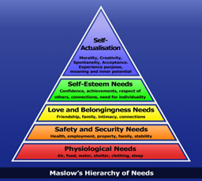
Our school is inclusive and support every pupil to experience success not just academically but socially and emotionally. We encourage and support children to explore topics in-depth to satisfy their hunger for knowledge. We encourage pupils to explore the world and provide educational visits, forest school activities and opportunities for them to follow their interests and passion. We provide opportunities for children who are very good in a subject to help their classmates with their work. We promote our values– working for a fairer world. We encourage our pupils to develop dreams and hopes and value these however humble or ambitious they may be.
Our school: Shows children that their efforts and hard work are noticed and appreciated. Provides powerful affirmative feedback. A simple “Good job!” or a “Well done!” can go a long way in self-esteem and self-worth. We Create opportunities for children to share positive feedback with their peers. We encourage students to participate in competitions and extra- curricular activities and events. We provide a rich range of extra curricula activities and encourage pupils to experience the joy of learning new skills in a supportive environment. Adults are not afraid to apologise and model failure without shame. We value the voice of the child and promote integrity encouraging pupils to do what they say and not be ashamed when things may not work out as expected or hoped.

Our school: Establishes ground rules about being respectful towards one another. We focus on our values of Love, Happiness, communication, learning and individuality. We create a sense of team by engaging children in team-building and bonding activities. We understand the importance of belonging and mattering and seek ways to shine a light on each and every child that celebrates them. The school encourages group work and other inclusive learning techniques. Teachers make conscious seating arrangements and groups, placing children where they can be best supported and aided and where they feel most comfortable.
Our school: Establishes well defined rules and expectations in classes and around the school that are clearly communicated to everyone. Our school follows Paul Dix model of 3. These are modelled consistently by staff. Rules and routines are followed consistently. Staff support children who do not manage the rules and routines through reflective conversations aimed at supporting them to do better not shaming or isolating them. The school foster an environment that allows for healthy discussion and non-judgmental conversation. Our school has a no shouting policy.

Staff monitor the environment of their class to identify and prevent bullying.
Our school: Allows pupils to take regular water and toilet breaks. Ensures that they have enough food to sustain them and when they do not, we provide this. We ensure that there are regular breaks for food - and offer nutritious snacking options. We consider carefully lighting and ventilation to make sure this is adequate and we monitor temperature so that students do not feel too hot or cold.
Maslow’s Hierarchy of Needs provides a clear rationale for the motivation of human behaviours.
Our schools have developed a culture and ethos which supports these five basics needs to be met through the everyday experiences of the pupils, staff and families.

Relational Approaches to Culture and Ethos

Underpinning this is the understanding relationships will have the greatest impact on the behaviour and wellbeing of our children. The nature of those relationships will either support the development of the positive culture and ethos in our schools or undermine it.

We expect all staff in our school to promote relationships which are warm, compassionate, forgiving and non-judgemental. They will model these in all their interactions with staff, pupils, families and across the wider school community.

Our school use PACE as the key relational model. PACE was developed by Dr Dan Hughes (a clinical psychologist specialising in childhood trauma) more than 20 years ago. The approach focuses on building trusting relationships, emotional connections, containment of emotions and a sense of security.

PACE is a way of thinking, feeling, communicating and behaving which aims to make the child feel safe. It is done by communicating the four elements of PACE together flexibly, not as a step-by-step process.

Using PACE helps adults to slow down their reactions, stay calm and tune into what the child is experiencing in the moment. It supports us to gain a better understanding of what the child is feeling. In tricky moments, it allows us to stay emotionally regulated and guide the child through their heightened emotions, thoughts and behaviours.
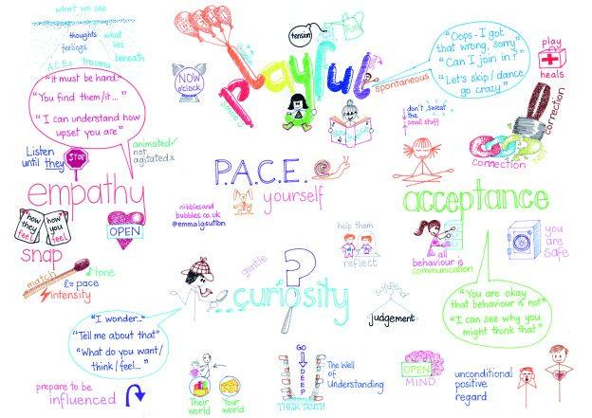
PACE helps children and young people feel more connected to and understood by important adults in their life and ultimately, to slow down their own responses.

We know that children respond best to adults they know well, like and trust. These are generally adults who know the children well, treat them with compassion and actively demonstrate they like them too. Such adults are known as Emotionally Available Adults (EEAs) and we aim to ensure children in our school have access to their EAAs when they need them.

‘The route to exceptional behaviour is not paved with a toolkit of strategies, a bag of classroom management tricks or magic dust from senior leaders. It lies in the behaviour of every adult and their ability to create a culture of certainty.’ (Paul Dix 2017)

Principles of Successful Behaviour Support Policies

We at The Grove School inTotnes, have adopted Plymouth CAST’s strategy which has been informed by the principles and practice advocated by Paul Dix in his books, When Adults Change Everything Changes and After the Adults Change: Achievable Behaviour Nirvana and by the teaching and training of Trauma Informed Schools UK.

To that end, all school leaders are expected to read both Paul Dix books as part of their Directed Leadership Time and each school should have commissioned, via the Trust SEND Lead Officer, TISUK whole school training. By 2025 all schools should have a TISUK practitioner on the staff team and have completed Senior Lead Training.

We know that successful behaviour support is dependent on a number of factors:

- Consistency
- Positive relationships and unconditional positive regard for each other
- Focusing attention on success and positive behaviour not poor behaviour

Our School will develop behaviour support policies which are simple, clear and coherent. We seek solutions to difficulties and are not compromised by process. We recognise individual needs and differences and seek to meet these as they would for pupils who are struggling with maths or English.

School policies will reflect the role that adult behaviour has and ensure that staff behaviour embraces the relational approach that PACE supports.

All pupils will be treated with unconditional positive regard and when behaviour falls below expectations, staff will ensure the pupils are supported without judgement. Systems to address behaviour will be non-shaming and take place away from the sight of other pupils.

Adults will ensure they remain regulated and contained when dealing with incidents or challenging behaviour and strategies should make emotional acceleration more difficult. Praise should be easy and positive.

The Rule of Three

We must remember not to over complicate systems, routines and practice. Over complication generally results in increased confusion, weaknesses in practice and systemic failure, as well as negatively affecting morale.

It is often the case that schools have numerous rules in place. There may be rules for lunch time, rules for the classroom, rules in assembly, rules on the playground, the corridors etc. With that many rules, no one can remember them and therefore they are not applied consistently.

To avoid this, our schools Behaviour Support Policies will follow The Rule of Three. This means that there will be no more than three rules and we recommend that these are:

- Be Ready
- Be Respectful
- Be Safe

These three simple statements can be shared and discussed with children. Schools should explore what this might look like in different contexts in the school. For example, what does it mean to be respectful in the classroom, or in the dining hall? What do we mean by being safe in the corridors or the playground etc. Everyone can then respond appropriately when children fail to reach the standards expected. For example, there is no grey area about running down the corridor - it is not safe. Refusing to come back into the classroom after break is not showing we are ready. It may also be unsafe and disrespectful, but staff should focus on one point.

The management of behaviour is everyone’s responsibility. All staff will be able to remember the three rules and model these in their classrooms, around school, during unstructured times and when outside school with the children.

All adults will be expected to address behaviour when it falls below the high standard expected. Staff never ignore, or walk past, behaviour that falls below the standard expected. All staff will engage, use positive reinforcement and support where appropriate.

Addressing Unhelpful Behaviour

Staff may need to take steps to support children who are not behaving well and failing to meet the standard of any of the three rules.

All staff should operate our stepped approach to sanctions, which allow pupils to identify the next consequence and how they can turn it around.

Pupils for whom this approach is not appropriate will have an individual plan detailing alternative and appropriate systems which work for them.

Engagement with learning is always the primary aim. For most learners, a non-verbal reminder such as a look or a gentle verbal reminder or nudge in the right direction is all that is needed. Praise the behaviour you want to see.

All learners must be given ‘take up time’ in between steps to enable them to turn behaviour around.

Our model policy sets out our recommended steps to follow in more detail.

Our school will develop 30 second scripts which staff can use to address unwanted behaviour quickly and in a non-confrontational manner. The premise of this is to reduce the time spent managing behaviour, avoid being drawn into confrontation or pulled into secondary behaviour and to support consistency.

Three Step Rules:  30 Second Script | 1. You aren’t following the rule about… (one of the three)  2. You have chosen to…. you have two minutes with me to talk…have time out to calm down….  3. Do you remember last week when you? (positive behaviour) That is who/what I need to see today. Thank you for listening.  Walk away/ give take up time/ follow sanctions if needed.

When speaking to pupils about their behaviour, staff will ensure they use a PACEful approach at all times. This will also help to prevent an escalation of the behaviour.

Playful | Accepting | Curious | Empathic
Use a positive, playful tone of voice and hold things lightly– this triggers positive hormones in the  child and can diffuse a situation | Actively accept the emotions underneath the behaviour ‘I accept that you are feeling angry but you cannot…so I need you to stop. I want to help you make sense of this…. but I have to set limits’. | Trying to find out about the behaviour without judgement –  CORRECTION WITH CONNECTION. ‘Will you help me to understand what it was like  for you when…?’ This forms part of ‘walk and talk’ or a restorative conversation and  gives the child a narrative for their behaviour. | Empathise with the child to help them express ‘I wonder if it was like this  when you did…’

Supporting Children with Additional Needs and SEND

Where there is a need due to an emotional difficulty or trauma in a child’s life, our schools may refer to additional intervention. This includes Trauma Informed Schools practitioners, appropriate outreach or groups focusing on social skills and emotional literacy.

This may also result in a need for a personalised approach to supporting behaviour which will follow the overall principles - but be differentiated in outcome.

Our aim is for these children to be as successful in school and life as their peers. This cannot be achieved if they are not in school or are internally excluded. Schools may therefore need to put individual behaviour support plans in place to mitigate the risk of exclusion. This may include provision which is additional and different - for example, time in a safe space, sensory breaks, pastoral support time etc.

All adults, who will be teaching a group of pupils or spending time with them, are personally responsible for knowing a child’s individual needs before teaching them. The school should ensure all staff have accessed the class provision maps, pen portraits or behaviour plans and use the suggestions on these.

Teachers need to use their understanding of the child’s needs to understand what works and what doesn’t work for that child. For example: If a child has ADHD and possibly has difficulty keeping calm and focusing, taking away their playtime could be detrimental to their behaviour for the rest of the day as they are missing vital physical time. There would have to be other steps/approaches in place for that child which should be followed.

Behaviour steps should be adapted to suit the needs of individual pupils. Equity is the aim for these high-needs pupils. Their individual plan and adapted expectations for behaviour should be on their Pupil Profiles, which will be monitored by the SENDCo, Senior Mental Health Leader or other member of SLT. A child’s triggers for negative behaviour need to be on their individual plan so that everyone can be aware of these.

Additional Information

See also:
Staff code of conduct
Whistle blowing policy
Safeguarding and Child protection policy
SEND policy
Promoting good behaviour and relationships guidance
Online safety policy
ICT and Internet acceptable use policy

Twenty-five years of neurobiological research tells us
that children learn best when they feel loved."

Dr Andrew Curran

This strategy is predicated on the principle that our school will
seek every opportunity to demonstrate authentic professional love.

Useful additional reading:
https://www.oxfordshire.gov.uk/sites/default/files/file/children-and-families/PACEforteachers.pdf

Creating Loving Attachments: Parenting with PACE to Nurture Confidence and Security in the Troubled Child by Kim S. Golding and Daniel A. Hughes

The Whole-Brain Child: 12 Proven Strategies to Nurture Your Child’s Developing Mind by Dr Tina Payne Bryson and Dr Daniel Siegel

