 | HISTORY DETECTIVES: TOTNES HIGH STREET
 | KEY DATES
1811  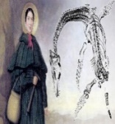  Ichthyosaur fossil discovered in the time of Mary Anning |  | 1837  Queen Victoria became Queen | 1840s  Victorian Beach Holidays became popular |  | 1861  Mrs Beeton’s Victorian Cookbook is published | 1865  The Grove School is built |  | 1901  Queen Victoria died | 1913  Rosa Parks born  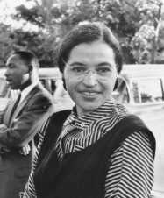 | 1955  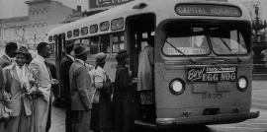  Rosa Parks protested about discrimination on a bus in America | 2009  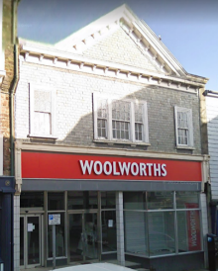  Woolworths | 2011  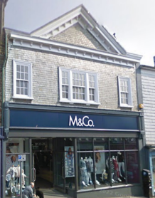  M&Co | 2015  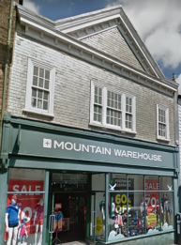  Mountain Warehouse | 2020/21  Started school at The Grove School  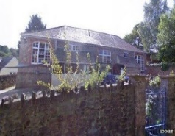
ROSA PARKS |  |  |  | THE VICTORIAN ERA |  |  | TOTNES HIGH STREET
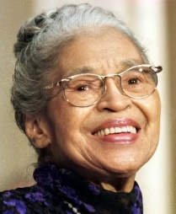  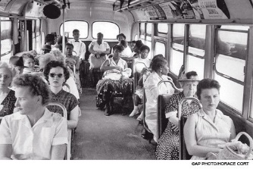  Previous Learning  Rosa Parks Discrimination |  |  |  | Previous Learning  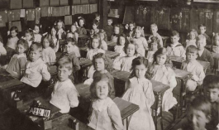  A Victorian school |  |  | 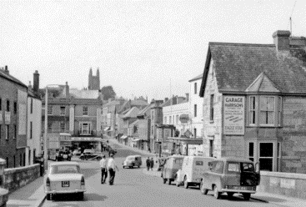  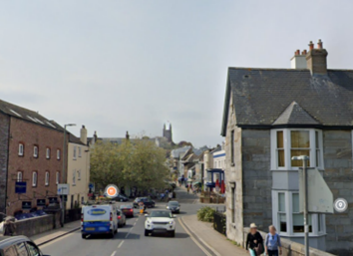  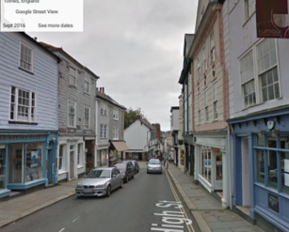  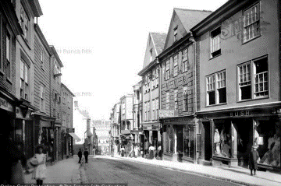  Past Present Old New
 | KEY VOCABULARY
Primary sources Secondary sources High street Change

Primary sources: Information from someone who was there at the time
Secondary sources: Information from someone else (books, online or television)
High street: The main street of a town.
Change: To make something different and replace it

