Key Words  Do we know what these words mean?  material  object  properties  magnetic  man-made  natural  waterproof | Science  Materials
 | Material  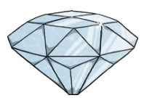  Wood | Made from  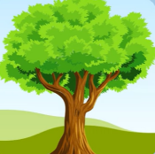 | 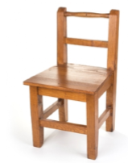  Objects  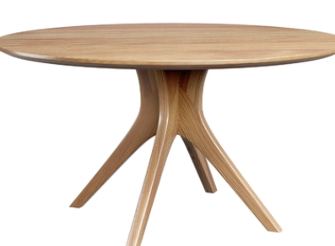
 | Plastic | 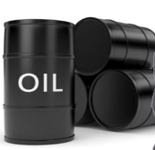 | 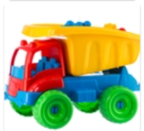  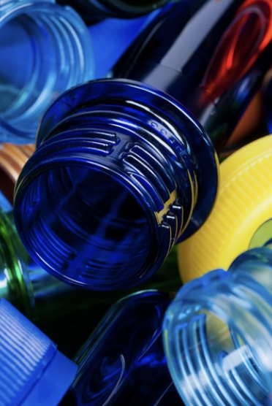
Famous Scientist  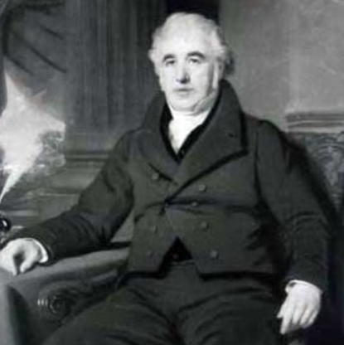  Charles Macintosh is best known for inventing the raincoat. He made rubber spreadable and placed it between two layers of fabric to make it waterproof. | Glass | 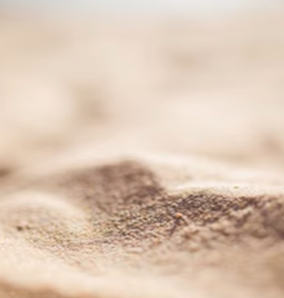 | 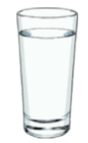
 | Metal | 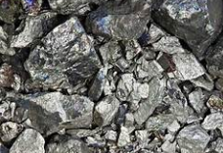 | 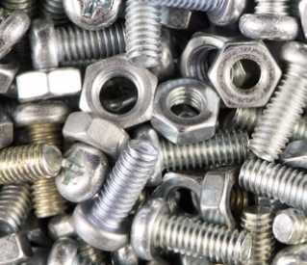
 | Rock | 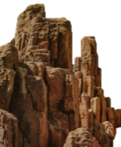 | 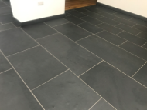
 | Paper | 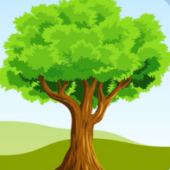 | 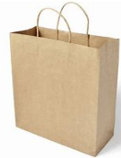  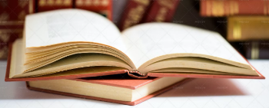
 | Fabric | 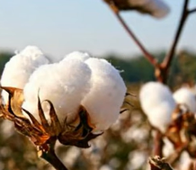 | 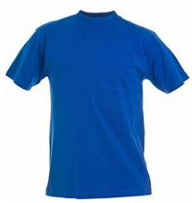  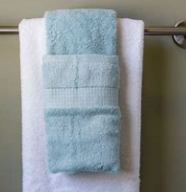
Properties of Materials
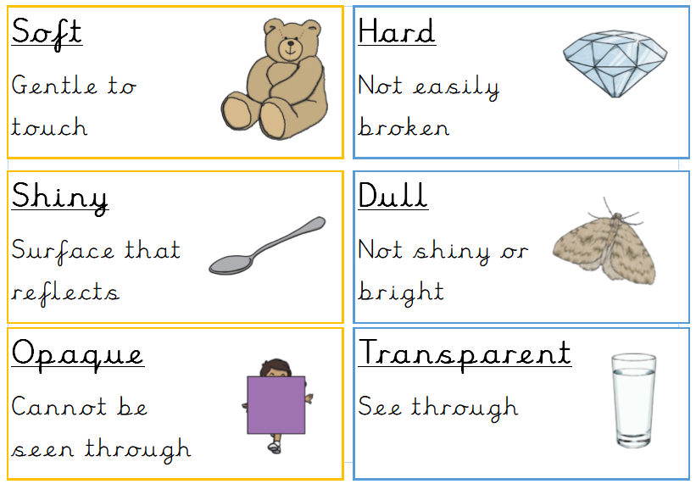
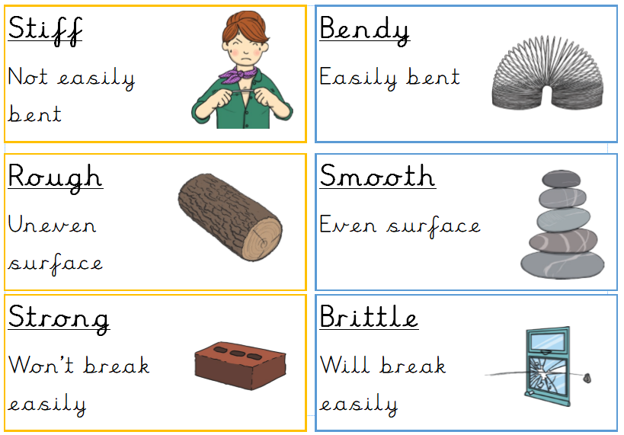

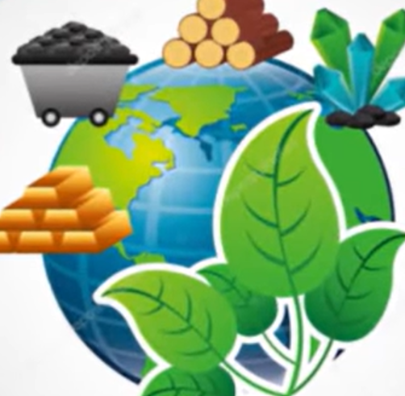  Man-made or Natural  Materials are natural if they come from animals, plants or the Earth.  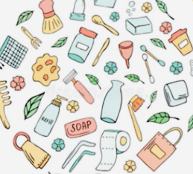  Materials are man-made if they are made by humans through chemical processes. |  | Magnetic  Magnetic materials are always made of metal.  Not all types of metal are magnetic.  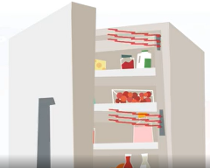  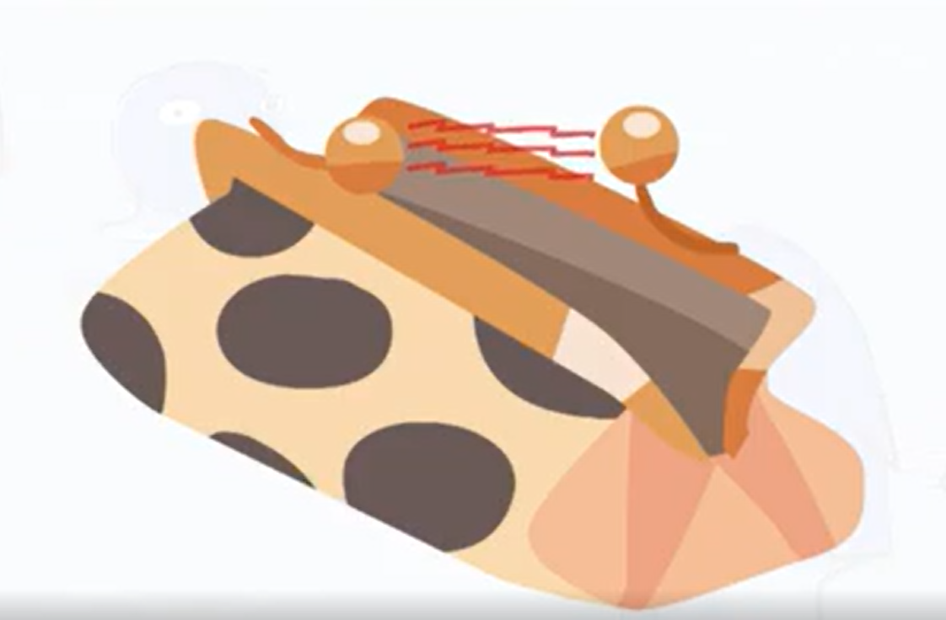  We use magnets every day.

