HISTORY DETECTIVES: MARY ANNING AND FOSSILS
KEY DATES
252 million years ago  Dinosaurs lived in the Mesozoic Era | 1799  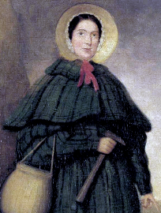  Mary Anning was born | 1811  Ichthyosaur fossil discovered in the time of Mary Anning | 1837  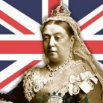  Queen Victoria became Queen | 1847  Mary Anning died | 1865  The Grove School is built | 1901  Queen Victoria died | 1955  Rosa Parks protested discrimination on a bus in America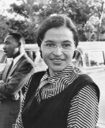 | 2020/21  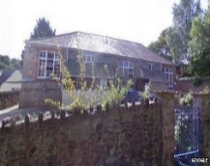  Started school at The Grove School
FOSSILS |  |  |  |  |  | THE VICTORIAN ERA
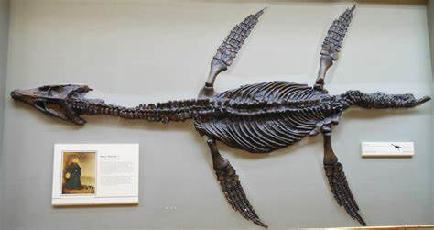  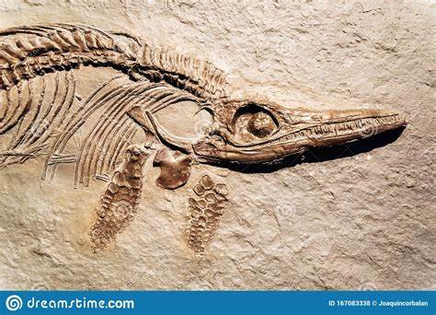  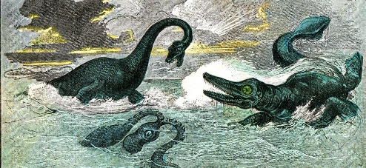  How dinosaurs might have looked Plesiosaur fossil Ichthyosaur fossil  in the Mesozoic Era |  |  |  |  |  | Previous Learning  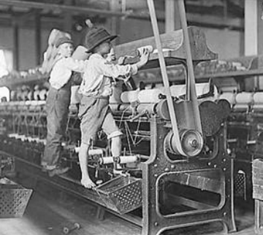  A Victorian school Children had to work if  they were poor
KEY VOCABULARY
Dinosaur: A creature that lived on land many million years ago.
Skeleton: The bones of the body form a framework called the skeleton.
Extinct: No longer exists.
Fossil: The remains or traces of plants and animals that lived long ago.
Palaeontologist: A scientist who studies fossils.
Mesozoic Era: A period of time when dinosaurs lived, 252 million years ago.
Plesiosaur: A marine reptile with a broad flat body, large paddle-like limbs and a long neck.
Ichthyosaur: A marine reptile similar to a dolphin with a pointed head and four flippers.

