Key Words  Do we know what these words mean?  country  Totnes  Plymouth  Torquay  Devon  United Kingdom  England  town  city  harbour  theatre  museum  English Channel  North Sea  Irish Sea  equator  north  east  south  west | Geography - Why is Torquay a holiday destination?  Popular Tourist Attractions | Where is Torquay?  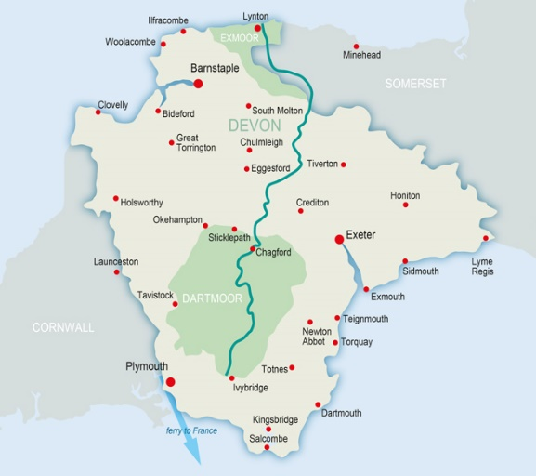  Where is the equator and the North and South Poles?  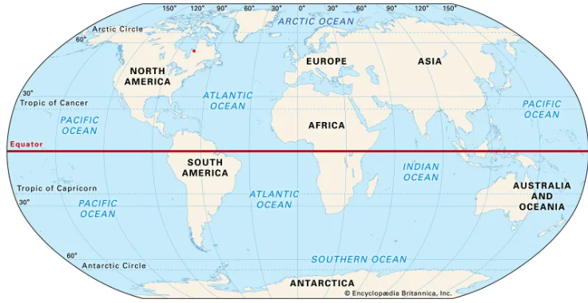
  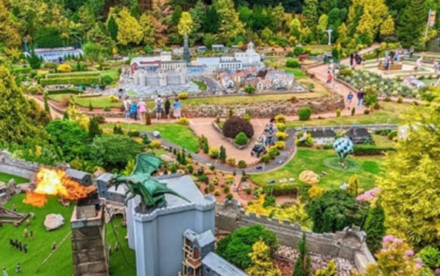  Babbacombe Model Village | 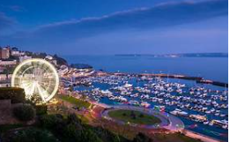  Torquay Harbour  and seafront
  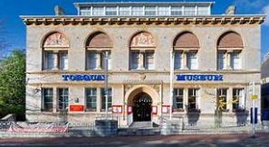  Torquay Museum  Clothes for hot places  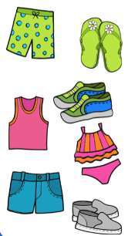 | 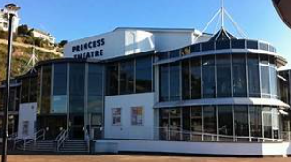  Princess Theatre  Clothes for cold  places  