**Freewrite Homework**

The freewrite is the part of our week where you get to write a story of your choosing. The story doesn’t need to be any longer than one single page.

The story that you write can be about any subject you like. If you can’t think of a subject, there are some photographs at the bottom of the page to help you.

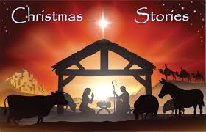 



You stories should be handed into your teacher by Friday 13th December.

We look forward to reading them!