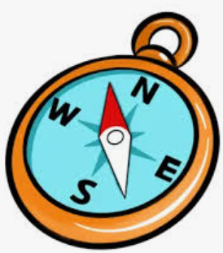

A COMPASS is an important tool for map readers. It tells us which way is North and where to find East, South and West - the 4 CARDINAL POINTS on the compass,

It has a magnetised piece of metal that turns towards the Earth’s North Pole.

In more detail, it’s a [magnetised](https://www.twinkl.co.uk/teaching-wiki/magnetism) piece of metal that will turn towards the Earth’s magnetic north [pole](https://www.twinkl.co.uk/teaching-wiki/pole).

A

TOTNES is in the South Hams area of South Devon. It has a population of about 9000. The first written record of Totnes is from 907 when the first Castle was built.

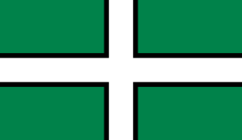

DARTMOOR NATIONAL PARK is the largest area of semi-natural habitat in Southern England. The landscape is varied with many features including tors, rivers, woodlands, settlements and reservoirs.

The rock on Dartmoor is mostly granite, an igneous rock formed by a SUPER VOLCANO 300 million years ago. Many people live and work on Dartmoor and many more visit it every year for recreation

MAPS come in many different types and scales. They can be paper or on a phone or tablet. Some maps show entire countries or continents while others are designed to help people find their way around a town on foot. Specific features or LANDMARKS such as rivers, bridges or castles help the map reader find precise locations.

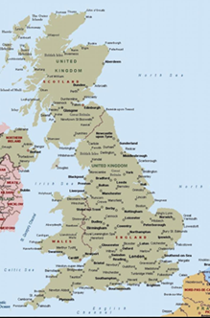 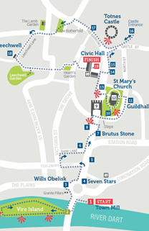

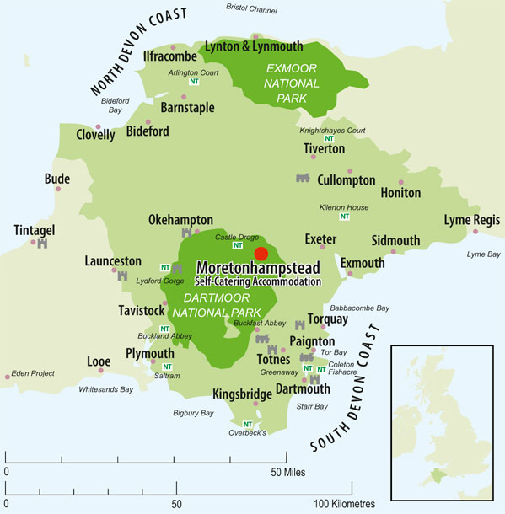

TOTNES and DARTMOOR are connected by the RIVER DART. which flows for 75 kilometres from its’ source on Dartmoor to the sea at DARTMOUTH.

**GEOGRAPHY**

**Totnes and Dartmoor**

MAP SYMBOLS AND KEYS Maps are generally too small to contain lots of writing, Instead, SYMBOLS are used to represent real-life features, such as roads, buildings and important landmarks. The symbol often looks like the thing it represents. For example, a picture of a tent is often used to indicate a campsite. The symbols are included in a KEY.

**SYMBOLS KEY**

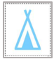 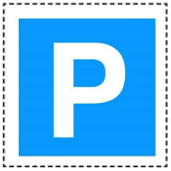

Campsite Car park

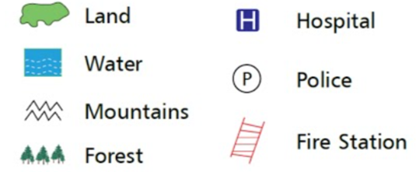

WHAT IS A GEOGRAPHY?

Geography is the study of the Earth. It is split into 2 parts.:

PHYSICAL GEOGRAPHY is the study of natural features. These features would still be here if there were no people!

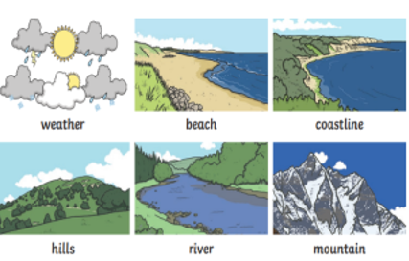

HUMAN GEOGRAPHY studies how people interact with the environment. It looks at things that would not exist without humans. Examples include buildings and towns, roads and railways, wind farms and agriculture.

