Key Words  Do we know what these words mean? | Religious Education  What does it mean to belong to a faith community? Christianity - Christmas
Christian  Jew  Muslim  Religious ceremony  Baptism (Christianity)  Brit Bat/Brit Milah (girl/boy Jewish naming ceremony)  Aqiqah (Muslim naming ceremony) | 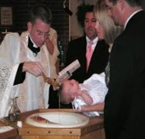  Baptism (Christianity)  Baptism Symbols  The cross, a white garment, oil, water, and light.  Brit Bah/ Brit Milah (Judaism)  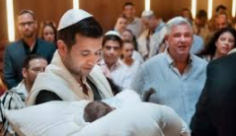  Aqiqah (Islam)  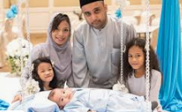 | Symbols of belonging  Christians: baptismal candles, christening clothes, crosses as badges or necklaces, fish/ichthus badges, a rosary, a Bible;  Muslims: an example of calligraphy, a picture of the Ka’aba, a taqiyah (prayer cap);  Jews: a mezuzah, a menorah, a Kiddush cup, challah bread, a kippah), | Advent  When Christians prepare for Jesus’ arrival.  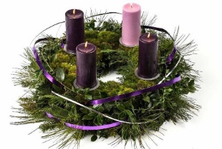  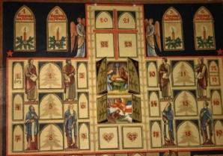  Advent Calendar and Wreath  Nativity Story  The Christmas story is told to Christians.  Angel Gabriel visited Mary and told her that she was going to have a baby and she would call him Jesus.  Jesus was born in a stable in Bethlehem.  Shepherds and Kings visited Jesus and gave him gifts.
Special Book
Christian – Bible
Jew – Tenakh – Torah
(Torah is part of the Tenakh) Muslim – Qur’an
Place of Worship
Christian – Church
Jew – Synagogue
Muslim - Mosque
Christians believe that all people are important to God – The Lost Sheep parable.
Jesus told his friends that they should all love one another.

Jewish teaching tells people they should love thy neighbour.

Muslim teaching say: ‘None of you is a good Muslim until you love for your brother and sister what you love for yourself.
Festivals
Christian – Christmas/Easter/Harvest
Jew – Chanukah/Hanukkah/ Passover/Sukkot
Muslim – Ramadan/Ede

