Anger and 'Bad Moods'
Anxieties, Worries, Fears
Bodies
Dementia and Alzheimer's
Grief and Loss
Kindness
LGBTQ+ Role Models
Moving House
Navigating Friendships
Neurodiversity
School and Nursery
Serious Illness
Shyness
Siblings / A New Baby
Sleep and Bedtime
Understanding Feelings and Emotions
War and Displacement
Celebrating Difference
Poverty and The Cost of Living
Unconditional Love
The Environment
Community

Separation and Divorce
Mindfulness/ Slowing Down

Anger and ‘Bad’ Moods

THE BIG ANGRY ROAR (Jonny Lambert)
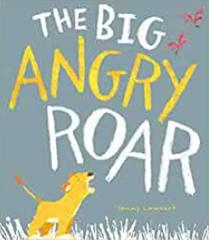
The fun word play and collaged characters in The Big Angry Roar (Little Tiger, 2022) work in perfect collaboration for a little cub’s journey through the savannah as he finds a way to let out his anger. When Cub has sibling troubles, and gets so angry he thinks he might POP, he sets off to find a solution. But stamping and stomping and bashing and crashing only make him angrier. Through Jonny’s characterful illustrations and dynamic text, Cub learns that everyone gets angry and that’s ok, but it is important to find a way to let his anger out.
Cub’s solution feels expected initially – with deep breaths in and out – but ends with funny faces and giggles. Soon Cub feels much better and apologises to his sibling for a suitably heartfelt ending.

SWEEP (Louise Grieg, Júlia Sardà)
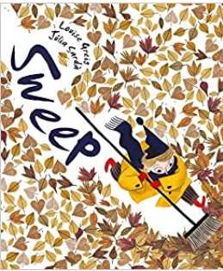
Sweep (Egmont 2018) is a wonderful story about what can happen if you let a bad mood get the better of you. Ed and his bad mood sweep, sweep, sweep through the town until his emotions grow and gather so much pace the town is dark and Ed is tired and hungry.
In this poetic, uplifting story, Louise Greig and Júlia Sardà use a suitable visual metaphor to show readers what can happen when you try to sweep your troubles away. Perfect for helping children learn to recognise and deal with big emotions.

BARBARA THROWS A WOBBLER (Nadia Shireen)
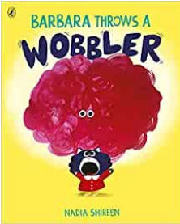
Barbara is the protagonist of Nadia Shireen’s Barbara Throws a Wobbler (Puffin 2021) who is having ‘one of those days!’ After a sock problem in the morning and a strange pea at lunchtime, her day goes from bad to worse, resulting in the appearance of a wobbler - a red, jelly-like cloud that emerges above Barbara’s head!
With patience, understanding and a dollop of humour, Barbara overcomes her wobbler, squishing it until she can hold it in her paw and POP! It vanishes! She’s goes back to the park where her friends are waiting, and where the reader is let into a secret. Everyone has wobblers from time to time.
Nadia’s playful, exaggerated illustrations convey the characters’ exasperation, hurt, and eventual delight at the newfound empowerment over her feelings. The humour is laugh out loud and perfect for the age group (and for adult readers, too!)

ANXIETIES, WORRIES, FEARS

PARACHUTE (Danny Parker, Matt Ottley)
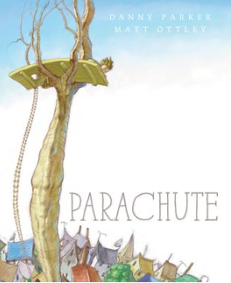
Parachute (Eerdmans, 2016) is a picture book story about a little boy who always wears a parachute wherever he goes. It makes him feel safe in case danger strikes.
But when his parachute is used to save someone, the boy learns to be brave and use his parachute less and less.
This story would be great for encouraging children to take small steps of courage out of their comfort zone.

THE VISITOR (Antje Damm)
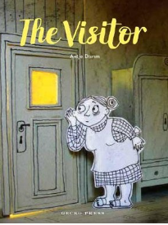
The Visitor (Gecko Press, 2019) is a truly glorious picture book starring Elise who is scared of everything, so never goes outside. But one day something blows in through the open window - a paper plane! When a boy comes along to collect it, he looks around and makes conversation with Elise, who ends up reading to the boy. Not content with a story, the boy also wants to play.
The 3D illustrations - cut out characters that move through hand-made paper scenes - are original and highly effective. There's a beautiful contrast between the dark of Elise's house and the warm yellow of the outside.
At the end of the story, Elise still lives alone, but thanks to Emil, the unexpected visitor, she has reconnected to her childhood. The illustrations intimate that she might have a plan to venture out and meet people again. A unique and subtle story about facing fears.

THE WORRY JAR (Lou John and Jenny Bloomfield)
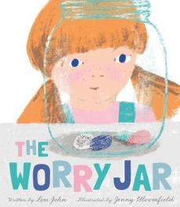
The Worry Jar (Oxford University Press, 2022) is a story about a little girl, Frida, who worries all the time. Little worries, big worries… all relatable to small children, from not knowing who to sit with in class to knowing what to wear. Some days, Frida’s worries become the only thing that Frida can think about. They weigh her down, just like the pebbles she collects in her pockets each time they appear. Then one day her granny teaches her an amazing trick to manage her fears.
This book has a subtle message of consciously choosing not to let worries take over and suggests a helpful way for children to do just that – their own worry jar, a place to keep worries so they are lighter and free to enjoy life.

EVERYBODY HAS WORRIES (Jon Burgerman)
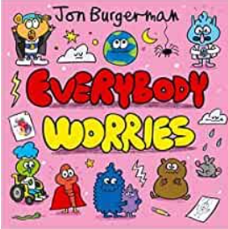
Big and small, we all have worries and that’s ok, because the friendly and exuberant characters in Jon Burgerman’s Everybody has Worries (Oxford University Press, 2021) give us reassuring and practical advice about how to deal with worries as they arise. The helpful tips, endorsed by clinical psychologists, are combined with fun rhyming couplets and colourful pictures to help children open up about their feelings and get anxiety under control. Indeed, in Jon's typically vibrant and fantastic style, this story shows readers there are many ways to support each other and that we are not alone in the struggles we face.
The book has been used to help children during the Coronavirus pandemic, but this is not specifically mentioned in the text, making it a relevant story for all families hoping to soothe worries and ease anxiety.

DRAMA LLAMA (Rachel Morrisroe, Ella Okstad)
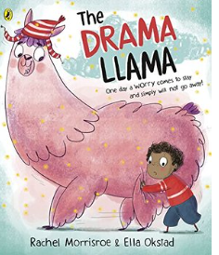
‘One day a worry comes to stay, and simply will not go away!’
Rachel Morrisroe and Ella Okstad’s Drama Llama (Puffin 2022) sees Alex Allen – a super worrier – with a seriously silly llama problem. The more Alex worries, the bigger the llama grows! Rachel’s snappy, energetic verse is dynamic and fun, while Ella’s illustrations— of the bright, pink, fluffy llama — are hilarious.
The ending has a powerful takeaway about living with a llama, rather than getting rid of it completely, meaning readers will not only be full of smiles but also empowered to share their worries. At the very back there is some further advice for managing worries.
SUPERHEROES DON’T GET SCARED (OR DO THEY?) (Kate Thompson, Clare Elsom)
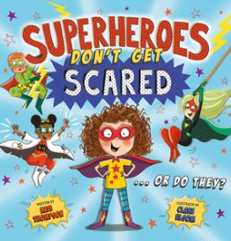
Superheroes Don’t Get Scared (Or Do They?) (Welbeck, 2020) is an important story for young readers, told in a lively, dynamic rhyme. In this fast-paced but sensitive story, Maisy Brown learns that even the strongest and bravest heroes get scared sometimes, giving this story an empowering message for all wanna-be superheroes – we all get scared sometimes! Because bravery isn’t the absence of fear, it’s feel afraid and doing it anyway.
As well as a poignant message for little ones, this book is also a great story – with fun and memorable characters, including Burpnado, Specstacular and Bogey Boy, and lots to enjoy in the bright and colourful illustrations. All in all, a great book to share with a child who needs a little encouragement to take a big step.
SPLASH! (Claire Cashmore, Sharon Davey)
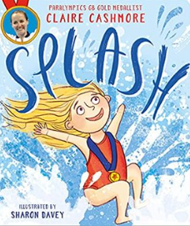
These are Claire's big sisters.
They call her Bear and ruffle her hair.
And whatever Claire's sisters can do,
Claire can do too...
But there is one thing Claire can't do!
Splash! (Farshore, 2021) is an empowering picture book following main character, Claire, as she navigates her worries around water. Claire would rather eat a pickle sandwich or be chased by a (real) bear than dip her toe in the swimming pool. But she learns to face her fear and is suitably proud of herself. Claire pushes herself further, entering swimming races. She doesn't succeed immediately, learning a very important lesson – what she can’t do today, she’ll conquer tomorrow.
Author, Claire Cashmore, MBE and Paralympic gold medallist, was born without a left forearm – but she never let being different stand in the way of her big dreams. Her foreword explains that Splash! is partly inspired by personal experience as well as a lack of representation of people with a disability in books.
Sharon Davey’s joyful illustrations bring the story alive. The characters are bold but warm, reaffirming the fun and positivity rippling through this text.
ME AND MY FEAR (Francesca Simon)
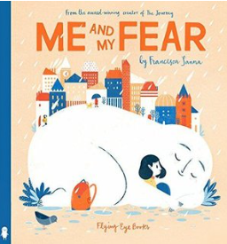
The main character in Me and My Fear (Flying Eye, 2018) has a secret - a tiny friend called Fear who keeps the girl safe and helps her explore new things. But when the girl moves to a new country, starts a new school and doesn't speak the language, settling in is difficult and the girl's personified Fear stops her doing things like playing and joining in. Fear even stops her from sleeping and the main character feels increasingly sad and lonely.
When a new boy reaches out, Fear shrinks and things improve. When the girl realises he has a secret fear too, their bond is strengthened. Things are still tricky at the new school – it takes time to adjust to big changes - but now the girl knows everyone has a little fear.
This book shows children that fear is important for keeping us away from danger, but also empowers them to manage their worries and mental health. We are all afraid at sometimes.

TIMID (Harry Woodgate)
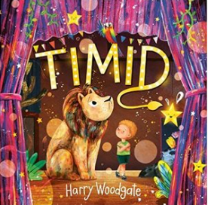
Timid! (Little Tiger Press, 2022) tackles shyness and finding the courage and strength to overcome our worries and nerves. It also has some incidental non-binary representation too which is sadly lacking in children’s picture books. It’s an adorable story and Timmy’s friend, Nia, provides support and encouragement throughout.
It’s a book full of sparkly, theatrical costumes, bright, modern illustrations and a strong reminder that we can do anything we put our minds to!

BODIES

EVERYBODY HAS A BODY (Jon Burgerman)
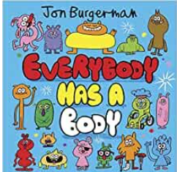
‘Everybody Has a Body’ (Oxford University Press, 2020) is bright and colourful book from Jon Burgerman that shows us everyone's bodies are different in some way - and that's OK! The rhyming texts delivers the message that whether your body is big, small, short or tall, it is something to celebrate and be proud of. The vibrant illustrations feature a diverse mix of characters including some with glasses and others in wheelchairs.
With eye-popping illustrations full of humour and colour, and an inclusive message about being perfect as you are, this story is packed with positivity. It would be a great book to share with children with and without disabilities. After all, we are all different and special.
WHAT HAPPENED TO YOU? (James Catchpole, Karen George)
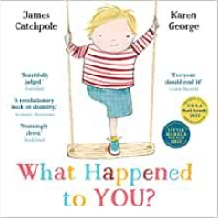
What happened to you? Was it a shark? A burglar? A lion? Did it fall off?
A positive and ground-breaking picture book featuring Joe – an imaginative main character who loves to play and who has one leg. What Happened To You? (Faber and Faber, 2021) aims to inform and educate non-disabled children about disabilities by acknowledging the challenges Joe faces… and the questions. One question in particular – what happened to you?
James’ text balances humour and message brilliantly. Karen’s characterful illustrations evoke childhood and the joy of imaginary play. And at the end of the story, the children in the book decide they don’t need to know what happened to Joe’s leg to play with him, and everyone is happy with that.

DEMENTIA AND ALZHEIMER’S

I REMEMEMBER (Jeanne Willis, Raquel Catalina)
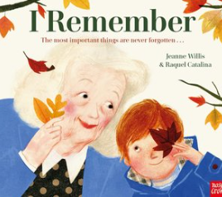
The Most Important Things Are Never Forgotten.
I Remember (Nosy Crow, 2022) is a timely and heartfelt picture book about the intergenerational friendship between George and his Granny, Kathleen. Kathleen is quite forgetful. Sometimes, she can't even remember George's name. But George doesn't mind. Together they play in the garden, dance, and share chocolate biscuits. Granny might not always remember the little things, but George knows she loves him more than words can say.
This story, which reads like an intimate conversation between the two characters, is an accurate look at how dementia can affect a loved one. It's also a celebration of the unforgettable love between a grandparent and grandchild, proving that even though the mind can sometimes forget, the heart will always remember. Raquel's illustrations draw us into the tender moments, bringing the relationship to life with tenderness and warmth. This is a special book to help little ones understand dementia.
THE FORGETTERY (Rachel Ip, Laura Hughes)
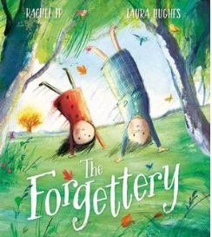
In Rachel Ip and Laura Hughes’ The Forgettery (Farshore, 2021) Amelia and her granny go for a wander in the woods when they stumble upon the Forgettery – a magical place where lost memories are stored. The lyrical text takes the reader on a real adventure as the characters discover a magnificent treehouse with ladders, door, a hot air balloon and memory keepers who look after lost things. Some memories are paper-thin like butterflies. All Granny’s lost things are there, who is living with significant memory loss, but so are Amelia’s, strengthening their relationship and the intergenerational connection between them.
Rachel’s poetic storytelling is complimented beautifully by Laura’s wistful artwork. A tender tale about where lost memories go that could initiate discussions around memory loss, including dementia and Alzheimer's for very young children.
THE TIDE (Clare Helen Welsh, Ashling Lindsay)
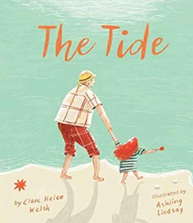
Grandad doesn’t remember things like he used to. But I love him as much as I always have. And I know that he loves me.
The Tide (Little Tiger Press, 2019) is an important and powerful story about families, laughter, and how we can help a loved one with dementia live well. Ashling’s illustrations are atmospheric and full of love and warmth, creating a thoughtful and reassuring picture book that is perfect for children who have a loved one with dementia or Alzheimer’s.
"What I adore about The Tide most of all is that it celebrates Grandad – truly celebrates who he is... [It] conveys a wonderfully clear description of dementia – put into language that can be understood by all. It celebrates families, and their love and support for one another." -- My Book Corner

GRANDMA (Jessica Shepherd)
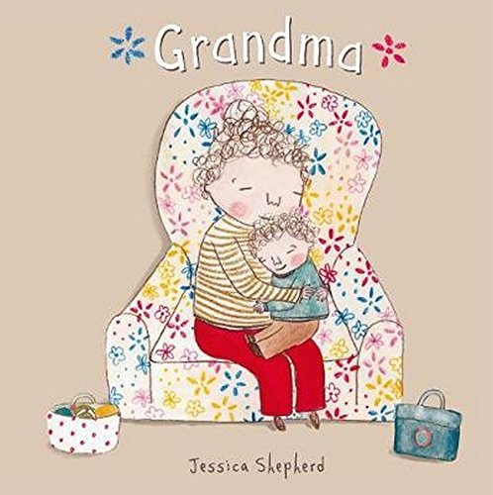
Full of touching moments, Grandma (Child's Play, 2014) is a picture book story about a child and their grandma, following Grandma as she moves to a ‘special home’ where she will get all the care she needs. It’s not a walk in the park. Grandma has dementia and that is sometimes upsetting, but the child knows they have friends and family who will look after them, and even when Grandma has bad days, she is still the best grandma in the world.
This is a well-observed and child-like look at dementia. What is especially lovely is the double page map of Grandma’s new home, which looks and smells different, that resembles a child's drawing. In fact, all of Jessica’s illustrations have a child-like innocence to them, adding to the child centred approach.
At the back of the book are some helpful facts about dementia and getting older, all written in a way that children can access and process. The child reader feels front and centre throughout, which is a big strength of this book, making it a reassuring and important read at a time when they might be struggling.

GRIEF & LOSS
CRY HEART BUT NEVER BREAK (Glenn Ringtved, Charlotte Pardi, Robert Moulthrop)
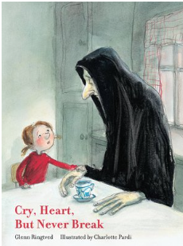
Cry Heart But Never Break (Enchanted Lion Books, 2016) is a story about a group of children who are preparing to lose their much-loved grandmother. One day Death visits them and they know he has come for her. They attempt to make a plan to save their grandmother, but don’t succeed and the children ask Death why she has to die. Death tells them a story about Joy, Delight, Grief and Sorrow living in harmony together. "What would life be worth if there was no death? he concludes.
This picture book deals with the loss of a loved one in a poignant and accessible way. The children always remember their grandmother but learn that life moves on and not to fear death. The illustrations add to the honest tone and directness, making this a beautiful means of explaining death, dying, loss and mourning. Death's story within the story perhaps means this is more accessible to older children and adds another layer of complexity for readers to unpick through discussion with an adult.
DADAJI’S PAINTBRUSH (Rashmi Sirdeshoande, Ruchi Mhasane)
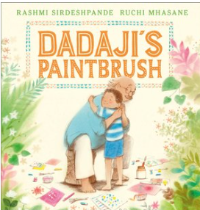
Dadaji’s Paintbrush (Andersen Press, 2022) is a stunningly beautiful picture book about a young boy in a tiny Indian village who loses his grandfather. Dadaji and the boy spent all their time together, creating art, tasting delicious fruits and making paper boats to float down the monsoon river. But after Dadaji passes away, the boy can’t bear to use the favourite paintbrush his grandfather left him.
It takes the arrival of a little girl who wants to know how to paint for the boy to see that losing a loved one can be a beginning instead of an end.
Rashmi’s text is beautifully lyrical and evocative of the Indian village setting. Ruchi’s illustrations are dreamy and gorgeously soft, adding to the love that beams through the pages of this book.
A tender, hopeful story for any child - any family - experiencing bereavement.
THE MEMORY TREE (Britta Teckeuntrup)
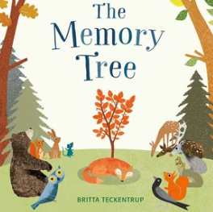
The Memory Tree (Orchard Books, 2014) is a powerful story featuring a group of animals that gather after their friend, Fox, dies. Fox has lived a long and happy life. As the animals recall their fondest memories of him, their sad hearts fill with warmth. The animals begin to notice a small and delicate plant growing in the place where Fox died. The animals continue sharing memories and a magnificent tree grows, helping the animals to see that Fox is still a part of them even after he has died.
The Memory Tree becomes a beautiful and accessible metaphor, showing little readers how the people we love can live on in the memories we have of them. A simple but tender and highly effective story for young children living with grief, that lends itself to planting something in memory of a loved one and reliving the actions of the characters in the story.
DADDY’S RAINBOW (Lucy Rowland, Becky Cameron)
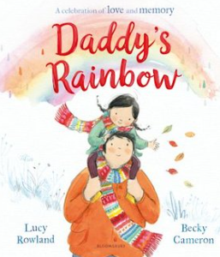
Daddy’s Rainbow (Bloomsbury, 2022) is a pitch perfect, important story for a child whose parent is terminally ill.
Lucy – usually known for her dynamic rhyme – writes this story beautifully in prose. It’s heart opening stuff, full of fantastic details about Erin's daddy, who sees the colour in everything. ‘In autumn, their walks were full of crunchy red, scrunchy orange and shiny-conker brown.’ But things start to change and Mummy tells Erin that Daddy is poorly.
This story was inspired by a real life Erin who Lucy knows and is close to. It shows. Emotions pour from the pages. Becky’s light watercolour illustrations are also full of love and feeling, with a soft, fragile touch, significant for any family finding themselves in this situation.
Despite the sadness and rawness felt when Daddy dies, the story ends with the reassuring takeaway that our loved ones live on in the memories we share and in the colour they gift to the world. Perfect for families who look to rainbows as a reminder of the people they’ve lost.
THE POND (Nicola Davies, Cathy Fisher)
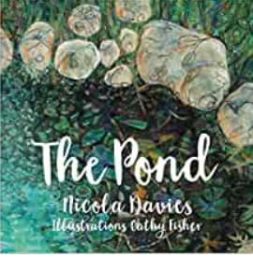
The Pond (Graffeg, 2018) is a heart wrenching story about a family struck by grief. Dad leaves a muddy, messy hole in their hearts and in their garden – a hole that was supposed to be a pond filled with tadpoles and dragonflies and water lilies.
At first the family considers filling the hole in, so no-one would ever know.
But Mum gets a liner and some stones and the family fill the hole with water. Soon a change happens and the pond becomes a vehicle for the family to talk and remember Dad.
This picture book is pitched for slightly older readers. It opens up discussion and space for the very raw feelings that come with bereavement of a loved one, especially a parent, reminding us that hope and the love of the ones we miss is there if we look for it, just like the life bubbling under the surface of a pond in the Spring.
Beautiful. Lyrical. Powerful.
THE RIVER (Tom Percival)
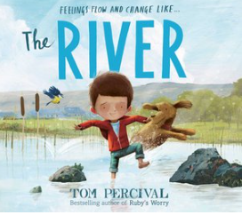
The River (Simon and Schuster, 2022) uses beautiful imagery to help children deal with grief. Stunning illustrations combine with a simple lyrical text to give comfort to young readers who may be coming to terms with loss. It’s an emotive story about friendship, grief, healing and kindness.
Rowan loves playing outside with his dog and particularly loves being by the river. But one cold winter Rowan’s dog dies and the river freezes. Rowan feels cold and alone and his parents find it hard to comfort him. But rescuing and caring for an injured bird helps Rowan start to come to terms with his loss.
The frozen river represents Rowan’s grief after the death of his beloved dog. The dog’s death is only shown in the illustrations and not mentioned in the text. It’s a fabulous example of how words and pictures work together to tell a story and how often images can be more powerful than words.
The River is a heart-warming, thought-provoking story that can be used to stimulate conversations about love and loss at home or in the classroom. At some point many children will experience grief and the story sensitively helps them to understand these feelings. The river in the story is a character in its own right and provides a metaphor for Rowan’s emotions. Sometimes it’s calm. Or playful. Or angry. But as Rowan comes to terms with his loss he realises that, just like the river, his own emotions are ever changing.

LEAVES - A STORY OF THE SEASONS AND THE CIRCLE OF LIFE (Stephen Hogtun)
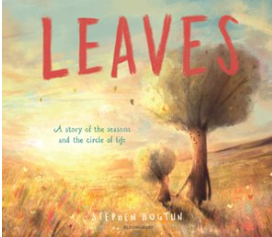
"I will always be with you.
Each time the wind blows,
in your leaves is where you'll find me . . ."
Leaves (Bloomsbury 2021) is a visually stunning picture book, sensitively tackling the circle of life in an accessible way for children. The words are carefully chosen and the illustrations are warm and comforting, as we follow a young sapling's elder towards the end of their life.
The message running through the pages advocates that whilst parents grow old, they leave us strong enough to survive in their absence, with happy memories and a love to help sustain us. An invaluable picture book with a message of unconditional and enduring love.

KINDNESS
ONE TINY DOT (Lucy Rowland, Gwen Millard)
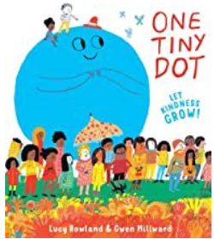
There once was a dot, who was really quite small,
walking along and not minding at all
that it wasn't that big or that bold or that tough,
for this dot was KINDNESS and that was enough.
Kindness comes in all shapes and sizes in One Tiny Dot (Templar, 2022) an uplifting and inspiring book about a dot that morphs into all sorts of different forms as it spreads joy. The power of kindness is explored in a distinctive and deceptively simple way as we witness kindness overcoming anger and sadness.
A beautiful book with a strong and important message.

KINDNESS GROWS (Britta Teckentrup
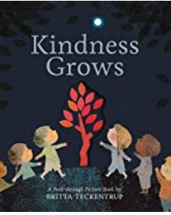
In Kindness Grows (Little Tiger, 2019), the reader can pore over beautiful peek-through pages as kindness grows from a tiny sapling into a beautiful tree via acts of thoughtfulness, sharing and working together. Told through Britta’s stunning illustrations and soothing rhyme, we also see a story line about what happens to unresolved anger. On the left-hand side of each spread are children arguing, leaving each other out and refusing to share.
The story resolves with the children on the right-hand side of each spread reaching out to the children on the left-hand side, and them meeting through a doorway of light. A powerful illustration of what a small act of kindness can do, and stunning production.

SUPERHEROES ALWAYS FIGHT BACK... OR DO THEY? (Kate Thompson, Clare Elsom)
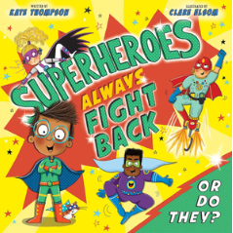
Superheroes Always Fight Back... Or do they? (Welbeck, 2023) is a picture book masterpiece! Beautifully illustrated and wonderfully written, this fun and lively rhyming story follows Arthur who dreams of being a mega-fast, super strong superhero so he can banish the baddie next door.
But when Grandpa explains that the best superheroes actually save the day by being kind, Arthur realises that we all have a superpower inside us - kindness! It's a message every family and every child will be able to relate to, delivered through plenty of action and with a fun cast of characters. The incidental representation of inclusive characters is also very welcomed.
This dynamic, accessible and empowering story is truly impressive. It will show little readers that kindness is truly the most amazing superpower and it's all you need to save the day... and change the world!

THE WOODCUTTER AND THE SNOW PRINCE (Ian Eagleton, David Ortu)
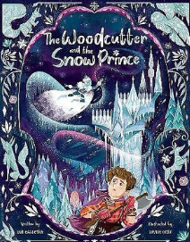
The Woodcutter and the Snow Prince (Owlett Press, 2022) invites young readers to enter the world of a lonely woodcutter named Kai, who carves statues for passers-by each winter. One magical night, Kai is visited by the much-feared snow prince who has a heart of ice. But Kai sees hope in the prince's eyes.
This very unique picture book sees Kai break the snow prince's curse, freeing him from the ice-palace where he has been imprisoned, and freeing himself from his loneliness, too. Kai shows immense bravery, succeeding against the odds, leaving the reader feeling uplifted and empowered.
Ian's soothing and lyrical text perfectly depicts the nuanced emotions and wintry scenes. Davide's illustrations portray danger and adventure, whilst also sprinkling the story with a special friendship that glistens and shines like snow.

LGBTQ+ ROLE MODELS
TIMID (Harry Woodgate)
Timid! (Little Tiger Press, 2022) tackles shyness and finding the courage and strength to overcome our worries and nerves. It also has some incidental non-binary representation too which is sadly lacking in children’s picture books. It’s an adorable story and Timmy’s friend, Nia, provides support and encouragement throughout.
It’s a book full of sparkly, theatrical costumes, bright, modern illustrations and a strong reminder that we can do anything we put our minds to!
FOREVER STAR (Gareth Peter, Judi Abbot)
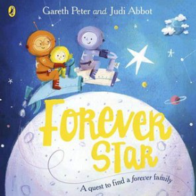
This is the dark and starless sky, where just past the moon a planet drifts by.
And this is the planet that's full to the brim, with friendly and caring space people called . . . TIM!
Gareth is so passionate about creating books which encourage early conversations about the experiences of LGBTQ+ families for the youngest readers and Forever Star, illustrated by Judi Abbot, is a charming, soothing, and calming story about adoption.
In the story we meet Tim and Tim - a couple who long for a family and set off on a quest to find their very own star child. Tim and Tim’s adoption journey is told against a beautiful backdrop of shimmering stars, expansive galaxies, friendly aliens and colourful planets and Judi Abbot’s artwork is full of imagination and magic.
It’s a moving story where foster carers and foster homes are presented in a loving and positive manner. A great book to introduce the concept of adoption in a loving, gentle way.

YOU NEED TO CHILL (Juno Dawson, Laura Hughes)
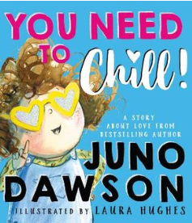
Author Juno Dawson is a super role-model for queer kids and You Need To Chill (Farshore, 2022) is an inclusive, bold, and funny read. When Bill can’t be found at school one day, the imaginations of the other children run wild. Is he on holiday? Is he lost in the park? Has he been eaten by a shark? Has he been taken to Mars by aliens? It’s up to Bill’s sister to explain…Bill is now Lily and if anyone has a problem with that, then they just need to chill!
The story makes it very clear that Lily is still the same brilliant, kind and clever sibling they’ve always been. Lily's family wrap her up in so much love and acceptance and that it’s the children that lead the way in setting an example about how to include others. Laura Hughes’ warm, lively illustrations are the perfect accompaniment to the bouncy, rhyming text.
NEN AND THE LONELY FISHERMAN (Ian Eagleton, James Mayhew)
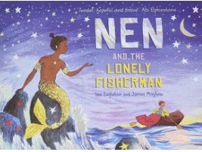
This beautifully illustrated story of loneliness and love, celebrates merman Nen and his new friend Ernest who find each other, and happiness, despite the odds stacked against them.
Far out to sea and deep below the whispering waves lives a merman called Nen. Nen spends his days exploring his underwater kingdom, but something is missing: his heart is empty. So, Nen ventures to the forbidden world above and it is here that he meets Ernest, a lonely fisherman.
With echoes of traditional tales, such as The Little Mermaid, this clever, poignant and beautiful book is packed with soothing language and beautiful imagery. An inclusive, hopeful story about love, friendship and acceptance, with a subtle thread about how to treat the ocean.

MY DADDIES! (Gareth Peter, Garry Parsons)
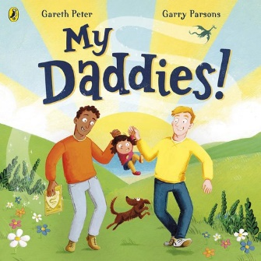
My Daddies (Puffin, 2021) is a lovely celebration of imagination and stories as well as adoption and LGBTQ+ families. Battle dragons, dodge deadly dinosaurs, zoom to the moon and explore the world in a hot air balloon, before winding down in a wonderfully cosy bedtime ending.
The joyful rhyming text and artwork is full of life. The story was inspired by Gareth Peter’s own experience as a parent within a same-sex couple. This would be a wonderful and important to read with any child, in order for them to see all different kinds of families that exist.

MOVING HOUSE
THE COMET (Joe Todd-Stanton)
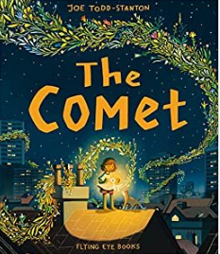
When Nyla has to leave to the city so Dad can get a job, the main character first person states that the new place is definitely not home. There aren’t hardly any stars to count and there are no sounds of the sea to fall asleep to.
But one night, Nyla sees a comet. She follows it and something magical happens. A tree grows and grows, showing her that together with her dad, she can make new memories and a new home in the city.
The Comet (Flying Eye, 2022) features luminously beautiful and detailed pictures that are a delight to pore over, with lots of things for little readers to spot. The artwork has a distinctive feel, almost like a graphic novel or animation stills. The storyline features a single parent family, with a takeaway of finding light in dark times. A great story to share with any child facing a big change.
MOONCAT AND ME (Lydia Corry)
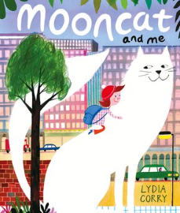
Pearl is moving house and she is not looking forward to it. Mum tells her it will feel normal soon, but she isn’t sure. On arrival, a huge fluffy cat as bright as the moon appears outside Pearl's window! Mooncat changes everything. Now Pearl doesn't feel quite so small. In fact, she is bigger and bolder and braver. Before long, Pearl even feels ready to give her new school a try.
What is especially nice about Mooncat and Me (Two Hoots, 2022) - aside from the gentle first person voice, the Mooncat friendship and the gorgeously soft and bright illustrations - is the empowering ending. Even when Pearl can’t see Mooncat, she learns he is with her. Even when she doesn’t feel brave, she is, meaning there is no stopping her in her new home.
This book is perfect for children moving house and/or starting a new school, but also for any child who gets the wobbles from time to time.
ME AND MY FEAR (Francesca Simon)
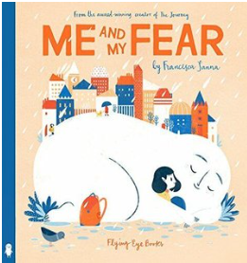
The main character in Me and My Fear (Flying Eye, 2018) has a secret - a tiny friend called Fear who keeps the girl safe and helps her explore new things. But when the girl moves to a new country, starts a new school and doesn't speak the language, settling in is difficult and the girl's personified Fear stops her doing things like playing and joining in. Fear even stops her from sleeping and the main character feels increasingly sad and lonely.
When a new boy reaches out, Fear shrinks and things improve. When the girl realises he has a secret fear too, their bond is strengthened. Things are still tricky at the new school – it takes time to adjust to big changes - but now the girl knows everyone has a little fear.
This book shows children that fear is important for keeping us away from danger, but also empowers them to manage their worries and mental health. We are all afraid at sometimes.

THE SUITCASE (Chris Naylor-Ballesteros)
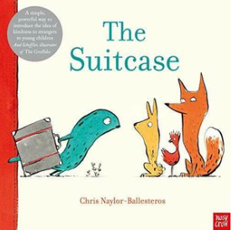
The Suitcase (Nosy Crow, 2020) is a simple but inspiring story to start conversations about migration with young children. With everyone, in fact. A strange-looking creature appears with a suitcase and the other animals in the story are uncertain about them. The creature has travelled for a long time and has come a long away. While the creature sleeps, the other animals break open their suitcase to find out more about them.
The economic speech and use of white space add to the poignancy of this story, and to the takeaway that we should treat displaced people with empathy and kindness.

LUBNA AND PEBBLE (Wendy Meddour and Daniel Egneus)
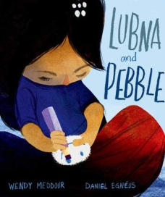
‘Lubna and Pebble’ (Oxford University Press, 2019) is a beautiful and powerful story about two children and a pebble that have fled their home, who find friendship ‘in a world of tents.’
Lubna finds the pebble on the beach when they arrive in the night, and she falls asleep in Daddy's salty arms. Pebble always listens to her stories and smiles when Lubna feels afraid. But when a lost little boy arrives, Lubna understands that he needs Pebble even more than she does.
This is a beautifully illustrated story, evoking all the emotions of this unknown and uncertain world. The writing is full of gentle but powerful emotive language. Overall, it's a very moving story of kindness, hope and friendship despite challenging times.
WILD FOR WINNIE (Laura Marx Fitzgerald, Jenny Løvlie)
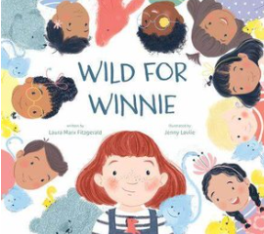
Winnie is no ordinary child. She sees, hears and views the world differently, which makes starting a new school challenging. It's also a bit difficult for the other children in the class. But when the teacher suggests they try things from Winnie’s point of view, they realise that what Winnie needs is to feel included in their world, on her terms—not theirs.
Wild for Winnie (Dial Books, 2022) is a story filled with useful ideas and interventions that prevent Winnie from being excluded from school with her peers, including time to monkey around outside and calm spaces.
At the end of the book there are some carefully considered suggestions that can make a classroom environment more inclusive for neurodiverse children, including swinging, deep-touch pressure, thrill-seeking activities and some calm ones.
Jenny's colour palette is cosy and perfectly chosen, as I’ve come to expect from Jenny's work. The metaphors and similes for Winnie's behaviours - howling like a hyena, being antsy, chomping like a piranha, monkeying around - are visual and accessible to young children. This would be a great class read, helping children and staff make their classrooms accessible for all, whilst also being a book to help neurodiverse children settle into a new setting.
THE BIG ANGRY ROAR (Jonny Lambert)
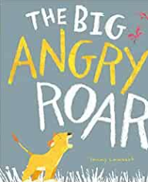
The fun word play and collaged characters in The Big Angry Roar (Little Tiger, 2022) work in perfect collaboration for a little cub’s journey through the savannah as he finds a way to let out his anger. When Cub has sibling troubles, and gets so angry he thinks he might POP, he sets off to find a solution. But stamping and stomping and bashing and crashing only make him angrier. Through Jonny’s characterful illustrations and dynamic text, Cub learns that everyone gets angry and that’s ok, but it is important to find a way to let his anger out.
Cub’s solution feels expected initially – with deep breaths in and out – but ends with funny faces and giggles. Soon Cub feels much better and apologises to his sibling for a suitably heartfelt ending. Whilst this is a story about siblings, it could easily be used to support friendships, too. A perfect combination of heart and humour with a relatable and empowering takeaway.
THE VISITOR (Antje Damm)
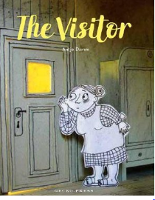
The Visitor (Gecko Press, 2019) is a truly glorious picture book starring Elise who is scared of everything, so never goes outside. But one day something blows in through the open window - a paper plane! When a boy comes along to collect it, he looks around and makes conversation with Elise, who ends up reading to the boy. Not content with a story, the boy also wants to play.
The 3D illustrations - cut out characters that move through hand-made paper scenes - are original and highly effective. There's a beautiful contrast between the dark of Elise's house and the warm yellow of the outside.
At the end of the story, thanks to the contact with Emil, the unexpected visitor, Elise has reconnected with the outside world. The illustrations intimate that she might have a plan to venture out and meet people again. A unique and subtle story about facing fears.

NAVIGATING FRIENDSHIPS

THE FRIENDSHIP BENCH (Wendy Meddour, Daniel Egneus)
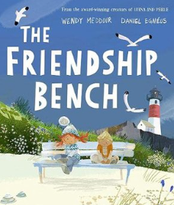
The Friendship Bench (Oxford University Press, 2022) is the story of Tilly who moves to a new house and starts a new school. But Tilly doesn’t find school easy, especially when she can’t take her best friend, Shadow the Dog, or Mum into school with her. Tilly loves doing cartwheels in the sand and playing catch with Shadow... but inside is full of strangers. Tilly’s teacher suggests she try the Friendship Bench but somebody is already on it.
The story centres around a friendship bench that Tilly isn’t sure is working. A boy has been sat on it for ages. When Tilly finally approaches the bench, the pair decide it must be broken and so fix the bench with sticks and leaves and magical sand.
This picture book has gorgeous light-filled illustrations and a perfectly judged text that combine to gently introduce the idea that sometimes you can make new friends without even trying, without even realising. Friendship benches or similar are popular in school playgrounds, but this picture book would be relevant to a range of settings, reassuring readers that friendship can blossom in unexpected places.

LEO AND THE OCTOPUS (Isabelle Marinov, Chris Nixon)
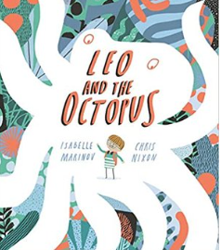
The world was too bright for Leo. And too loud.
"I must be living on the wrong planet," Leo thought.
In Leo and the Octopus (Templar, 2021) Leo struggles to make sense of the world. He doesn't understand the other children in his class, and they don't seem to understand him. Sometimes it feels like he is living on an alien planet. But then one day, Leo meets Maya. Maya is an octopus, and the more Leo learns about her, the more he thinks that perhaps he isn't alone in this world, after all.
Isabelle’s text navigates the world and friendship through the eyes of a child with Asperger’s and Chris’ illustrations are bright and eye-catching, especially the neon detailing on the cover. Together they depict a subtle yet accurate look at how it feels to have autism, helpful for neurodiverse and neurotypical readers.

HOW TO GROW A FRIEND (Sara Gillingham)
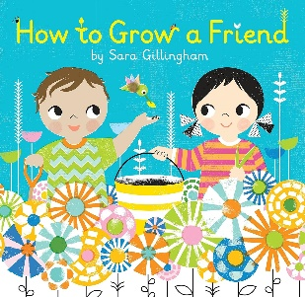
A lovely metaphor teaches valuable lessons in how to treat others and make friendships blossom! Making a friend takes patience, care, and room to bloom—just like growing a flower. Soon your little gardeners will have their very own green thumbs for this most important of life skills.
This cheerful, graphic summery board book teaches a mindful approach to making friends! It uses a lovely metaphor to teach valuable lessons in how to treat others and make friendships blossom. Making a friend takes patience, care, and room to bloom – just like a flower

NEURODIVERSITY

UP AND DOWN MUM (Summer Macon)
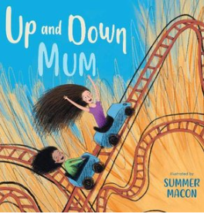
Up And Down Mum (Child’s Play, 2019) depicts the ups and downs of having a parent with bipolar disorder. The child and mother do lots of things together. Most day are fine but some days Mum seems different and even scary. The bipolar disorder is explained in an accessible way for young children. “Everyone has days they feel happier than others, but for your mum it's more extreme.” Grandad describes it as though Mum is riding a roller coaster and the child gives mum the nick name, Up and Down Mum. “When she is happy it feels like she is on the top of the world, and she can do anything. When she is sad nothing can make her feel better.”
The child learns it isn’t down to them to help Mum when she is having a hard time. The family have help from other relatives and trained professionals including a social worker, and a trained therapist.
This book could benefit children growing up in the care of parent who has bipolar disorder, who sometimes spends time away to get specialised help. Whilst such a life can be filled with uncertainty and anxiety, the child in the story loves their mum despite her difficulties and ups and downs.

WHERE BJORN BELONGS (Sam Langley-Swain, Mirna Imamovic)
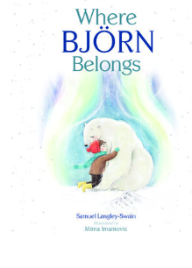
Where Bjorn Belongs (Owlet Press, 2022) is written by Owlet publisher, Sam Langley-Swain, and beautifully illustrated by Mirna Imamovic. Arthur wants to be an arctic explorer and carries his toy polar bear with him everywhere he goes. It’s approaching Christmas time, and Arthur is finding the lights, the noise, the bustle, all a bit too much but he finds comfort in his toy bear. Then, disaster – the bear is lost. Arthur asks Father Christmas for a new one and wakes up to find a gorgeous polar bear in his garden. A real one!
This is an inclusive and sensitive story of friendship and belonging and letting go, centred around the unbreakable bond between a boy and a bear. There's a generous sprinkling of magic, too. The perfect Christmas story for animal lovers who sometimes struggle with big celebrations and festivities.
I TALK LIKE A RIVER (Jordan Scott, Sydney Smith)
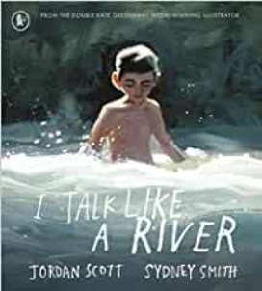
I wake up each morning with the sounds of words all around me.
And I can't say them all . . .
The first person voice in I Talk Like A River (Neal Porter Books, 2018) is powerful and honest, combining with Sydney Scott’s emotive illustrations to create an empowering story of a child who is as quiet as a stone, who gets ready for his day without a word. At school he hopes he doesn’t have to speak because his words tangle in his mouth. But throughout the story, his parent helps him to see that his bad speech day is temporary, not fixed or permanent. “When the words around me are hard to say I think of the river all around me. Even the river stutters like I do,” says the child.
This touching book for children who live with speech difficulties, is also relevant to children who have felt different from their friends and/or who might know someone who struggles. This is a stunning book, both visually and metaphorically, that leaves a lasting impression.

PIFF IN A PUFFLE (Sarah Lavelle, Jill White)
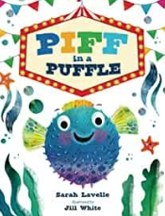
This exciting and colourful story follows Piff the puffer fish as she sets off in pursuit of her dream to join the fishy circus. But she needs an act! Unfortunately, lionfish taming and hermit crab juggling all end in disaster. Piff feels like she's done something wrong, even though she can't help getting into a puffle. Eventually, she learns to embrace who she is. Maybe being a puffle isn't a bad thing after all?
This is a fun and playful story that will show neurodiverse children that they are not alone, especially girls with ADHD.

WILD FOR WINNIE (Laura Marx Fitzgerald, Jenny Løvlie)
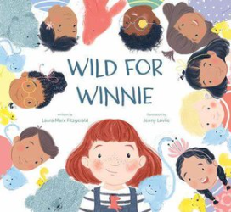
Winnie is no ordinary child. She sees, hears and views the world differently, which makes starting a new school challenging. It's also a bit difficult for the other children in the class. But when the teacher suggests they try things from Winnie’s point of view, they realise that what Winnie needs is to feel included in their world, on her terms—not theirs.
Wild for Winnie (Dial Books, 2022) is a story filled with useful ideas and interventions that prevent Winnie from being excluded from school with her peers, including time to monkey around outside and calm spaces.
At the end of the book there are some carefully considered suggestions that can make a classroom environment more inclusive for neurodiverse children, including swinging, deep-touch pressure, thrill-seeking activities and some calm ones.
Jenny's colour palette is cosy and perfectly chosen, as I’ve come to expect from Jenny's work. The metaphors and similes for Winnie's behaviours - howling like a hyena, being antsy, chomping like a piranha, monkeying around - are visual and accessible to young children. This would be a great class read, helping children and staff make their classrooms accessible for all, whilst also being a book to help neurodiverse children settle into a new setting.

SCHOOL & NURSERY
THE NEW GIRL (Nicola Davies, Cathy Fisher)
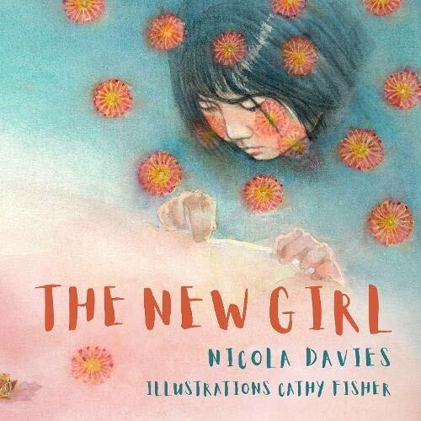
The New Girl (Graffeg, 2021) features a new girl and the ways in which she is treated when she arrives at a new school, not all of them kind. She doesn't speak the same language, she eats smelly food, and she looks different. The story is told from the secondary character's point of view, but the illustrations keep us firmly focused on the girl. When beautiful flowers begin to appear all over the classroom, the children try to make their own flower but it isn't easy… until the new girl shows them how and it’s the start of a new friendship.
This beautiful picture book is full of acceptance and understanding. It feels like it is pitched for slightly older children. There is lots to enjoy and unpack. The illustrations are soft and gentle, in keeping with its themes of kindness towards strangers, which remind us that even if you make mistakes when you first meet someone, it's never too late to make things right.

SERIOUS ILLNESS
THE PERFECT SHELTER (Clare Helen Welsh, Åsa Gilland)
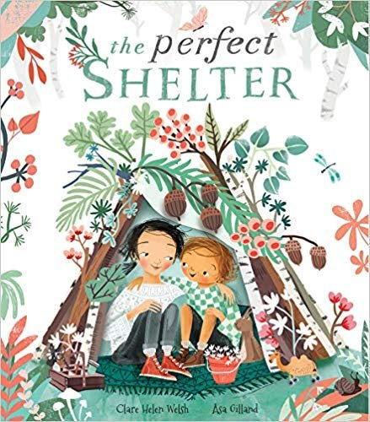
At first, nobody knew. It seemed like the perfect day, the perfect weather to build a shelter in the woods. But then they told me my sister was sick.
With gentle, lyrical text by Clare Helen Welsh, this book is the perfect springboard for you and your child to discuss the complex emotions surrounding family illness. Sensitively tackling an unnamed but serious illness, this heart-warming picture book tackles a difficult diagnosis with authentic and empathetic tenderness. Much like Michael Rosen’s Sad Book, A Shelter for Sadness or The Building Boy, The Perfect Shelter (Little Tiger Press, 2020) offers children a way to understand and articulate complex, often overwhelming emotions. What sets this picture book apart is that the child's sister is the unwell character receiving treatment, not the grown up. This is not a book about grief or bereavement - there is an intentionally hopeful and more ambiguous ending about making the most of everyday.
Combined with Åsa Gilland’s flair for illustrating the natural world and capturing raw emotions, The Perfect Shelter is a powerful picture book that explores how we feel when someone we love is living with a serious illness - representing the uncertainty many families will be feeling at the time.

ONLY ONE OF ME (Lisa Wells, Michelle Robinson, Tim Budgen/ Catarina Echeverri)
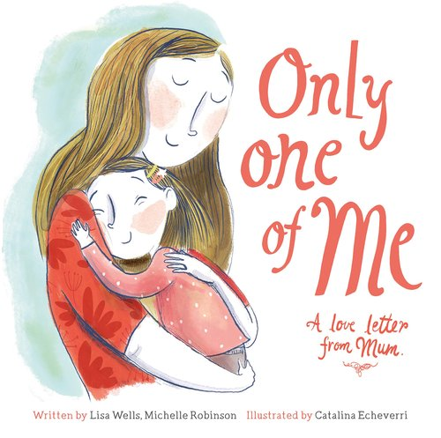
Only One Of Me (Graffeg, 2018) is a special book written by Lisa Wells in collaboration with children's author, Michelle Robinson. Lisa crowdfunded to create the books, gifting copies to children’s charities, before sadly passing away from terminal bowel cancer. Only One of Me was part of her lasting legacy to her daughters and her desire to help other families who face the heartbreak of the death of a parent.
There are two versions of this book, one featuring a mummy (illustrated by Catarina Echeverri) and one featuring a daddy (illustrated by Tim Budgen) which helps the story to feel as relatable as possible to as many children as possible. The rhyme is soothing whilst also being honest, not shying away from the thoughts facing those with an imminent terminal illness in their lives. The books call on the community to support children whose parents is dying, whilst ultimately reassuring children that even after a parent passed away, love never dies.

SHYNESS
TIMID (Harry Woodgate)
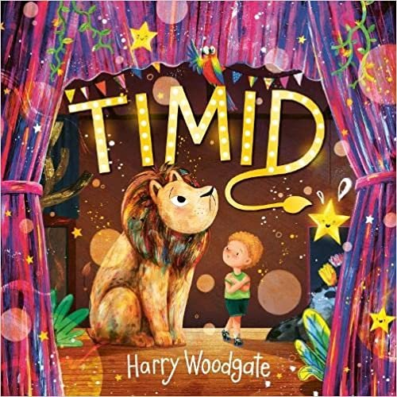
Timmy is a born performer! They dream of singing and dancing and performing on stage. But there’s a problem. Timmy is shy! Whenever they try to do something new, a giant lion roars all their confidence away. Then Timmy meets Nia who doesn’t feel confident enough to turn her designs into a real costume. The pair decide to help each other overcome their shyness. As well as practising and rehearsing together, Nia and Timmy get some top tips from their families and teacher that include meditation, positive affirmations and acting out the worst-case scenarios.
At the climax of the story, the school play, Timmy realises their lion is actually scared too. “I’ve spent all this time trying to get rid of you," they say, "when maybe we should have faced our fears together!"
Timid (Little Tiger Press, 2022) is adorned with beautiful characters and show-stopping costumes, all stitched together in an empowering storyline about overcoming shyness. Readers will be inspired to face shyness when it appears and not to push it away, making space for feelings however difficult they may be.
This is a book for children who realise their shyness is holding them back, who want encouragement to tackle their shyness head on. It will show them just how dazzling confidence can be when you're brave enough to go looking for it.

SIBLINGS / A NEW BABY
WOLFIE THE BUNNY (Ame Dyckman, Zachariah O’Hora)
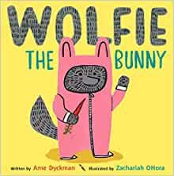
Dot isn’t too impressed when she comes home one day to find a wolf cub on her doorstep! She is even less impressed when her new brother gets all Mama and Papa’s attention. ‘Wolfie the Bunny’ (Andersen, 2016) would be a good book to read with a child that has a toddler or young sibling in the family, unpicking how Dot feels when Wolfie is seemingly the centre of everything.
Throughout the story, Dot appears to be the only one that realises Wolfie might, and could, gobble them up (!) which adds to the fun and lighthearted approach to this #BookThatHelps. The twists and turns of this story eventually settle celebrating siblings and their special bond, re-affirming to readers that Dot will always be there to protect her baby brother.

SLEEP & BEDTIME
THE NIGHT BOX (Ashling Lindsay)
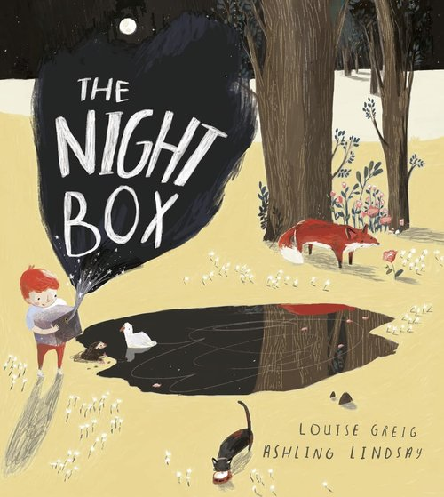
The Night Box (Farshore, 2017) is a magical exploration of night. Through a poetic text and stunning illustrations, the book explores the shifting of day to night from the point of view of main character, Max, who anticipates bedtime.
The use of deliciously descriptive language adds to the dreamy tones of this book, making it a story that could help little ones who struggle to settle at bedtime. The whimsical illustrations, carefully chosen text and sprinkling of night-time magic makes this a different kind of Book That Helps - a gentle lullaby of night.

WOLVES IN HELICOPTERS (Sarah Tagholm, Paddy Donnelly)
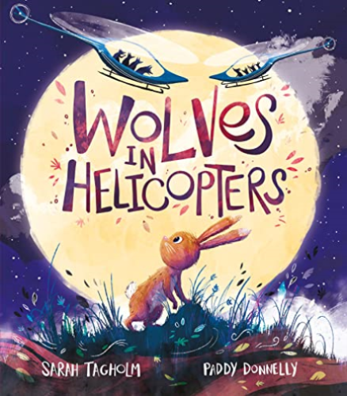
Wolves in Helicopters (Andersen Press, 2022) invites brave young readers to enter the world of Hop's spine-tingling nightmares. This is an original picture book about a bunny called Hop, who each night has night terrors filled with scary, hungry-eyed wolves! Hop knows they only exist in her dreams, but they seem so real. Mummy comforts her and has some good advice, but can Hop find the courage to conquer the wolves?
This picture book has a unique and clever structure. Sarah's text and use of repetition are perfectly timed and depict Hop's courage and the escalating peril. Paddy's illustrations are both menacing and comforting, portraying the danger of the wolves but also the safety Hop feels with her mummy. There's also a whisker of humour dotted throughout.
By the end of the story, Hop overcomes the darkness and takes control of the scariest of situations, but with an unexpected twist! The reader is left feeling uplifted and empowered, knowing that they can be the director of their own dreams.

UNDERSTANDING FEELINGS & EMOTIONS
A SHELTER FOR SADNESS (Anne Booth, David Litchfield)
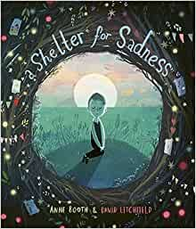
‘Sadness has come to live with me and I am building it a shelter. I am building a shelter for my sadness and welcoming it inside.’
The child narrator of Anne Booth and David Litchfield’s A Shelter for Sadness (Templar Publishing, 2021) talks the reader through his experiences of living with sadness. The small boy creates a shelter for his sadness, a safe space where sadness is welcome, where it can curl up small, or be as big as it can be, where it can be noisy or quiet, or anything in between. This offers the reader down-to-earth ideas of how to cope with sadness when it appears, which it does for us all.
Anne’s text is heart-felt and honest. David’s stunning illustrations give this story a light and hopeful feel, making it a poignant and heart-warming picture book exploring the importance of making space for sadness.

PEGGY THE ALWAYS SORRY PIGEON (Wendy Meddour and Carmen Saldana)
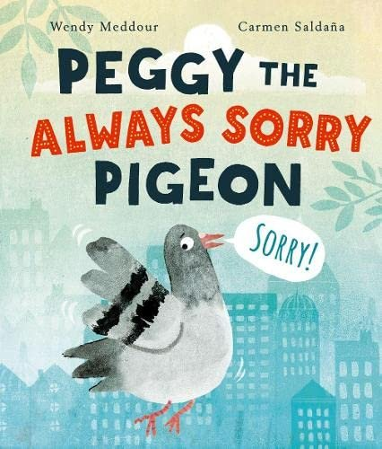
Peggy the Always Sorry Pigeon (Oxford University Press, 2022) is a book that will really resonate with a certain kind of reader. Through plenty of action and fun characters, it drives home the important and helpful message that you only need to apologise if you've genuinely done something wrong.
Peggy is a very apologetic pigeon. She always assumes she's in the wrong, even when she's the one being bullied. But Cynthia, an older female seagull, gives her the necessary skills to stand up for herself.
A great book for children that need to practise being more assertive.

WHEN SADNESS COMES TO CALL (Eva Eland)
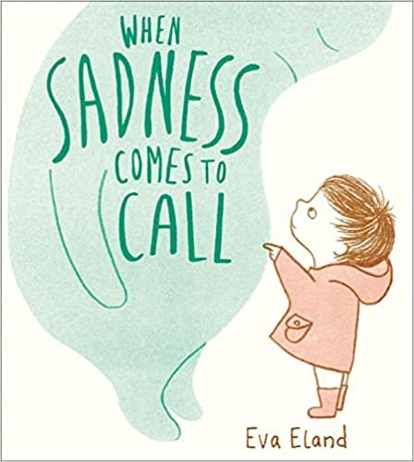
Eva Eland’s When Sadness Comes to Call (Andersen Press, 2020) is a powerful and accessible picture book that can be used to talk about sadness with children.
The illustrations are soft with effective use of white space, allowing the poignancy of discussing all feelings, especially the negative ones, to shine through. The direct storytelling voice facilitates conversations with children about how sadness makes them feel and what can be done about it. Children will be inspired to talk about and problem-solve what the protagonist can do. The story ends with the child making friends with sadness, encouraging readers to spend time with the emotions that make them feel uncomfortable, and not to fear them.

FEELINGS (Libby Walden, Richard Jones)
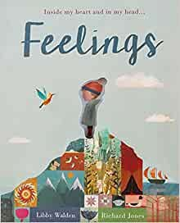
Libby Walden and Richard Jones are the perfect pairing in Feelings – Inside My Heart and In My Head (Little Tiger, 2016), which is a lyrical and poetic portrayal of the feelings we have so strongly, but do not see. Richard brings feelings, including bravery, sadness, happiness, jealousy and more, alive with his evocative landscapes and striking use of colour. Libby’s poems are bursting with dynamic word choices and metaphors for the feelings that feel like a mystery sometimes.
This book could easily be used with children and young people older than the traditional picture book age as a starting point for children creating their own feeling-inspired poetry.
This book was recommended by HRH The Duchess of Cambridge in HRH The Duchess of Cornwall’s Reading Room, and rightly so.
SWEEP (Louise Grieg, Júlia Sardà)
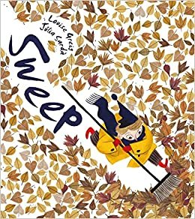
Sweep (Egmont 2018) is a wonderful story about what can happen if you let a bad mood get the better of you. Ed and his bad mood sweep, sweep, sweep through the town until his emotions grow and gather so much pace the town is dark and Ed is tired and hungry.
In this poetic, uplifting story, Louise Greig and Júlia Sardà use a suitable visual metaphor to show readers what can happen when you try to sweep your troubles away. Perfect for helping children learn to recognise and deal with big emotions.

BARBARA THROWS A WOBBLER (Nadia Shireen)
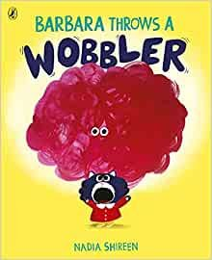
Barbara is the protagonist of Nadia Shireen’s Barbara Throws a Wobbler (Puffin 2021) who is having ‘one of those days!’ After a sock problem in the morning and a strange pea at lunchtime, her day goes from bad to worse, resulting in the appearance of a wobbler - a red, jelly-like cloud that emerges above Barbara’s head!
With patience, understanding and a dollop of humour, Barbara overcomes her wobbler, squishing it until she can hold it in her paw and POP! It vanishes! She’s goes back to the park where her friends are waiting, and where the reader is let into a secret. Everyone has wobblers from time to time.
Nadia’s playful, exaggerated illustrations convey the characters’ exasperation, hurt, and eventual delight at the newfound empowerment over her feelings. The humour is laugh out loud and perfect for the age group (and for adult readers, too!)

THE BIG ANGRY ROAR (Jonny Lambert)
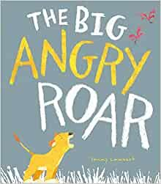
The fun word play and collaged characters in The Big Angry Roar (Little Tiger, 2022) work in perfect collaboration for a little cub’s journey through the savannah as he finds a way to let out his anger. When Cub has sibling troubles, and gets so angry he thinks he might POP, he sets off to find a solution. But stamping and stomping and bashing and crashing only make him angrier. Through Jonny’s characterful illustrations and dynamic text, Cub learns that everyone gets angry and that’s ok, but it is important to find a way to let his anger out.
Cub’s solution feels expected initially – with deep breaths in and out – but ends with funny faces and giggles. Soon Cub feels much better and apologises to his sibling for a suitably heartfelt ending. A perfect combination of heart and humour with a relatable and empowering takeaway.

CHOICES (Roozeloos)
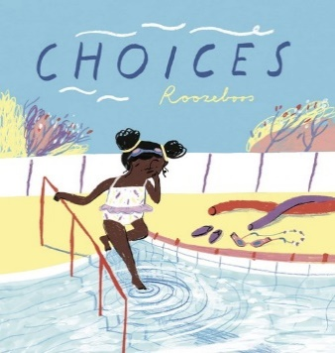
Overthinkers will resonate with this book, Choices (Child's Play, 2021). It’s a visual look at the many different choices we face every day. Big ones, small ones and some in between ones... from choosing an ice cream to deciding whether or not to face our fears.
The sparse text and detailed illustrations are a lovely combination. The 'space' leaves a gap for readers to peruse Roozeboos' use of colour and movement and invites reflection. When faced with difficult choices, this story suggests readers should follow their heart, gently encouraging them to try new things.

WAR & DISPLACEMENT
LUBNA AND PEBBLE (Wendy Meddour and Daniel Egneus)
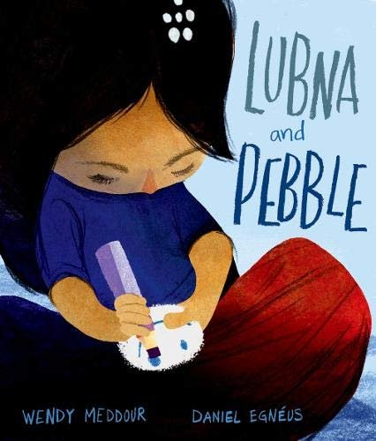
‘Lubna and Pebble’ (Oxford University Press, 2019) is a beautiful and powerful story about two children and a pebble that have fled their home, who find friendship ‘in a world of tents.’
Lubna finds the pebble on the beach when they arrive in the night, and she falls asleep in Daddy's salty arms. Pebble always listens to her stories and smiles when Lubna feels afraid. But when a lost little boy arrives, Lubna understands that he needs Pebble even more than she does.
This is a beautifully illustrated story, evoking all the emotions of this unknown and uncertain world. The writing is full of gentle but powerful emotive language. Overall, it's a very moving story of kindness, hope and friendship despite challenging times.

MY NAME IS NOT REFUGEE (Kate Milner)
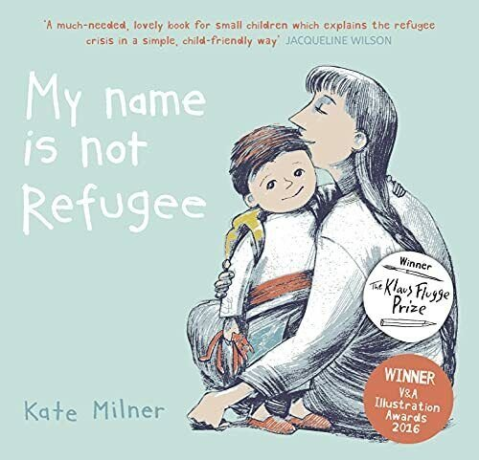
A touching, timely and tender exploration of refuge and migration for the youngest readers, this picture book offers a moving insight into the real journeys being made by children today. Winner of the Klaus Flugge Prize 2018.
Told from the point of view of a child and their parent who have to leave their home, My Name is Not Refugee (Barrington Stoke, 2017) foretells to a child what life will be like as a refugee. The situations, such as waiting, walking, queuing and eating strange foods are poignant and emotive. The parent, who narrates the book, suggests it’ll be hard but interesting too. Ultimately, the parent reassures the child that whilst they’ll be called ‘refugee’ that isn’t their name.
The story would benefit children who have been forced to flee their homes, but also all readers to develop empathy towards displaced families. Little questions posed in the illustrations help readers relate to the characters and their situation: What would you take? How far could you walk? Can you speak more than one language?

THE SUITCASE (Chris Naylor-Ballesteros)
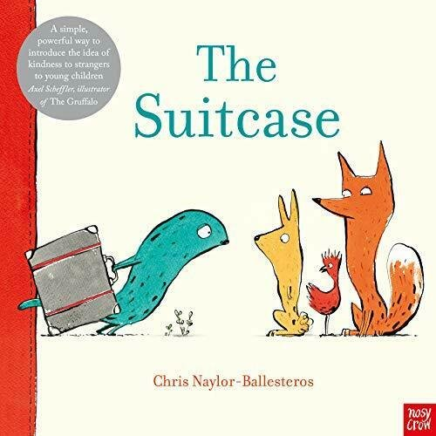
The Suitcase (Nosy Crow, 2020) is a simple but inspiring story to start conversations about migration with young children. With everyone, in fact. A strange-looking creature appears with a suitcase and the other animals in the story are uncertain about them. The creature has travelled for a long time and has come a long away. While the creature sleeps, the other animals break open their suitcase to find out more about them.
The economic speech and use of white space add to the poignancy of this story, and to the takeaway that we should treat displaced people with empathy and kindness.

ME AND MY FEAR (Francesca Sanna)
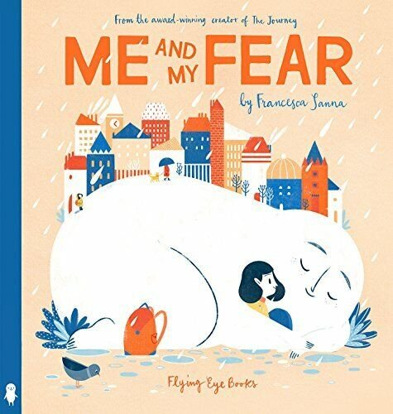
The main character in Me and My Fear (Flying Eye, 2018) has a secret - a tiny friend called Fear who keeps the girl safe and helps her explore new things. But when the girl moves to a new country, starts a new school and doesn't speak the language, settling in is difficult and the girl's personified Fear stops her doing things like playing and joining in. Fear even stops her from sleeping and the main character feels increasingly sad and lonely.
When a new boy reaches out, Fear shrinks and things improve. When the girl realises he has a secret fear too, their bond is strengthened. Things are still tricky at the new school – it takes time to adjust to big changes - but now the girl knows everyone has a little fear.
This book shows children that fear is important for keeping us away from danger, but also empowers them to manage their worries and mental health. We are all afraid at sometimes.

THE NEW GIRL (Nicola Davies, Cathy Fisher)
The New Girl (Graffeg, 2021) features a new girl and the ways in which she is treated when she arrives at a new school, not all of them kind. She doesn't speak the same language, she eats smelly food, and she looks different. The story is told from the secondary character's point of view, but the illustrations keep us firmly focused on the girl. When beautiful flowers begin to appear all over the classroom, the children try to make their own flower but it isn't easy… until the new girl shows them how and it’s the start of a new friendship.
This beautiful picture book is full of acceptance and understanding. It feels like it is pitched for slightly older children. There is lots to enjoy and unpack. The illustrations are soft and gentle, in keeping with its themes of kindness towards strangers, which remind us that even if you make mistakes when you first meet someone, it's never too late to make things right.

CELEBRATING DIFFERENCES
THE PERFECT FIT (Naomi and James Jones)
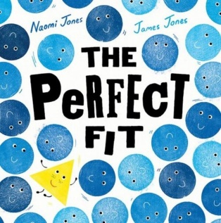
Triangle doesn’t feel like she fits in with the other shapes. No matter how hard she tries, she doesn't roll like the circles, or stack like the squares. So, so she sets off to find friends that look exactly like her, somewhere she truly belongs.
But when Triangle finds the other triangles, playtime isn't as fun! She misses the shapes that roll and stack; she misses being different. So she starts a new quest, one that gets all of the different shapes playing and having fun together.
This cleverly conceptual and joyfully designed book, touches on diversity and inclusion in a visual and age-appropriate way.

PIRATE MUMS (Jodie Lancet-Grant, Lydia Corry)
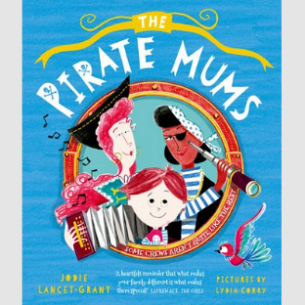
In Pirate Mums (OUP, 2022) more than anything Billy wishes his swash-buckling, sea-loving mums would be normal and a bit less piratey. They’re not exactly what you'd call ordinary: his mums won't listen to NORMAL music, they love to sing sea shanties and dance jigs in the lounge. Their clothes are highly unusual, they have a rude parrot for a pet, and their taste in house design is, well . . . FISHY!
Billy wishes his family could be more like everyone else's. However, when disaster strikes on a school trip out to sea, his mum’s nautical knowledge might just save the day.
This is a funny adventure story that also celebrates same sex families.

POVERTY & THE COST OF LIVING
IT’S A NO MONEY DAY (Kate Milner)
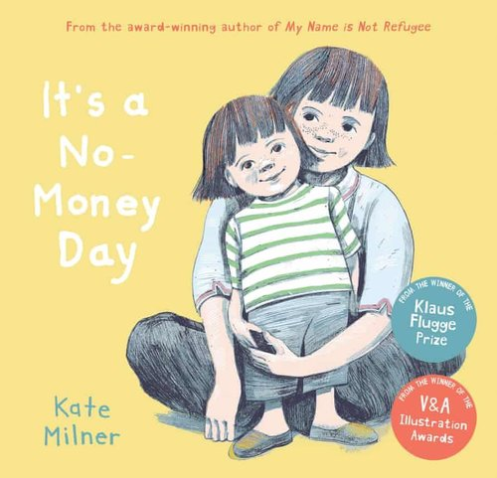
A young girl takes the reader through her 'no-money day' in this gentle and pertinent perspective of life below the poverty line. An essential book to help develop empathy in young readers.
It’s a No Money Day (Barrington Stoke, 2019) explores the powerful idea of a no money day. The story begins with a depiction of the family’s situations, including budgeting and mum seemingly not eating so the child can. And once its established it’s a no money day, the main character shares with the reader all the fun things you can do that are free – including making a kitten from a dressing gown, going to the library and singing. Except today Mum and the child have to go to the food bank. On the way home, the characters play the ‘maybe one day game’ lightening the harsh reality and dribbling a little humour and hope into the story line that one day things will be different. For now though, they are grateful to those donating to the foodbank.
The colour palette and linework are emotive. There’s plenty of space between pictures and words for readers to notice details in the artwork, such as the empty shelves, allowing children to comment and ask questions if they want to, which is so important in a book that touches on a potential triggering topic.
A moving insight into the sad rise and necessity of foodbanks from the perspective of society's most vulnerable, and an essential book to help develop empathy in younger readers.

THE INVISIBLE (Tom Percival)
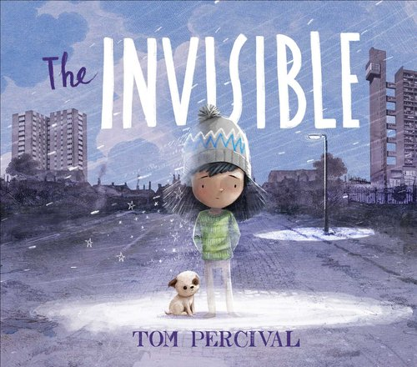
This is a powerful and moving story about a girl called Isabel who becomes invisible when her family leave their home, no longer having enough money to pay rent and bills. Isabel meets other invisible people and, in spite of adversity, finds a way to make a difference.
Carefully chosen words and emotive illustrations combine to depict a story that shines a light on those often overlooked in society. The reader is left with a positive and empowering message of love and humanity - everyone has a place. We all belong.
A stunning story, sensitively handled.

UNCONDITIONAL LOVE
WELL DONE, MUMMY PENGUIN (Chris Haughton)
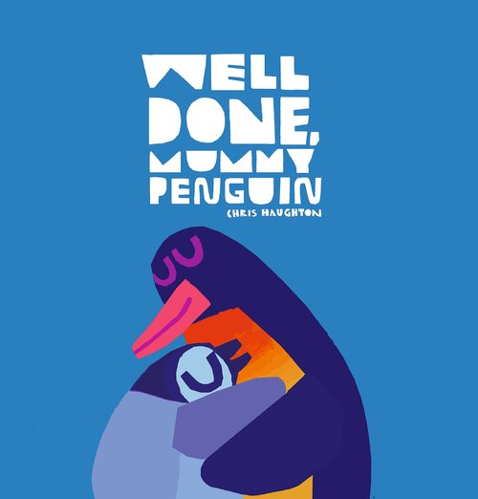
Well done, Mummy Penguin (Walker, 2022) is an exciting celebration of all the things mothers are and do, delivered in Chris Haughton's distinctive and acclaimed style. Humour and heart run through the pages as Mummy Penguin sets off to find a fishy dinner for her family. She has to swim very fast, climb a slippery cliff – cu-crunch, cu-crunch, cu-crunch – and even tiptoe past some sleeping seals… Shh! All the while, Little Penguin looks on in awe and says: “Well done, Mummy Penguin!”
The onomatopoeia and dynamic language make this story a joy to read to aloud. The icy Antarctic landscapes are breath-taking. This could be used to help little ones who are temporarily separated from parents, reassuring them that their loved ones will return once their job lists are complete. A funny and exciting exploration of unconditional love with super cute penguins!

HOW THE STARS CAME TO BE (Poonam Mistry)
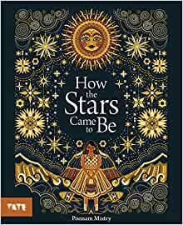
Have you ever wondered how the stars came to be in the sky? In How The Stars Came To Be (Tate Publishing, 2021), the Fisherman’s Daughter learns a different and magical way to understand the night sky.
This beautifully designed, exquisitely illustrated book holds a modern-day folk tale starring the fisherman's daughter, who loves to dance in the sunlight and bathe in the glow of the moon. But when the moon disappears for a few nights each month, she worries about her father and how he will find his way home to her. One night, after the sun finds her crying, the girl discovers there is always light in the darkness.
A magical compilation of words and pictures.

THE BOY WHO LOVED EVERYONE (Jane Porter, Maisie Paradise Shaerring)
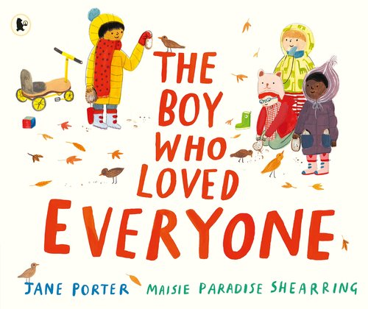
"I love you," Dimitri tells everyone, from his friends at nursery to the big tree in the playground. But Dimitri can’t understand why no one says ‘I love you’ back. When he worries that no one loves him, his mum explains that there are lots of different ways to show our feelings and to show love.
The old man tells the stray cats he loves them with tuna. The dinner lady says 'I love you' with a smile and Stella, Sue and Sophie feed the birds seed to show them they love them. Dimitri begins to see that there are many ways that love can spread through the world.
The Boy Who Loved Everyone (Walker Books, 2020) is a beautiful and uplifting story that oozes unconditional love.

MY DADDIES! (Gareth Peter, Garry Parsons)
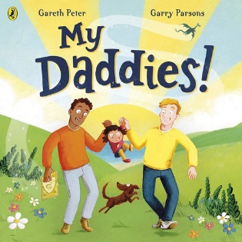
My Daddies (Puffin, 2021) is a lovely celebration of imagination and stories as well as adoption and LGBTQ+ families. Battle dragons, dodge deadly dinosaurs, zoom to the moon and explore the world in a hot air balloon, before winding down in a wonderfully cosy bedtime ending.
The joyful rhyming text and artwork is full of life. The story was inspired by Gareth Peter’s own experience as a parent within a same-sex couple. This would be a wonderful and important to read with any child, in order for them to see all different kinds of families that exist.

My Daddies (Puffin, 2021) is a lovely celebration of imagination and stories as well as adoption and LGBTQ+ families. Battle dragons, dodge deadly dinosaurs, zoom to the moon and explore the world in a hot air balloon, before winding down in a wonderfully cosy bedtime ending.
The joyful rhyming text and artwork is full of life. The story was inspired by Gareth Peter’s own experience as a parent within a same-sex couple. This would be a wonderful and important to read with any child, in order for them to see all different kinds of families that exist.

THE ENVIRONMENT
THE ODD FISH (Naomi Jones, James Jones)
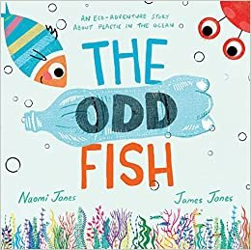
Naomi and James have created a wonderful picture book together, helping to introduce younger readers to the issue of plastic pollution in our seas. The Odd Fish (Farshore, 2022) is a story that follows a fish who is trying to help an 'odd fish' (a plastic bottle) find its family. Along the way, they encounter other sea creatures who are sadly all too often the victims of discarded plastic, washing about in the oceans' currents. The child reader is gently encouraged to learn how bad discarded plastics are for sea creatures, without being overwhelmed by the issue.
James' illustrations perfectly show the journey that fish and 'odd fish' go on, with a delicate colour palette and lovely details for the reader to explore. I think this is the perfect way to engage younger readers about this topic and would highly recommend reading it. The end spread provides some excellent, child friendly facts about the issues of plastic pollution, as well as some practical suggestions as to how children can work with adults to reduce our own plastic impact.

WHEN THE STORKS CAME HOME (Isabella Tree, Alexandra Finkeldey)
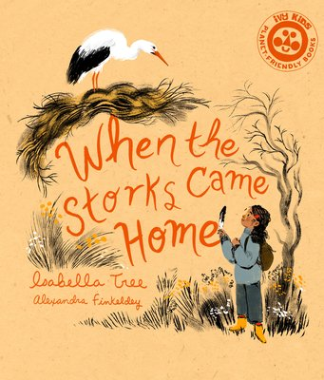
Beanie loves birds. When she discovers that beautiful white storks used to live in her neighbourhood but were hunted to extinction, she is determined to find a way to bring them back. But reintroducing a vanished species is not so simple! With the help of her neighbours, Beanie hatches a plan...
When The Storks Came Home (Ivy Kids, 2022) is an empowering story of a young girl who's passion for nature leads her to learn about, and then strive to bring about, the reintroduction of white storks to her local community. This story captures what can be achieved when people come together, as well as the joy of seeing nature appear when a home is provided for them. It is the essence of 'if you build it, they will come' - a message for all of us about providing a home for nature. A lovely blend of story and fact, families will find this book inspiring and hopeful. Isabella (well known for the work they have done to 'rewild' their own Knepp estate in Sussex) has also included a factual end page about the real life story of 'reintroducing' white storks to Britain. Alexandra's illustrations are beautiful, capturing the range of human emotions experienced as the story unfolds and with glorious pictures of the storks. And what makes this book even more special, is that it has been printed on high quality recycled paper, here in the UK. A must read!

VARMINTS (Helen Ward, Marc Craste)
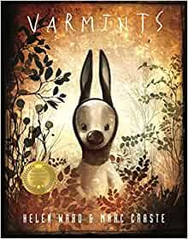
There was once only the sound of bees and the wind in the wiry grass, the low murmuring of moles in the cool dark earth…
Varmints is a powerful picture book, exploring another world where most of the creatures do not notice nature. Just a few hear the bees and the birds and take care of their natural world. They save a small piece of the wilderness, protecting it from the many who fill their world with noise and buildings. But those that cared for the wilderness find a new home for their precious nature and once more the sound of birds and bees returns.
This cautionary tale helps children to understand how humans need to learn to live alongside nature; to live in harmony with it. It is a timeless story of hope told beautifully by Helen Ward and with exquisite illustrations by Marc.

COMMUNITY
THE BLUE UMBRELLA (Emily Davison, Momoko Abe)
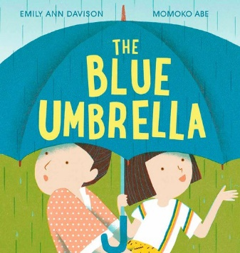
The most magical things can happen even on the rainiest of days...
One day a small blue umbrella appears on the main character’s doorstep. They take the umbrella out with them, even thought it isn’t forecasted to rain… and something magical happens! As each drop of rain falls, and more people gather, the umbrella grows taller and wider. The umbrella doesn’t just provide the people with shelter, but community, brought together by kindness and friendship.
Emily’s voice is gentle and deceptively simple and when paired with Momoko’s clean and warm illustrations, there is plenty of space for the reader to decide what causes the umbrella to grow and to discuss how the community benefits. A clever and powerful metaphor, beautifully illustrated.
ADOETTE (Lydia Monks)
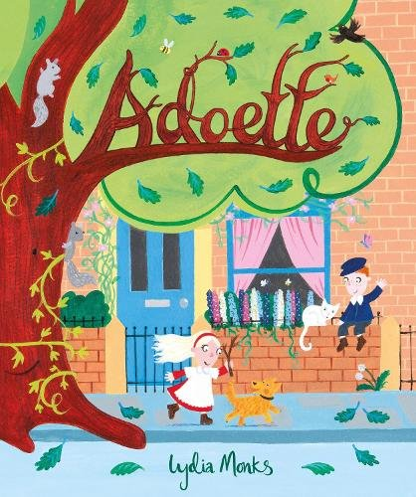
Adoette is a wonderful picture book by Lydia Monks, inspired by the true events in Sheffield, UK when 10,000 street trees were due to be chopped down.
The story follows the tale of the life of one tree, aptly named Adoette which means ‘big tree’, and the changes she sees. Within Lydia Monks’ bright and bold illustrations, we see community life on the street and how it changes over time. Sadly, one day, Adoette is no longer welcome and some want her to go. Adoette was at the heart of the community, and her memories live on when one little girl plants one of her acorns in a garden, which the community has come together to create.
The author’s note at the end is really moving and the book is dedicated to all the people who took the time to care and campaign to save the trees.
Adoette is a story about how the small seed of an idea can grow and how there is always hope.

THE GIRLS WHO PLANTED TREES (Caryl Hart, Anastasia Suvorova)
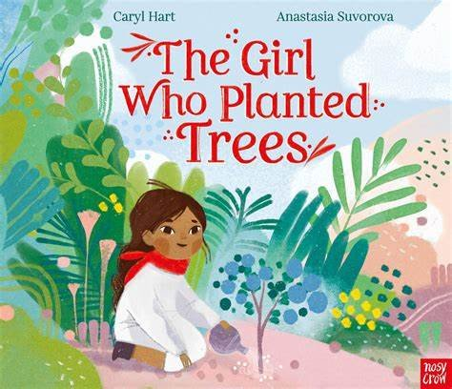
The Girl Who Planted Trees is many things! It’s a story about never giving up, it’s a story about bringing a community together to create something incredible and it’s a story about looking after our world.
The girl discovers that there was once a lush forest on the great grey mountain, and after the discovery, she is determined to plant as many trees as she can. Even though the blazing sun and fierce storms nearly put an end to her hard work, she never, EVER gives up.
The Girl Who Planted Trees is a powerful story, beautifully told and illustrated. It is an empowering story for children, where one girl’s dream inspires a whole village and together, they create something incredible.

THE QUEEN ON OUR CORNER (Lucy Christopher, Nia Tudor)
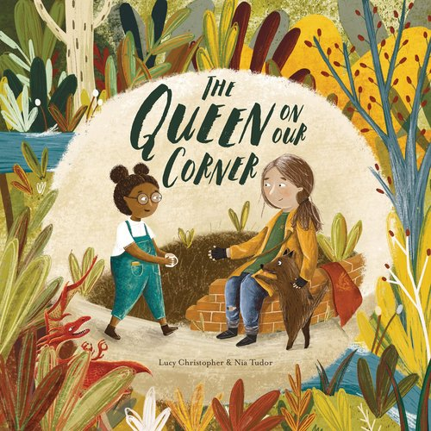
The Queen On Our Corner is narrated by the girl in the story, who notices a homeless woman who sits on the corner of their street. The girl calls her a Queen and imagines all the different adventures she may have had, included fighting dragons and the battles she’s been in. When a fire spreads on the street, it is the ‘Queen’ who alerts everybody. The girl brings to everyone’s attention that it was the Queen who helped, and finally the other people notice her. With the child’s encouragement, the community comes together to build her a home on the corner.
Nia Tudor’s illustrations and earthy tones suit the gentle story well. Children will enjoy exploring all of the little details that Nia has brought to the book.
With poignant words by Lucy Christopher, and stunning illustrations from Nia Tudor, this book gently introduces the concept of homelessness to children.

FLOODED (Mariajo Ilustrajo)
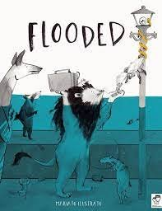
In Flooded, we follow the story of a city which wakes up to find that everything is a little bit… WET! However, at first, nobody seems to mind. Despite being inconvenient, the animals find ways to cope with the problems that the water brings, in funny and ingenious ways. But soon, it becomes apparent that a little bit of water can turn into a HUGE problem. Eventually, the community of animals have to listen to a quieter voice to help solve the problem, but it’s going to take all of them working together to achieve it.
The story is uniquely illustrated with a gorgeous colour palette of greys and blues. Flooded is a story about learning to face up to problems before they become too big, and about the strength that comes when a community comes together to solve a problem.

SEPARATION & DIVORCE
EVERYTHING CHANGES (Clare Helen Welsh, Åsa Gilland)
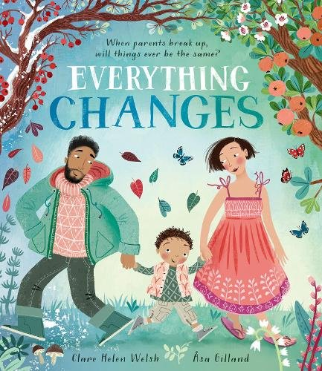
Laughing and playing together as a family on the beach, it seems the happy, warm days of summer will never end. Then, everything changes. Mummy and daddy say they can’t live together anymore, and sad, worried feelings begin to emerge – It’s not fair! Was it all my fault? But, as time passes and the seasons change, it becomes clearer that hard times won’t always be quite so hard . . .
Everything Changes (Little Tiger Press, 2022) lyrical book about the difficult emotions a child can feel when their parents break up, with an optimistic message of hope and resilience. Gorgeous illustrations and an emotive colour palette perfectly capture the nuances of emotion felt by both the child and parents during a separation.
7Stories said: “It is brilliant to see more books that tackle merged families, divorce and the variety in the ways familial love manifests, but I haven't seen one so elegantly and universally handled as Everything Changes. Using the cyclicality of seasons to explore a shifting of emotions, this book helps little ones appreciate that the only constant is change, and why there's value to be found in that."

MY BIG FANTASTIC FAMILY (Adam and Charlotte Guillain, Ali Pye)
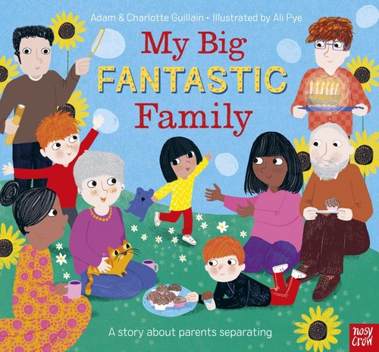
From the very first page we know from the outset that the main character, Lily-May, lives with Mum, not Dad. Lily-May's story is set post-parental split and she recounts some of the changes and difficulties there have been. But there are plenty of advantages too! Like more play time and more of everyone. Now Lily-May has extra grandparents and more siblings. It isn't always plain sailing, but in My Big Fantastic Family (Nosy Crow, 2022) the reader follows the main character through the ups and downs of what it can look like when parents separate... and grow!
This is a colourful and accessible look at parental separation with a focus on a fun and hopeful future, and on what families can look like further down the line. A great book for those whose who are soon to be introduced to new partners and kin.
Bright illustrations from Ali Pye and a clear and positive message from Adam and Charlotte Guillian.

REMIXED (Aree Chung)
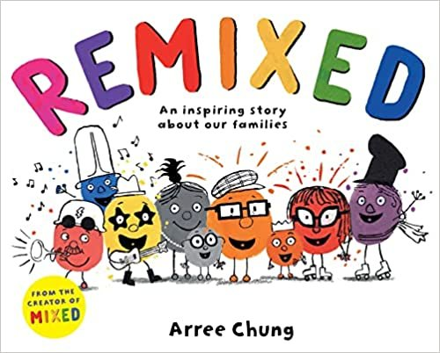
In Mixed City, colours mix when they fall in love. Things are bright and joyful at the beginning of the story, but families change. All sorts of worries go through the characters’ heads as the characters experience loss and separation: Am I good enough? Did I make a mistake? Will they get along? Will he like me? But Remixed (Macmillan, 2022) reaffirms to the reader that with open minds and hearts, love grows.
The message of this picture book – that families don’t always stay the same, they remix, blending past and present – is perfectly executed through the use of colour, and is accessible to very young children. Fun and bright illustrations give this a pitch perfect, light-hearted feel, great for readers with newly blended families. Indeed, this would be an especially good read for a child meeting new members of their family for the first time because whilst change isn't easy, things usually turn out ok, and sometimes much better than before.

FRED STAYS WITH ME (Nancy Coffelt, Tricia Tusa)
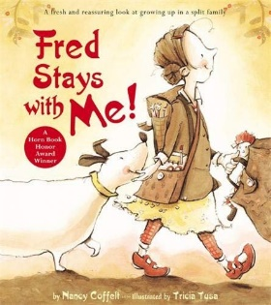
Fred Stays With Me (Little, Brown Young Readers) is a picture book told in first person point of view about a character who sometimes live with Mum and sometimes lives with Dad. The experiences at each parent’s house are shown largely through the eyes of Fred, the dog and how he behaves. At Mum’s, he barks at next door's poodle. At Dad’s, he steals the socks! Neither parent wants Fred to stay with them, but the main character helps to solve the dispute by declaring to her parents that Fred doesn’t live with either of them. Fred stays with her.
What’s nice about this is the sorry is the symbiotic relationship between the girl and Fred. When one is happy, they both are. When one is sad, they are there for each other. Whilst a separation can feel like a loss of control, this story empowers readers and shows them how, in this case, strength is found in the consistency of the family pet.

MUM AND DAD GLUE (Kes Gray, Lee Wildish)
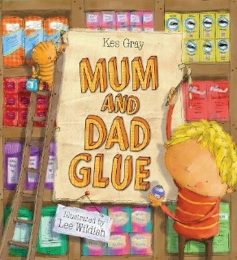
Told in a soothing rhyme, Mum and Dad Glue (Hodder, 2010) follows the main character as he navigates the worries that occur to him when his parents separate. The little boy searches for a glue to hold his family together, but he eventually realises there is no glue for parents and that's ok, because despite his parents' break up, their love for him will always remain. The boy is encouraged to be strong and look past the hurt into the future, making this book more suited to families with an acrimonious breakup.

MINDFULNESS / SLOWING DOWN
THANK YOU FOR THE LITTLE THINGS (Caryl Hart, Emily Hamilton)
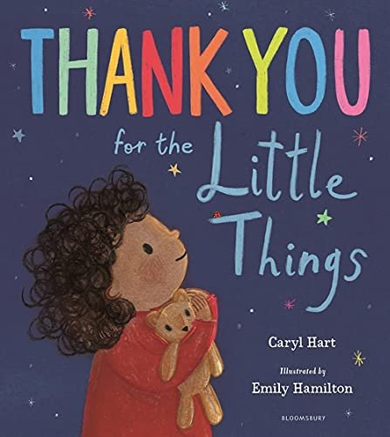
Whenever I am feeling sad
or life feels hard or wrong or bad,
I focus for a little while
on little things that make me smile.
In this reassuring and uplifting story, we follow a main character who discovers the things that make them happy - whether that’s swinging high on the swings or licking ice cream, there are lots of small things that bring them joy and cheer up a grey day.
The takeaway, that everyone has bad and sad days from time time, is a soothing antidote to worries big and small, reminding anxious little ones (and big ones) that it’s often the smallest things that make us smile!

SHINE LIKE THE STARS (Anna Wilson, Harry Woodgate)
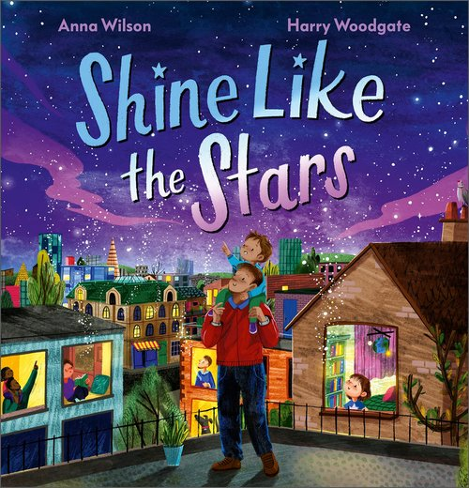
You are part of this earth. You grow like the seed. You shine like the stars.
We are all connected to the natural world, and it is connected to us. And just as the stars shine brightly in the night sky, so can you.
Shine Like The Stars (Andersen Press, 2023) is a stunning collection of monologues from the natural world. In soothing and rhythmic prose, the reader hears from Planet Earth, the Sun, the ocean, the stars and more, as they share their story and invite us to connect to the world through them.
This gorgeous and clever book is both poetic and educational - a conversation with nature that both informs and calms. Anna’s thought-provoking words read like a lullaby, making this a beautiful bedtime read. The back matter is gently informative. Exquisitely illustrated by Harry Woodgate, readers will want to jump into the double page landscapes that are vibrant and unfold like dreams.
Lyrical, mindful, educational, this is a special story that reminds and informs us about our relationship with the natural world.
STOP THE CLOCK (Pippa Goodhart, Maria Christania)
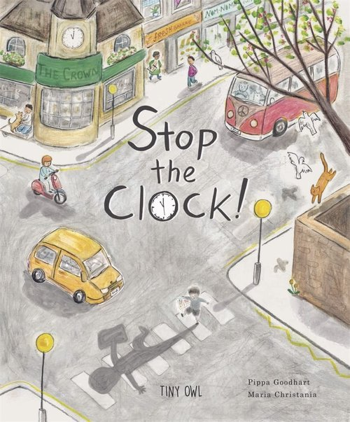
In Stop The Clock (Tiny Owl, 2022) by Pippa Goodhart and Maria Christania, Joe is busy! So busy that he misses all the exciting things happening around him. He doesn’t even notice his sister crying on the way to school – but the reader might. Joe's teacher asks him to draw what he saw on the morning school run, but he realises he was in such a rush that he doesn’t know what to draw. Joe decides to stop time and retrace his steps in order to appreciate the small but important things. As Joe notices all the meaningful things in his life, his world is filled with more and more colour, cleverly reflected in Maria’s transitioning colour palette. Joe also works out why his little sister was crying, which is a nice secondary storyline going on in the illustrations.
A lovely introduction to mindfulness, advocating the importance of slowing down.

TISHA AND THE BLOSSOM (Wendy Meddour, Daniel Egneus)
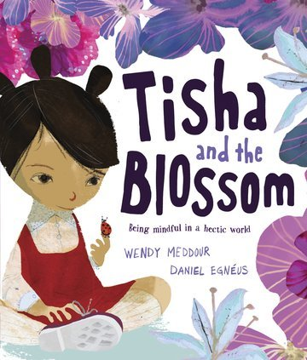
In Tisha and the Blossom (Oxford Univserity Press, ) the main character is having a hurried kind of day. Her mum, her teacher, her friends are all telling her to hurry up. Tisha opens up to her mummy and the pair decide to walk home and slow down. Together they chat and look carefully at their surroundings. Daddy joins them too! The story ends with everyone catch ing blossom, slowing down and with Tisha fast asleep.
We all have busy lives and Tisha is no exception. This book encourages families to move at at slower pace because all that hurrying up can be exhausting.

