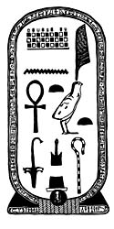

**THE RIVER NILE**

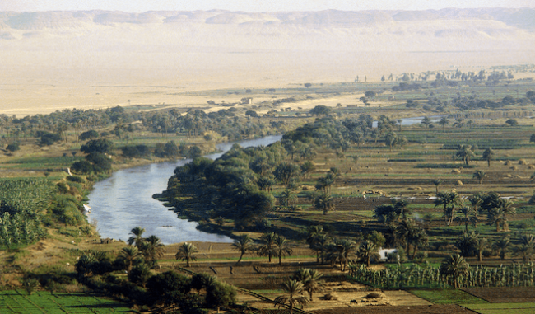

The Nile was essential to life in ancient Egypt. Every year it flooded and the black **silt** left behind enriched the soil for growing crops. Most people lived alongside the river. This is still true today., The river was also used for water, fishing and trade.

ANCIENT EGYPT 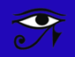

**HEIROGLYPHICS and CARTOUCHES**

The Ancient Egyptians created a writing system that used pictures and symbols instead of words, called **hieroglyphics.** It took experts hundreds of years to work out what the hieroglyphics meant!

Important Egyptians, such as Pharoahs, had their own symbols, with their names written in heiroglyphics This was called a **Cartouche**.

**MUMMIFICATION**

1. Wash the body
2. Pull out the brain through the nostrils and fill the skull with sawdust
3. Remove all the internal organs except the heart and put them in **Canopic Jars**
4. Cover the body in **natron salt** and leave it to dry for 40 days
5. Remove the salt and pack the body with dried grass, straw or linen
6. Apply make-up and fake eyes
7. Wrap the body in fabric, adding amulets and a Book of the Dead.
8. Place the body in a **sarcophagus.**

**GODS AND GODDESSES**

Ancient Egyptians worshipped a huge number of gods and goddesses! Some of them looked very human; while others had human bodies and the heads of animals like crocodiles, jackals, cats and birds..

One of the most important gods was Ra, the sun god. He was shown with the head of a falcon crowned with a sun disk!

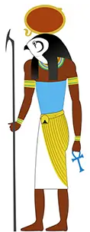

The most powerful Pharoahs were buried in enormous tombs. The biggest of these is the **Great Pyramid at Giza,** built for a Pharoah called Khufu.

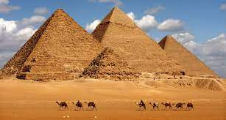

**TUTENKHAMUN**

Tutenkhamun became **Pharoah** in 1332 BC, aged 9. He ruled for less than 10 years and died suddenly at the age of 18, possibly murdered.

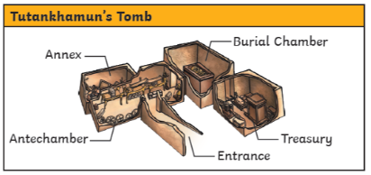

Tutenkhamun’s tomb was discovered in 1922 by an English archaeologist called **Howard Carter**. Inside were over 5000 items including a death mask made of **solid gold**. Historians and archaeologist have learnt a lot about Ancient Egypt from these items. There were more important Pharoahs than Tutenkhamun, but their tombs were raided by grave robbers. This is why Tutenkhamun is so well-known.

