HISTORY DETECTIVES: ROSA PARKS
KEY DATES
1811  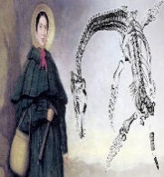  Ichthyosaur fossil discovered in the time of Mary Anning | 1837  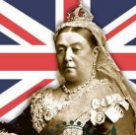  Queen Victoria became Queen | 1840s  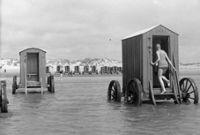  Victorian Beach Holidays became popular | 1861  Mrs Beeton’s Victorian Cookbook is published | 1865  The Grove School is built | 1901  Queen Victoria died | 1913  Rosa Parks born  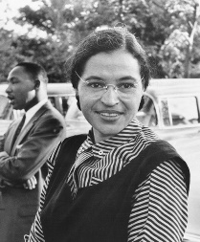 | 1955  Rosa Parks protested about discrimination on a bus in America | 2020/21  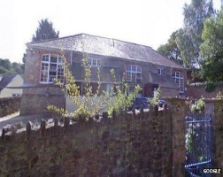  Started school at The Grove School
ROSA PARKS |  |  |  |  | THE VICTORIAN ERA
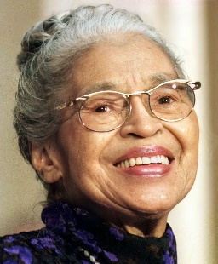  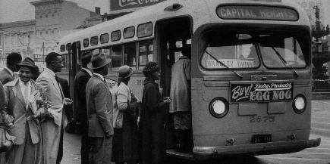  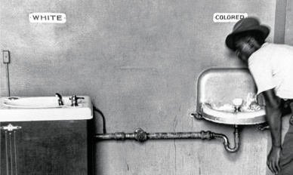  Rosa Parks Separated by race Bus that the protest happened on |  |  |  |  | 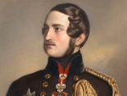  Previous Learning  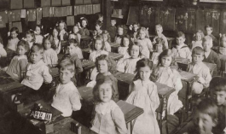  A Victorian school Prince Albert
KEY VOCABULARY
Discrimination Segregation Integration Diversity Protest
Discrimination: Treating people differently. (Sometimes based on race, religion or disability)
Segregation: Keeping people apart.
Integration: When people are brought together and treated the same.
Diversity: Describes differences between people. (race, religion, ability)
Protest: Speaking up about something that is wrong

