Key Words  Do we know what these words mean? |  | Religious Education  Judaism – Who is Jewish and how do they live? (part 1)
Judaism  Jews  Synagogue  Tenakh  Torah  Tallit  Yad  Kippah  Chanukiah  Mezuzah | Challah  Kiddush cup  Kosher  Seder plate  Star of David  Siddur  Menorah  Shofar  Hanukkah  Chanukah | Things that are precious to us  Things can be precious to us for lots of reasons:  - To remind us what is important.  - To remember special people, places or events. | Who do Jews believe in?  Jews believe that God is one and cares for all people. They also believe that it is important to love God. | Special Objects  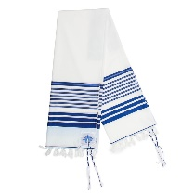  Tallit  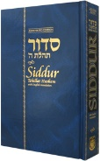  Siddur  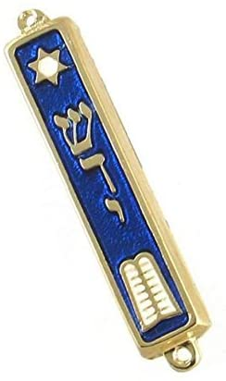  Mezuzah  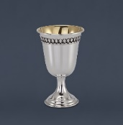  Kiddush cup  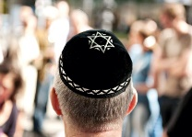  Kippah  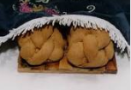  Challah bread  challah board  challah cover
 |  | Jewish Families  Family and home are very important to  Jewish people.  Jewish people have special objects in their homes to help them praise God. | 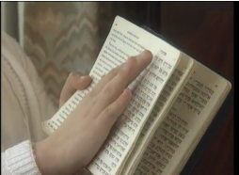  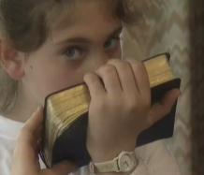  Jewish people kiss their prayer book on both sides when they close it.  It’s written in Hebrew and read from right to left.
Special Book
Tenakh – Torah
(Torah is part of the Tenakh)
Place of Worship
Synagogue
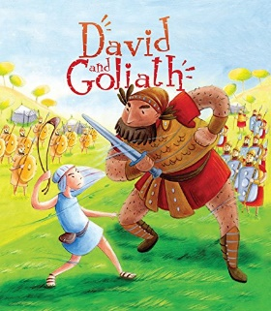
Story of David and Goliath
The Israelites and Philistines face each other.
Goliath makes his challenge to single combat.
David volunteers to fight Goliath.
David selects five smooth stones from a creek-bed to be used in his sling.
David defeats Goliath, the Philistines flee the battlefield.
Festivals
Chanukah/Hanukkah
Passover
Sukkot

