Key Words  Do we know what these words mean?  country  Totnes  Plymouth  Devon  United Kingdom  England  town  city  harbour  theatre  university  museum  aquarium  English channel  Atlantic Ocean  map  scale  symbol  key | Geography - Plymouth  Landmarks of Plymouth  The Theatre Royal The Box Museum  Plymouth Cathedral The Hoe Plymouth University Plymouth Aquarium  Plymouth harbour | Where is Plymouth?  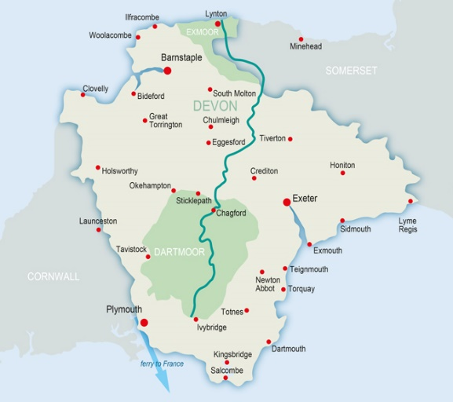  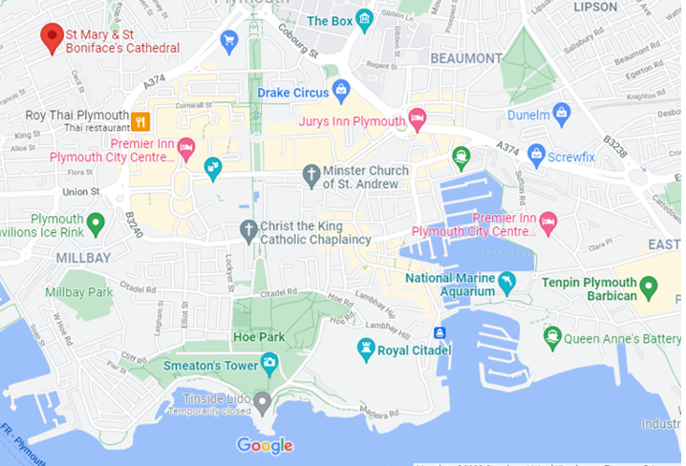  Map Symbols  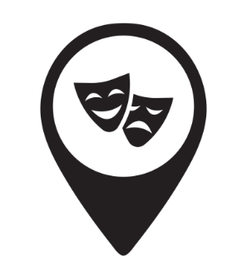  Theatre museum cathedral  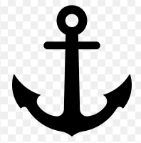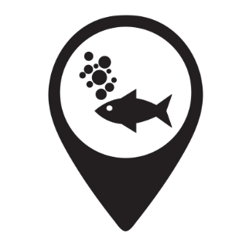  university harbour aquarium

