Key Words  Do we know what these words mean? | Religious Education  Judaism - Who is Jewish and how do they live? Part 2
Jew  Judaism  Star of David  Shabbat  Menorah  Tenakh  Torah  Challah bread  Challah board  Challah cover  Chanukah/Hanukkah  Kosher food | Shabbat  - According to the Bible what did God do on the 7th day? (He rested.)  - When does Shabbat begin? (Every Friday at sunset.)  - How long does Shabbat last? (25 hours.)  - What can't Jews do on Shabbat? (Do anything involving electrical or electronic items - eg can't turn on lights, use the oven, play with computer games or use mobile phones.)  - What do Jews think are good things about Shabbat? (Playing games, candles, no homework, singing, family gathering, chicken dinner, bread and juice, time to talk, an extra meal, time to ponder, a fresh start for a new week)  - How do Jews welcome Shabbat? (They light candles, say a blessing in Hebrew, and enjoy a special meal with all the family.) | Jews believe that God is one and cares for all people. They also believe that it is important to love God.  Jewish people have special objects in their homes to help them praise God.  Family and home are very important to Jewish people.  Hanukkah  Hanukkah is a festival that remembers the re-dedication (giving back) of the temple in Jerusalem to God.  Importance of the menorah – represents hope, resilience and faith.  9 Candles - symbolise the eight nights of Hanukkah plus the shamash, or helper candle, which is used to light the others.
Special Book
Tenakh – Torah
(Torah is part of the Tenakh)
Place of Worship
Synagogue

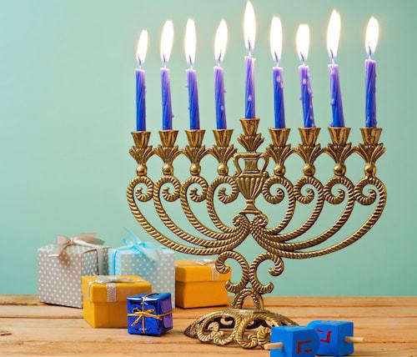
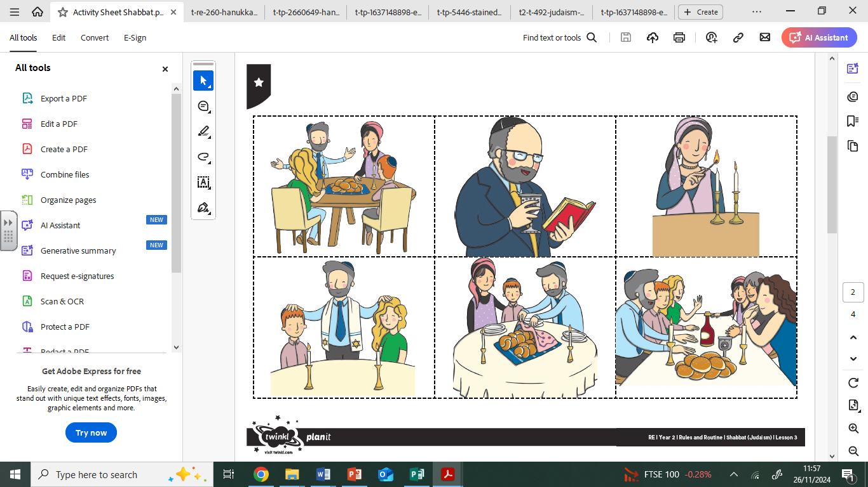

Festivals
Hanukkah
Passover
Sukkot

