Key Words  Do we know what these words mean?  classification  reptile  mammal  amphibian  birds  insects  fish  omnivore  herbivore  carnivore  scales  fins  gills  Our Scientist: Beatrix Potter  Lived between: 1866 – 1943  Famous for: Study of fungi (mycology), writing Peter Rabbit and other tales.  Loved : Nature and worked hard to preserve land for people to enjoy.  Struggles: Her scientific ideas were not accepted at the time because she was a woman.  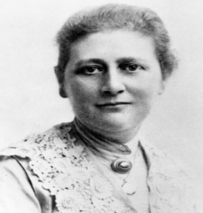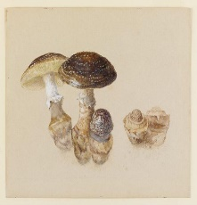 | Science  Animals and their classifications
 | Mammals  Has fur, gives birth to live babies and is warm-blooded.  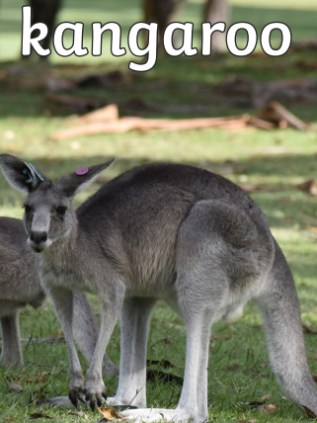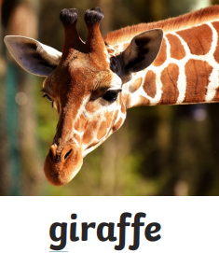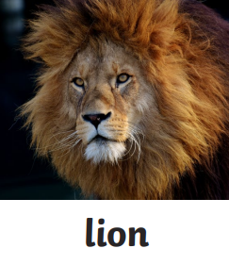 | Amphibians  Cold-blooded, live on land and water, born with gills then develop lungs. No scales.  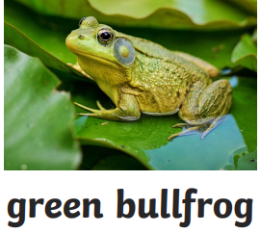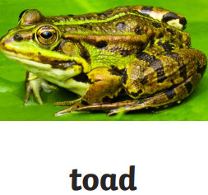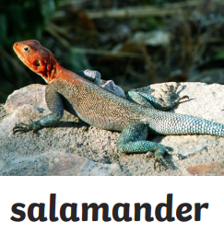 | Reptiles  Cold-blooded, lay eggs and are covered in scales or bony plates.  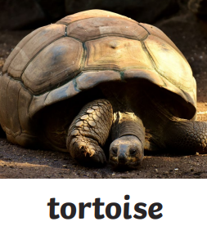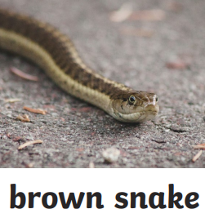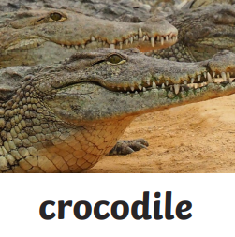
 | Fish  Live underwater, have gills to breathe. Cold-blooded.  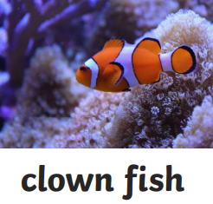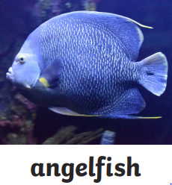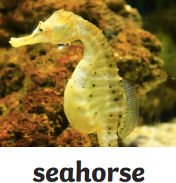 | Birds  Has feathers, lays eggs and is warm-blooded.  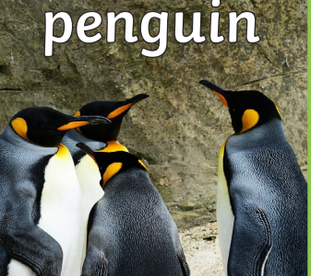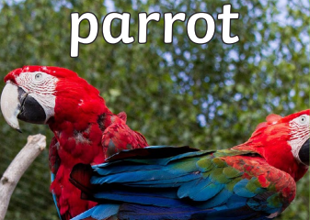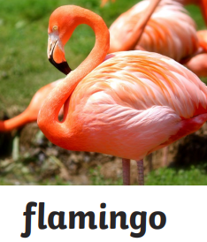 | Insects  6 legs (3 pairs), body is in 3 segments, often have wings. Cold-blooded.  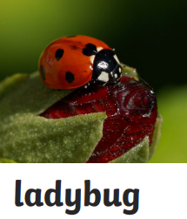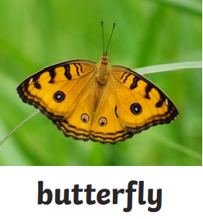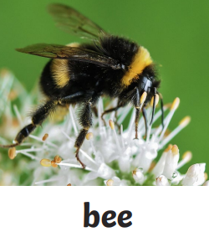
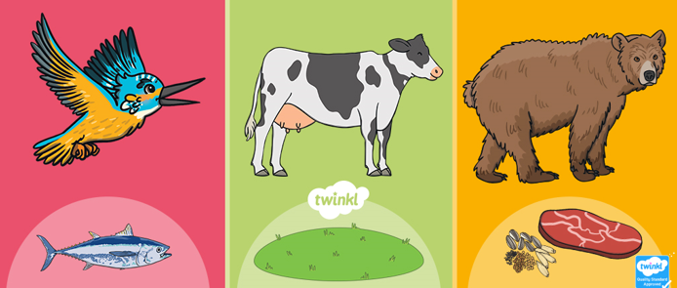
carnivore herbivore omnivore
eats only meat eats only plants eats meat and plants

