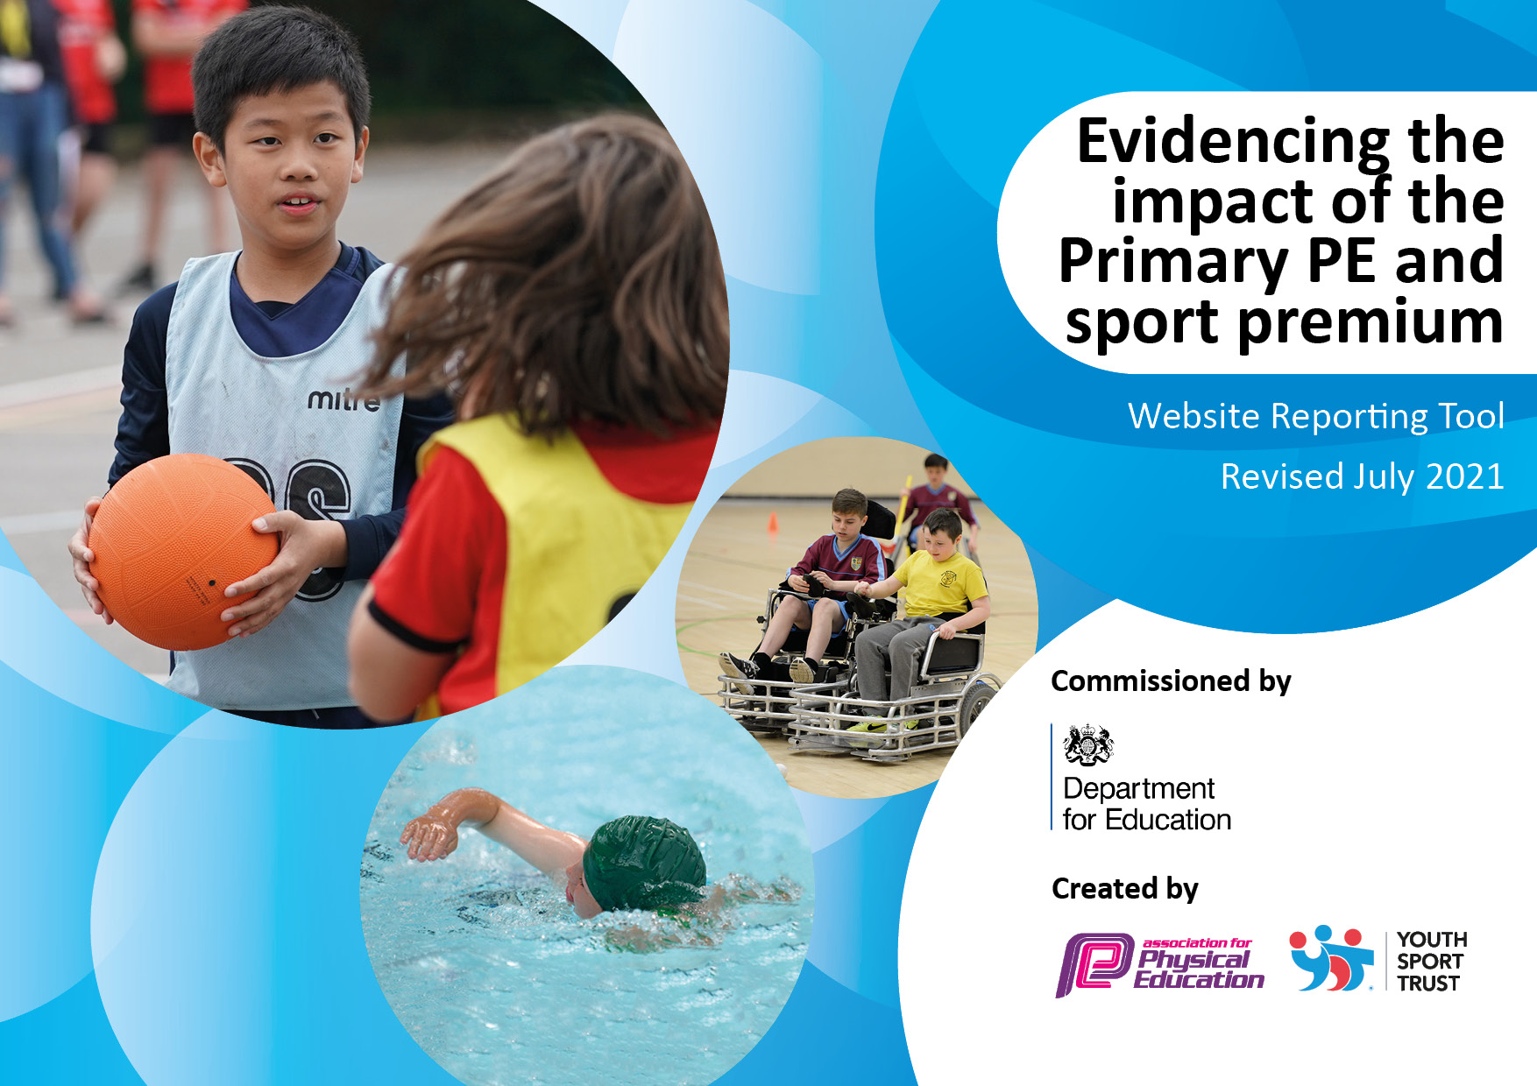
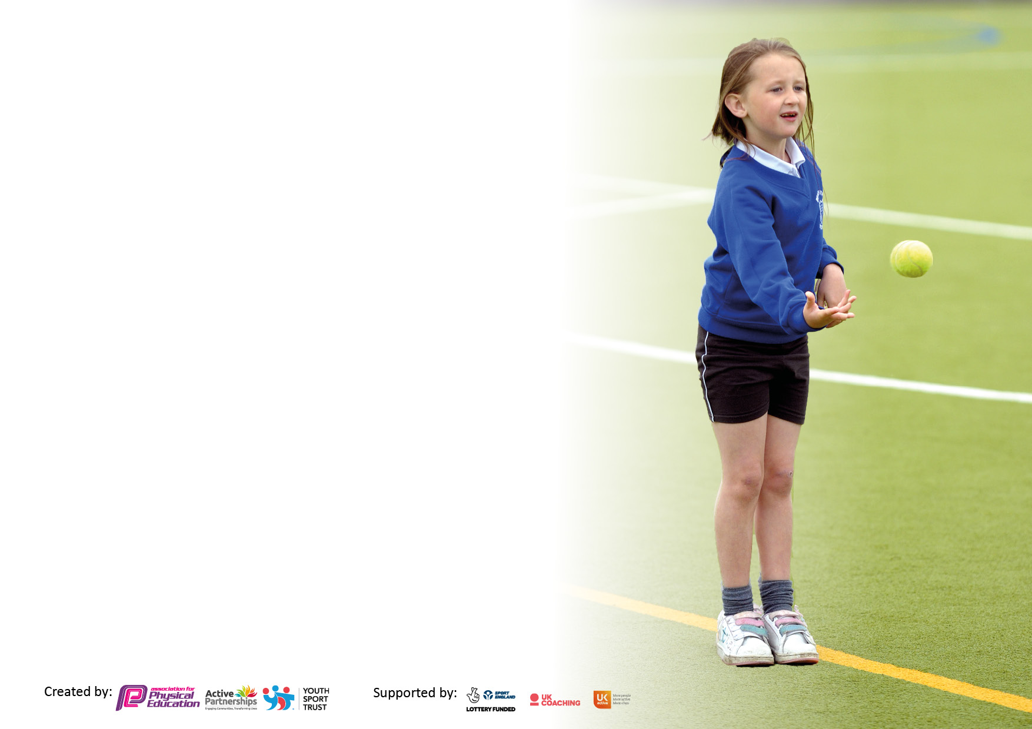

It is important that your grant is used effectively and based on school need. The Education Inspection Framework makes clear there will be a focus on ‘whether leaders and those responsible for governors all understand their respective roles and perform these in a way that enhances the effectiveness of the school’.

Under the Quality of Education Ofsted inspectors consider:
Intent - Curriculum design, coverage and appropriateness
Implementation - Curriculum delivery, Teaching (pedagogy) and Assessment
Impact - Attainment and progress

To assist schools with common transferable language this template has been developed to utilise the same three headings which should make your plans easily transferable between working documents.

Schools must use the funding to make additional and sustainable improvements to the quality of Physical Education, School Sport and Physical Activity (PESSPA) they offer. This means that you should use the Primary PE and sport premium to:

- Develop or add to the PESSPA activities that your school already offer
- Build capacity and capability within the school to ensure that improvements made now will benefit pupils joining the school in future years
- The Primary PE and sport premium should not be used to fund capital spend projects; the school’s budget should fund these.

Pleasevisitgov.ukfortherevisedDfEguidanceincludingthe5keyindicatorsacrosswhichschoolsshoulddemonstrate animprovement.Thisdocumentwillhelpyoutoreviewyourprovisionandtoreportyourspend.DfEencouragesschools to use this template as an effective way of meeting the reporting requirements of the Primary PE and sport premium.

We recommend you start by reflecting on the impact of current provision and reviewing the previous spend.

Schools are required to publish details of how they spend this funding, including any under-spend from 2019/2020, as well as on the impact it has on pupils’ PE and sport participation and attainment. All funding must be spent by 31st July 2022.

We recommend regularly updating the table and publishing it on your website throughout the year. This evidences your ongoing self-evaluation of how you are using the funding to secure maximum, sustainable impact. Final copy must be posted on your website by the end of the academic year and no later than the 31st July 2021. To see an example of how to complete the table please click HERE.
Created by: Supported by:

Details with regard to funding for 2022 -2023
Please complete the table below.

Total amount carried over from 2020/21 | £ 5,000.00
Total amount allocated for 2021/22 | £15,780.00 (Inc above)
How much (if any) do you intend to carry over from this total fund into 2022/23? | £5,000.00
Total amount allocated for 2022/23 | £19,860.00(inc above)
Total amount of funding for 2022/23. To be spent and reported on by 31st July 2023. | £24,860.00

Swimming Data
Please report on your Swimming Data below.

Meeting national curriculum requirements for swimming and water safety.

N.B. Complete this section to your best ability. For example you might have practised safe self-rescue techniques on dry land which you can then transfer to the pool when school swimming restarts.
Due to exceptional circumstances priority should be given to ensuring that pupils can perform safe self rescue even if they do not fully meet the first two requirements of the NC programme of study
What percentage of your current Year 6 cohort swim competently, confidently and proficiently over a distance of at least 25 metres?  Pupils leaving at the end of the summer term 2023 | 80%
What percentage of your current Year 6 cohort use a range of strokes effectively [for example, front crawl, backstroke and breaststroke]?  Please see note above | 80%
What percentage of your current Year 6 cohort perform safe self-rescue in different water-based situations? | 80%
Schools can choose to use the Primary PE and sport premium to provide additional provision for swimming but this must be for activity over and above the national curriculum requirements. Have you used it in this way? | Yes Summer 2023 We use this to support the non-swimmers so that they leave primary swimming  £500

Action Plan and Budget Tracking
Capture your intended annual spend against the 5 key indicators. Clarify the success criteria and evidence of impact that you intend to measure to evaluate for pupils today and for the future.

Academic Year: 2022/23 | Total fund allocated: | Date Updated:
Key indicator 1: The engagement of all pupils in regular physical activity – Chief Medical Officers guidelines recommend that primary school pupils undertake at least 30 minutes of physical activity a day in school |  |  |  | Percentage of total allocation:
 |  |  |  | %
Intent | Implementation |  | Impact
Your school focus should be clear what you want the pupils to know and be able to do and about  what they need to learn and to  consolidate through practice: | Make sure your actions to achieve are linked to your intentions: | Funding allocated: | Evidence of impact: what do pupils now know and what can they now do? What has changed?: | Sustainability and suggested next steps:
Sustain participation in daily activities, through active playtimes and DPA.  Train playground leaders and to provide storage and equipment | Buy into the Dartmoor School Sports Partnership, leaders to be trained  Jump Start Jonny Subscription  Buy and replace equipment for active playtimes. | £4800  £299  £2275 | DSSP ensure access to quality training and coaching for children, access to competitions and festivals and improving our in school quality of teaching of PE  Jump start jonny is essential in EYFS and EY for accessing active participation of all children every day | Percentage of total allocation:  30%
Key indicator 2: The profile of PESSPA being raised across the school as a tool for whole school improvement |  |  |  | Percentage of total allocation:
 |  |  |  | %
Intent | Implementation |  | Impact
Your school focus should be clear what you want the pupils to know and be able to do and about  what they need to learn and to  consolidate through practice: | Make sure your actions to achieve are linked to your intentions: | Funding allocated: | Evidence of impact: what do pupils now know and what can they now do? What has changed?: | Sustainability and suggested next steps:
Membership of the Dartmoor Schools Sports Partnership to attend festivals, giving all children the opportunity to experience different activities.  Use Leaders to run festivals for other year groups. | Buy into the partnership  Transport costs to attend festivals | £2360  And we use parental transport | Large amounts of our children attend the festivals, events, competitions and all children attend impact days and benefit from sports training for staff | 9.5%

Key indicator 3: Increased confidence, knowledge and skills of all staff in teaching PE and sport  Key indicator 5: Increased participation in competitive sport |  |  |  | Percentage of total allocation:
 |  |  |  | %
Intent | Implementation |  | Impact
Your school focus should be clear | Make sure your actions to | Funding | Evidence of impact: what do | Sustainability and suggested
what you want the pupils to know | achieve are linked to your | allocated: | pupils now know and what | next steps:
and be able to do and about | intentions: |  | can they now do? What has
what they need to learn and to |  |  | changed?:
consolidate through practice:
Membership of the DSSP for INSET to give staff an Increased knowledge of touch rugby, KS1 planning, handball and athletics  Teachers to attend Swim INSET | Buy into the Dartmoor School Partnership  Staff inset and Impact days  Supply cover and training and staff over time  PE trip to south Brent festival  Wild Tribe Forest school training with DSP | As above  And  £7365  £180  £1800 | Staff training as above impacts into the quality of education, the quality of skills that children leave primary with  . All teachers are now forest school trained and incorporate these skills across the curriculum in outdoor activities | Percentage of total allocation:  38%
Key indicator 4: Broader experience of a range of sports and activities offered to all pupils |  |  |  | Percentage of total allocation:
Intent | Implementation |  | Impact
Your school focus should be clear | Make sure your actions to | Funding | Evidence of impact: what do | Sustainability and suggested
what you want the pupils to know | achieve are linked to your | allocated: | pupils now know and what | next steps:
and be able to do and about | intentions: |  | can they now do? What has
what they need to learn and to |  |  | changed?:
consolidate through practice:
Children to experience different activities, linked to The Grove 100, giving them a broad experience | Year 5 / 6 – Skiing / sno-tubing  Year 3 / 4 – Climbing / abseiling  Year R, 1 / 2 – I bounce  Trampolining and Gymnastics | £2175  £2838  £498  £270 | Pupils have become skilled at beginner standards in these sports and have experienced sports wider than the National curriculum | Percentage of total allocation:  23%

Signed off by
Head Teacher: | Hilary Priest
Date: | July 23
Subject Leader: | Helen Fernyhough and Hannah Westrope
Date: | July 23
Governor: | Chair of Governors Ian Stewart
Date: | September 23

