Key Words  Do we know what these words mean? |  | Religious Education  Islam - Who is Muslim and how do they live?
Muslim  Allah  Mosque  Muhammad | Shahadah  Messenger  Tawhid  Qur’an  Prophet | Five Pillars of Islam  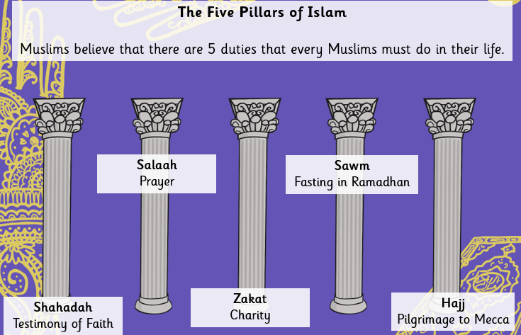 | Allah  Muslims believe that there is only one God referred to as Tawhid. Muhammad (Peace Be Upon Him/PBUH) is his messenger.  Muslims have 99 names for Allah, such as ‘All Compassionate, The Pure One and the Source of Peace’.
Special Book
Qur’an
Place of Worship
Mosque
Shahadah
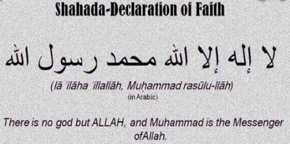

Qur’an
Muhammad received the Holy Qur’an on the ‘Night of Power’. Muslims treat the Qur’an with the upmost respect by wrapping it up.
Festivals
Ramadan
Ede

