Key Words  Do we know what these words mean?  classification  reptile  mammal  amphibian  birds  insects  fish  omnivore  herbivore  carnivore  scales  fins  gills  Our Scientist: David Attenborough  Lived between: 8th May 1926 – Present day  Famous for: British broadcaster, biologist, natural historian, and writer. He’s best known for his writing and presenting. He films animals in different habitats.  The Queen made him a knight.  Lots of animals and plants have been named after him.  Struggles: When he was at university, his study was put on hold because he was called up for national service in the Royal Navy. | Science  Animals and their classifications- British Wildlife
 | Mammals  Has fur, gives birth to live babies and is warm-blooded.  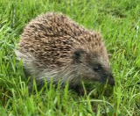  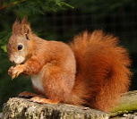  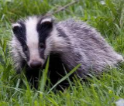  Badger Squirrel Hedgehog | Amphibians  Cold-blooded, live on land and water, born with gills then develop lungs. No scales.  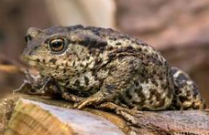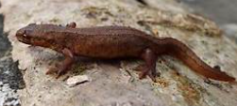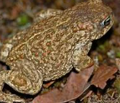  Common Newt Toad  Frog | Reptiles  Cold-blooded, lay eggs and are covered in scales or bony plates.  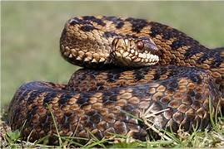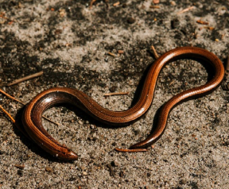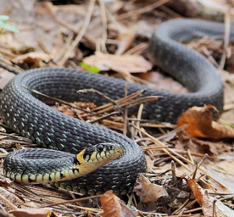  Adder Slow Grass  Worm Snake
 | Fish  Live underwater, have gills to breathe. Cold-blooded.  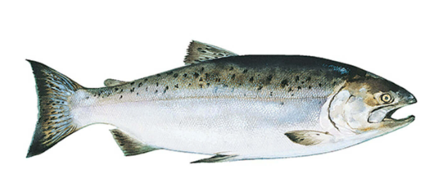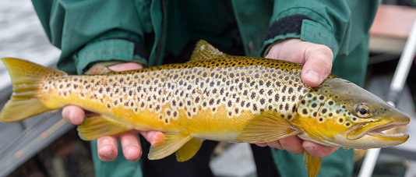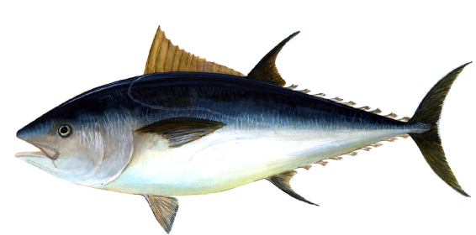  Salmon Brown Trout Blue Fin  Tuna | Birds  Has feathers, lays eggs and is warm-blooded.  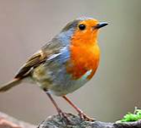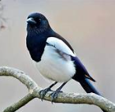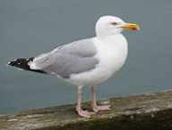  Robin Magpie Seagull | Insects  6 legs (3 pairs), body is in 3 segments, often have wings. Cold-blooded.  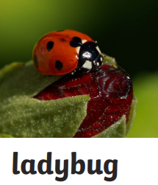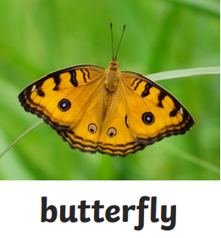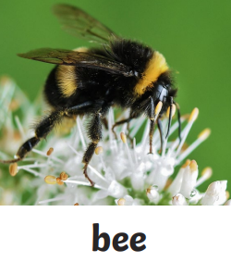
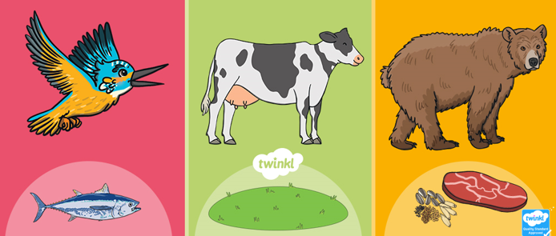
carnivore herbivore omnivore
eats only meat eats only plants eats meat and plants

