 |  | HISTORY DETECTIVES: VICTORIAN SEASIDE
 |  | KEY DATES
1753  Bathing Machines invented  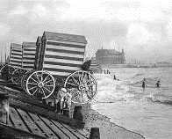 | 1799  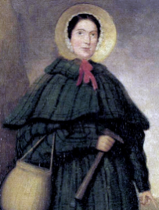  Mary Anning was born |  | 1811  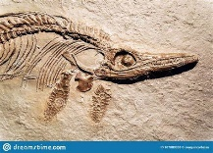  Ichthyosaur fossil discovered | 1837  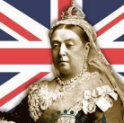  Queen Victoria became Queen | 1850s  Hokey Pokey stalls began to sell ice cream  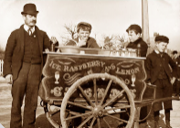 | 1865  The Grove School is built | 1880  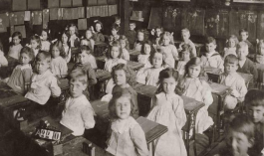  Children had to go to school | 1901  Queen Victoria died | 1955  Rosa Parks protested discrimination 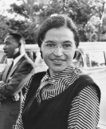 | 2020/21  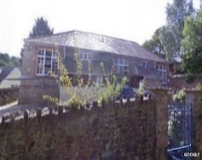  Started school at The Grove School
VICTORIAN SEASIDE |  |  |  |  |  |  |  | THE VICTORIAN ERA
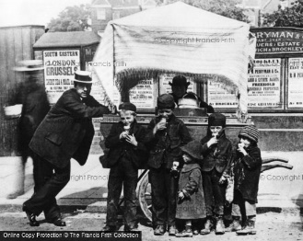  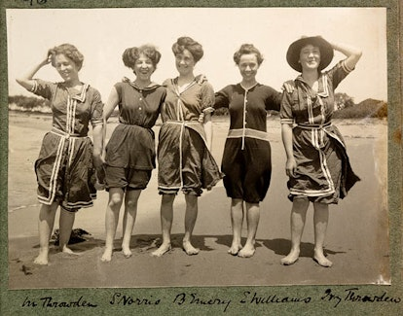  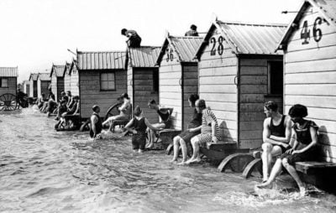  Bathing Machines allowed Bathing suits Hokey Pokey stall  people to get changed |  |  |  |  |  |  |  | Previous Learning  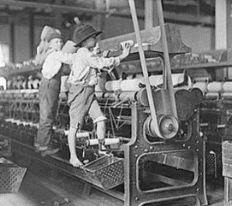  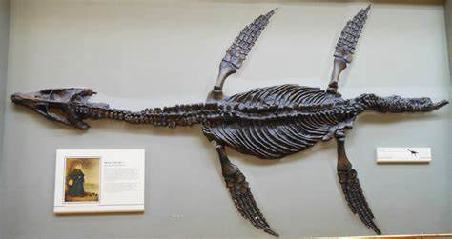  Children worked if Mary Anning discovered  they were poor a Plesiosaur fossil
KEY VOCABULARY
Past: A time before now
Present: What is happening now
Tourist: When people travel on holiday they are tourists
Victorian: Happening while Queen Victoria was the Queen
Bathing Machines: Allowed people to change into swimwear and wade in the sea
Hokey Pokey: Victorian word used for cheap ice cream sold in a cart by street-vendors
Punch and Judy: A puppet show with Mr Punch and his wife Judy

