Key Words  Do we know what these words mean?  country  Totnes  South Hams  Devon  United Kingdom  England  river  valley  town  village  house  aerial view  map  scale  symbol  key  River Dart | Geography - Totnes  Landmarks of Totnes  Totnes Castle The Grove School  River Dart The Guidhall Market Square Cranch’s  East Gate Arch St Mary’s Church | Where is Totnes?  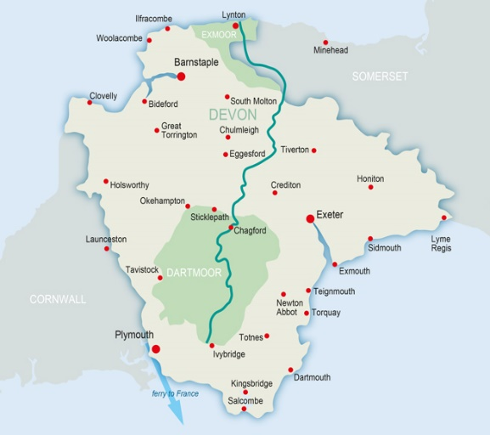  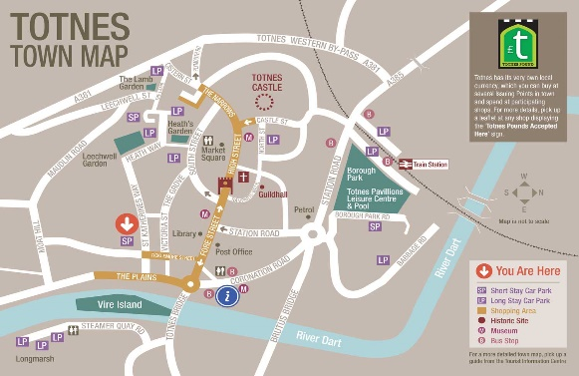  Map Symbols  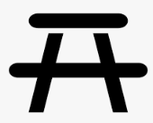  church car park picnic area  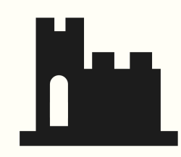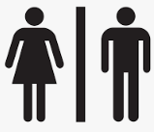  Hospital castle toilets
 | scale 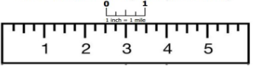 | aeriel view  