Key Words  Do we know what these words mean?  map  symbol  river  forest  hill  valley  house  shop  village  town  Totnes  city  Plymouth  Devon  Country  England  United Kingdom | Geography - Totnes Castle  Where is Totnes Castle?  Totnes Castle is built on a hill and by a river.  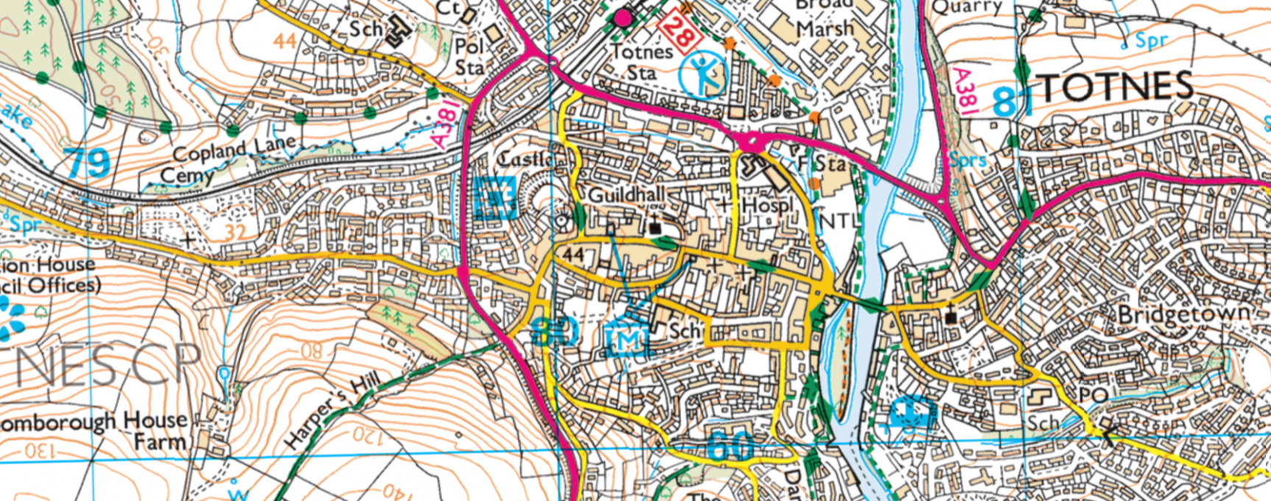  Map symbols Main road footpath river trees building School English Heritage Museum Place of Worship Leisure centre | Aerial view  An image taken from hig h up.  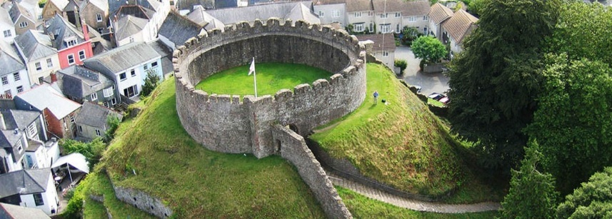  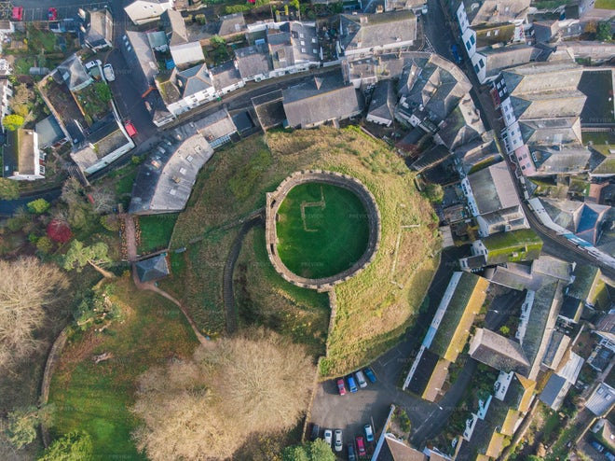  Ground-level view  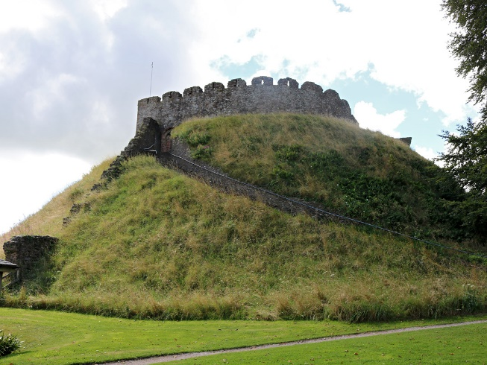  An image taken from the ground.

