**STONE AGE HOMEWORK**

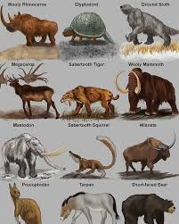

Your homework this half-term, Year 3 and 4, is to create an information page on an animal from the Stone Age period.

You will need to carry out some research on your chosen animal and include any the facts that you find.

You should aim to make your work bright and eye-catching, with illustrations or pictures printed out if you prefer.

Below are some of the things you might want to include/think about:

* When were the animals around?
* Was it a predator or prey animal?
* Where was it found in the world?
* How did the Stone Age people use the animal in their everyday lives?

Any projects should be handed into your teacher by Friday 18th October.